Acupuncture for pain, mandibular function and oral healthrelated quality of life in patients with masticatory myofascial pain: A randomised controlled trial
Franklin Teixeira de Salles-Neto1 | Janice Simpson de Paula2 |João Gabriel de Azevedo José Romero1 | Camila Megale Almeida-Leite31Pathology Postgraduate Program, Faculty of Medicine, Universidade Federal de Minas
Gerais (UFMG), Belo Horizonte, Brazil;; 2Department of Social and Preventive Dentistry, Faculty of Dentistry, UFMG, Belo
Horizonte, Brazil; 3Department of Morphology, Biological Sciences Institute, UFMG, Belo Horizonte, Brazil

Abstract

Background: Masticatory myofascial pain is the most prevalent muscular temporomandibular disorders (TMD). It primarily affects masseter and temporal muscles. Several treatments, including acupuncture, have been recommended. However, systematic reviews have highlighted gaps in studies and absence of conclusive results.

Objectives: We performed a randomised controlled clinical trial to evaluate the effectiveness of acupuncture in improving pain, mandibular function and oral health related quality of life in women with masticatory myofascial pain.

Methods: Thirty-six patients diagnosed with masticatory myofascial pain according to the Research Diagnostic Criteria for Temporomandibular Disorders (RDC/TMD) were divided into the following two groups: acupuncture and control (non-penetrating acupuncture). Treatment was performed weekly for 5 weeks, and pain, mandibular function and oral health-related quality of life were evaluated one week before treatment, one week after treatment and one month after treatment. Non-parametric and parametric tests were used for comparisons between times and treatment groups (significance level of P ≤ .05).

Results: The acupuncture group showed a significant reduction in pain (P ≤ .01), which was not observed in the control group. Pain intensity was reduced by 61% and 84% at 1 week and 1 month after treatment, respectively. Both groups showed significant improvements in mandibular function and oral health-related quality of life over time (P ≤ .01). Statistical analysis did not show a significant difference between the groups for any other evaluated outcome (P > .05).

Conclusion: Although acupuncture was effective in pain reduction, non-specific factors may have influenced mandibular function and oral health-related quality of life improvements in both groups, and this needs to be further addressed.



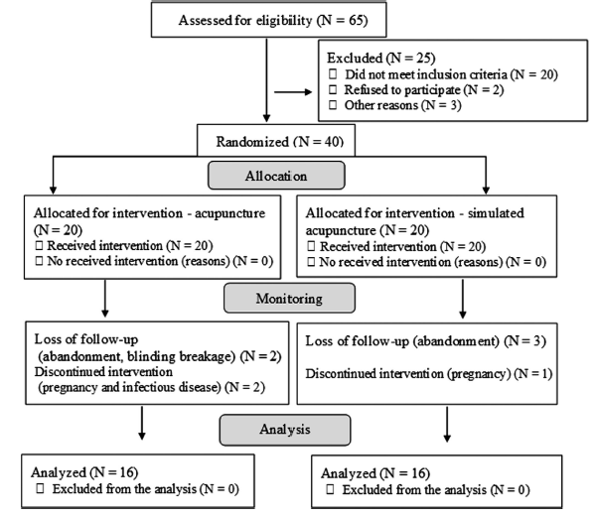
Figure 1: Study flowchart

- Chen J, Huang J, Li JV, Lv Y, He Y, Zheng Q. The Characteristics of TCM Clinical Trials: A Systematic Review of ClinicalTrials. gov. Evidence-Based Complementary and Alternative. Medicine. 2017;2017:1-9.

- Edwards RR, Dworkin RH, Sullivan MD, Turk DC, Wasan AD. The role of psychosocial processes in the development and maintenance of chronic pain. J Pain. 2016;17(9 Suppl):T70-92.

- Pan RY, Hsu YC, Wong CS, et al. Comparing complementary alternative treatment for chronic shoulder pain of myofascial origin: Collateral meridian therapy versus local tender area-related meridians therapy. Medicine. 2016;95(35):e4634.
- Turk D, Dworkin R, Msdermott M, et al. Analyzing multiple endpoints in clinical trials of pain treatments: IMMPACT recommendations. Pain.2008;139(3):485-493.

- Xiang A, Cheng K, Shen X, Xu P, Liu S. The Immediate Analgesic Effect of Acupuncture for Pain: A Systematic Review and Meta- Analysis. Evid Based Compl Alternat Med. 2017;2017:1-1

Biography
Bachelor's at Odontologia from Universidade Federal de Minas Gerais. Brazil (2001). Has experience in Odontology, focusing on Orthodontics and TMD/Orofacial pain. He has specialization in Orthodontics, Implantodontics and TMD and orofacial pain. Master in pathology with research line in TMD and orofacial pain.
Email: franklintsneto@gmail.com

