Effective homoeopathic treatment for every human problem
Dr.Nirav Rughani, MD (Homoeopathy), Harmony Homoeopathic Clinic, India.
Abstract
Homoeopathy is a system of therapeutic which focusing on the genesis and evolution of a person in his illness. Since the human body is a unification that involve every parts and organs and its role in maintaining the health. Nature has created our system in a way that it heals minor problems by its own and it always try to maintain the homoeostasis and keep under balance. Disease is reflected at one part but it shows the disharmony of whole human economy. The true homoeopathic science focuses of these parameters and found the root cause of an illness through the window of signs and symptoms and integrates the problems and finds the right solution for that. There are ample results which show the effectiveness of the treatment and true value of homoeopathic science.
Photograph
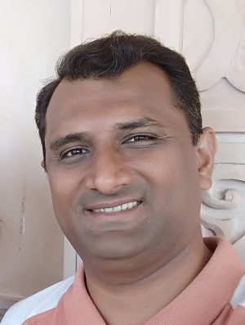
Biography
Dr.Nirav Rughani M.D. (Homoeopath) has rich experience in field of Homoeopathy. He has received excellent training during his p.g. from well established 50 bed Homoeopathic Hospital and got training in dermatology, gynaecology, paediatric, surgery, clinical medicine, psychiatric, rheumatology, orthopaedic & emergency department managed with Homoeopathy as a priority. He is doing fellowship in special children and managing cases like Autism, Cerebral palsy, Mental retardation, Dyslexia and children with genetic and congenital problems. He is a professor in Subject of Organon of Medicine since 2010 and the only teacher who teach psychology to the graduate students in his college. He is the proprietor of Harmony Homoeopathic Clinic and treating number of patients with various illnesses. He has received the award of standardise case record in homoeopathy.
Contact: -
http://www.harmonyhomoeopathy.com/
drnrrughani@gamil.com
+91 93765 77704

