THE EFFICACY OF HOMOEOPATHIC
MEDICINES IN BRAIN TUMORS
DR.K.P.Nandakumar.MD,PG Hom(Lon)
Introduction
The role and efficacy of Homeopathic medicines, on treatment of malignant tumors is largely unknown and unproven so far. Homeopathic therapy is mainly used for supportive cancer care only and some have advised for an integration of this therapy with conventional methods..
Most patients indicated their problem had improved with Complementary and Alternative Medicine (CAM).

PROTOCOL APPROACH IN BRAIN TUMOR
- Combination of two potentized medicines, are used in a meaningful way based on years of clinical observations .They are combined for special advantages in treatment, so that the aggravation due to the medicines can be checked, side effects of the medicines abated, quick and uneventful recovery can be ensured in a much shorter time.
.
- “Ruta 6 selectively induces cell death in Brain Cancer Cells but proliferation in normal Lymphocytes”
- A novel treatment for Human Brain cancer” in the International Journal of Oncology in October 2003
- Along with the Professor of Cell Biology and Genetics, at the University of Texas MD Anderson Cancer Center, Houston, one paper has been published entitled “Ruta 6 selectively induces cell death in brain cancer cells but proliferation in normal peripheral blood lymphocytes: A novel treatment for human brain cancer” in the International Journal of Oncology in October 2003 where the method of treatment with Ruta6 and Calcarea Phosphorica 3x was followed with excellent results.

These slides show FISH (Fluorescent in-situ Hybridization) preparations of interphase cells from a human B-lymphoidcell line and brain cancer either untreated or treated with Ruta 6 + Ca3(PO4)2 are stained with DAPI for DNA (blue), and telomeric DNA labeled with rhodamine (red).
B-lymphoid control cells (A)
- Shows FISH preperations of interphase cells from a human B-Lymphoid cell line and Brain Cancer either untreated or treated with Ruta 6 + Ca3(Po4)2 are stained with DAPI for DNA (Blue) and telemeric DNA labelled with Rhodamine (red)
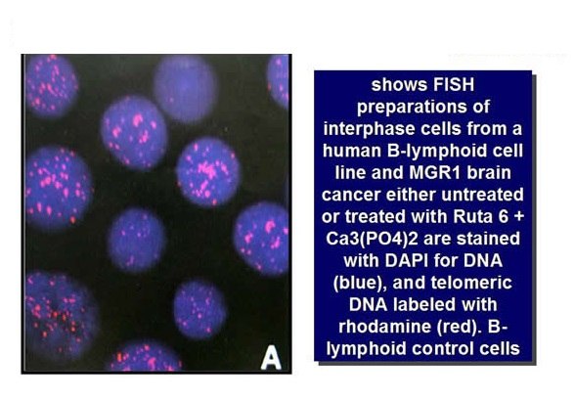
Untreated control (C)
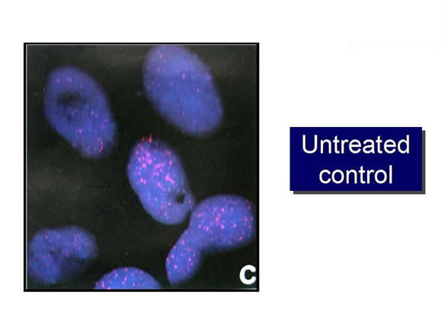
Ruta-treated Large Nuclei from Ruta treated Cells show reduced
Telomeric signals
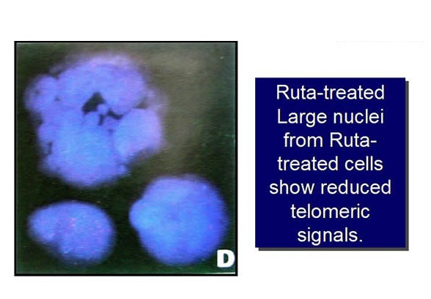
- From these observations, it is evident that these medicines have the definite power to reduce and cure Intracranial SOL. It may be interesting to note that these claims with regard to the action of these medicines have been successfully vindicated in vitro. These slides show Metaphases from control and Ruta 6-treated human brain cancer cells showing mitotic catastrophe and Ruta-treated … human brain cancer cells show significant difference in telomeric signals. Large nuclei from Ruta-treated cells show reduced telomeric signals. All microphotographs were taken at the same Signification. Both in vivo and in vitro results showed induction of survival-signaling pathways in normal lymphocytes and induction of death-signaling pathways in brain cancer cells. Cancer cell death was initiated by telomere erosion and completed through mitotic catastrophe events. These experiments propose that Ruta in combination with Ca3(PO4)2 could be used for effective treatment of brain cancers, particularly glioma.
- Thus presently it appears from all these findings that this new method of treatment with Homeopathic medicines may be regarded as the Future drug for cancer research and treatment for the benefit of mankind.

Ruta- How it works
Rutin, the active ingredient of Ruta, is known for its anti-oxidant and anti-inflammatory activities and also for reducing oxidative damage in a rodent model.

Anti inflammatory action of Ruta
A comparable concentration of this flavonoid in the highest concentration (500 μg/ml) of plant extract was used for this study; a 20% inhibition (p = 0.058) was observed. Inhibition in inducible nitric oxide synthase (inos) gene expression in the cells treated with the plant extract suggests an inhibition at the transcription level.
Interestingly, a concomitant decrease in transcription of cyclooxygenase-2 (COX-2) gene has also been observed in cells treated with the plant extract and this inhibition is significantly higher than that observed with the highest concentration of rutin (80 μM) used in the study.
In addition, Ruta is also known to protect from DNA strand breaks and to prevent mutagenesis.
Cal phos- How it works
Calcium phosphate activates phospholipase, which cleaves phosphalidylinositol biphosphate, a membrane bound molecule that activates protein kinase C. Thus one may consider these aspects for a possible explanation of such effects.
Protein kinase C
Protein kinase C has a crucial role in signal transduction for a variety of biologically active substances which activate cellular functions and proliferation. The enzyme serves as a receptor for the tumor promoters.

