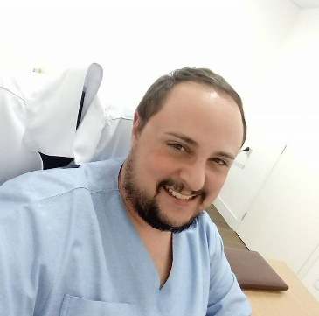
Prof. Eduardo Egisto
Homeopathy and Orthomolecular
Holistic Health Counselor
Associate CONAHOM nº 1604
E-mail: dudubrasp@hotmail.com
Website: http://www.homeopatias.tk
Mobile: +5519988663778

Coordinator and Professor of Homeopathy at the Hahnemann Institute of Technology; Master's degree in Naturopathic Sciences from Universidad Europea del Atlántico; Student in Physiotherapy at Metrocamp School of Campinas; Homeopathy Sciences, Federal University of Viçosa; Adult Intensive Physical Therapy by SECAD; Orthomolecular and Clinical Nutraceuticals by the IPUPO Institute; Bach Flowers by the Bach International Education Program in London; Pranic Healing from the Pranic Healing Foundation of the Philippines; Integrative and complementary therapies in Acupuncture, Reiki, Chromotherapy, Reflexology and Clinical Mesotherapy; Author of the books “Repertório Homeopático de A a Z”, “Homeopatia Natural Energética” e “Pensamentos Homeopáticos – Livre Escolha”.

Philosophy of the Beginning

To speak about the Philosophy of the Beginning, requires opening the mind and understanding some principles that govern, the physical and astral planes that lead us to its foundation.
Some ways of gaining knowledge lead us to think and other doubts arise, but from the moment you have discernment, you have liberation.
Demonstrating a line of reasoning for an issue known to the beginnings is easy, but like any good process discovered before the new possibilities and modern knowledge, it becomes only a dreamy vision.
There was perhaps no technological reasoning to prove this statement, but the concept and its steps yes, because everything is connected to the source.
Expose this research and its studies in detail, in order to review the experience that came to this conception.
The starting point of this study was one of the questions as to why when we reach the cure of our current symptoms, we have an old new system of symptoms, or a more remote disease that we remember our lives for example, simply arises and installs, being like another new illness, or other new symptoms.
After placing in the balance, in a considerable way the variants as current studies on the subject, miscegenation, cultures, knowledge, noxas developed by the life system that we take as food, stress, exposure to chemicals, drugs, immunizations, radiation, sedentarism and many others forms of learning, living and sickness that people have been having.
All these variants described are our aspects, and cannot be excluded or ignored, but left aside for the moment for a new explanation.
We will direct our line of reasoning based on a newborn (RN) individual. An NB did not have most of the external influences of the variants we mentioned earlier, which an adult suffered in the course of his life.
We will not take into account at this first moment also the resonance of the homeopathic medicine and the response that the body produces in its use.
My question is why even treating an RN, does it have the same improvements and worsening, the same symptoms as an adult?
When this RN individual returns to the previous state of the disease, do we have new symptoms?
Even without having the verbal report of the patient NB, the form of improvement and worsening is visual and if it responds by itself. In addition, the change of state is much faster than in adults.
Then these beings of light also fall ill also to an adult who undergoes external influences.
What is the connection that sickens the human being, even after being harmonized of all sorts of illnesses that he has suffered throughout his physical existence?
The baseline conclusion of our study was the origins of diseases even after treated and cured has inbreeding. It is in our blood, we go through certain pathologies.
In theories, studies and practices, we can even prove where we came from, but we do not prove where we are going.
What we have measured is the moment of our conception until the last vital sign of our physical body, or for us readers, the present moment, the now.
Then we have a real, palpable and true line of existence. Our existence, our life line. To be generated, we need fifty percent of the genetic information, the DNA of each of our parents. Then we have, in true form, our true and direct ascendancy. The same goes for our parents when they were generated because they had their percentages of coding’s and so on. So we can base it in a true and scientific way that we have a prior history, an ancestral lineage, based in real form, our information at the cellular and quantum level, in our genetic coding, our DNA.
Recent studies on the human genome have shown that a DNA strand has storage capacity equal to the union of all existing computers on earth.
So much storage space for information?
To just code our hair?
The color of the eyes?
Another study suggests is that we use only 8.2% of the DNA's capacity, representing about 250 million ATCG (ATCG are the nitrogen bases Adenine, Thymine, Cytosine, Guanine), our DNA with vital codifications, and what remains has no functional principle.
Are we talking about 2 billion inactive, useless or inoperative ATCGs?
Sometimes a concept thrives, where part of this 2 billion ATCG storage space, are reserved for our evolution, such as powers of the mind and superhuman capabilities.
If today we use 8.2%, imagine how many thousands of years we would take to fill 20%, 40%, 80% of this capacity?
This concept shocks us because we are skeptical, but when we talk about Fundamental Theories, SETI Genome or any other theory that justifies what we are or where we come from, it becomes vague.
The question is why do not we have the technological rationale to understand them?
Vague because we do not have the technology to read the rest of the 2 billion reasons for our existence, but since we are in constant connection with the source, we feel what this codification means. She's screaming for a solution.
The DNA in our conception carries not only information on how to reproduce our cells, it carries life!
DNA carries, in addition to our vital information and genetic information, carries experiences, carries our history, carries feelings.
Who taught us to love?
Who taught us to dream?
Who taught us to be thinking beings?
We carry the joys, the victories, the conquests and everything else that resonates positive that our ancestors witnessed.
But we have one, however, we also carry the negativities and the diseases.
All baggage is part of the process of storing DNA and its memories.
Why did Hahnemann say, that we are all Psoric by birth? And when we come to the state of the scab built, this state of healing is a hydra of a thousand heads, where you cut a head and grow two more?
Because when we heal the state of the current disease, do we return to the earlier state of the disease and return to an earlier disease as well?
If we go back to the basal state of existence, what disease is left over?
It is with this question that we begin our philosophy. It is with this insertion on the diseases of our ancestors, etched in our DNA.
This is where part of those almost 2 billion ATCGs come in without "active function", waiting to be understood.
In this conjuncture of ideas, we enter with the Philosophy of the Beginning.
It is as if we were doing a regression of past lives using Homeopathy. We are dealing with the repressed and remitted diseases of our ancestors.
What is the key to this coding?
Simple!
Harmonize the individual by guiding through the presented symptoms and disassociating the most recent disease with the previous disease attached to it.
We already do this in our offices!
Always remembering that our mission is not to treat the disease, it is to treat the individual. When we refer to diseases here in this context, we are referring to a set of symptoms.
By constantly harnessing homeopathy, we heal our DNA that carries the diseases of our ancestors and make our offspring healthy, stronger against epidemics, diseases of known and unknown etiology.
And in this context, we make the flow of the Philosophy of the Beginning happen.
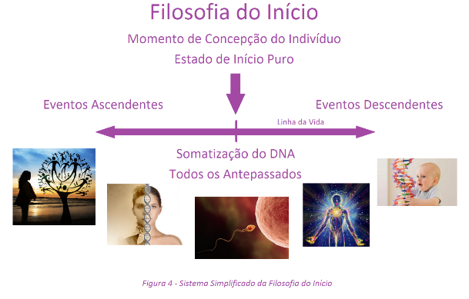

Pure Start State: Basal equivalence of the individual's conception. It is the beginning of our existence. It's our Big Bang, it's our moment of uniqueness.
At this moment all the genetic information of all maternal and paternal ancestors is added. It is the creation of our universe. It is the moment of our physical and energetic formation. It is the moment that the branes line up. This moment of singularity is recorded in the new DNA that is in formation.
It is at this moment that our higher bodies become permanently attached. As you all know, we are individual beings, and this explosion of creation we record our genetic information continuously. Our initial conception reveals to us that death and birth are practically the same things, for even without the physical body, we relive our ancestors now of our creation, even in an energetic way.
We have come from the dust and to the dust we will return. Could it be more modern to say we came from quantum and quantum will we return?
Upward Events: These are the events recorded in the DNA of our generators and that preceded the moment of the State of Pure Start. All the genetic baggage of all beings that preceded our creation as our parents, grandparents, great-grandparents, great-grandchildren and so on.
Descending Events: These are events that are logged after the Pure Start State. Events that we suffer throughout the process of existence. The line where we walk our process of physical, mental, etheric and emotional experience.
We can say that it is the moment when we begin to become ill or to heal. As we carry ancestral information, it is at this point that we begin our DNA maturation process, at which point we begin to have mental and physical control of our body.
With these concepts, we can explain why the onset of diseases and physical problems.
Symptoms of previous pathologies arise through the process of interiorization of their experience. Do not confuse with pathogenesis.
Previous symptoms are the set of symptoms that the individual has experienced in a range of interiorization.
Pathogenesis is the artificial aggravation due to the use of a certain medication. Quantify which diseases will affect an individual. Because a cancer is generated, cease a hereditary disease and many other concepts. Homeopathic, energetic and quantum healing doors open.
Amplifying this healing power by Homeopathy is the cheapest and most efficient way a nation could do for its people.
We can heal from our existence, our children and grandchildren. We are talking about healing our descendants before they are even born.
Where is the passion for life?
What is your greatest joy?
At what point in life do we become bitter?
What stage of life have you been happiest in?
So, disease is the somatization of what we live, see, feel, witness and verbalize.
We are solely responsible for what we become, what we will become, and what we become ill.
We can even say that we are responsible for the personality of our children, grandchildren and great-grandchildren.
Did you understand the importance of being better?
Remember the process of feeding, where the solid turns into energy? It is the same process only from a different stage.
Then adopt a new way of living and nourishing yourself with things that will heal your body and mind. Adopt principles that transform your state of mind. Homeopathy is one of the most complete keys to transforming your mental and physical state into the healing process.
Take control of your life, do not let the setbacks hamper your moments of joy and happiness. Its positive feeding ensures longevity.
Our body has been programmed to have a lifespan of at least 100 years. By the energy lag, our energy field ceases and the individual's lifetime decreases.
What we do know is that our vital energy is unique and unique. It is only for our existence. Our energy is encoded into the body of each being individually. My vital energy is of no use to another person. Just as the vital energy of another person is no good to me.
That's why it's important to find your Simillimum.
The therapist's skill requires that this individual be referred to the energy condition prior to the current pathology and heals his body and his DNA to reprogram himself in a healthy way.
Finding your similarity, you amplify your vital energy and increase your life expectancy.
Get to work!

