Association between Oral Microbiome and Breast Cancer in East Asian Population: A Mendelian Randomization Analysis and Case-control Study
Dr Kexin Feng , Department of Breast Surgical Oncology, National Cancer Center/National Clinical Research Center for Cancer/Cancer Hospital, Chinese Academy of Medical Sciences and Peking Union Medical College, Beijing, 100021, China
Dr Xiang Wang, Department of Breast Surgical Oncology, National Cancer Center/National Clinical Research Center for Cancer/Cancer Hospital, Chinese Academy of Medical Sciences and Peking Union Medical College, Beijing, 100021, China

Abstract (300 word limit)
Background: While observational research has established an intimate correlation between breast cancer and the oral microbiome, the causative relationship remains unclear. The objective of this study was to thoroughly examine the relationship between oral microbiota and breast cancer in the East Asian population, using a two-sample Mendelian randomization (MR) analysis alongside a case-control study.
Methods: Genetic summary data pertinent to oral microbiota and breast cancer were gathered from genome-wide association (GWAS) studies involving participants of East Asian descent. Various analyses were conducted to generate MR estimates. The validity of these findings was reinforced through the use of sequencing data from a case-control study.
Results: The MR analysis revealed 30 tongue and 37 saliva bacterial species that demonstrated significant associations with breast cancer. Interestingly, the causal influence of six genera (Family Pasteurellaceae Genus Aggregatibacter, Family Streptococcaceae Genus Streptococcus, Family Bacteroidaceae Genus Prevotella, Family Pasteurellaceae Genus Haemophilus, Family Genus Lachnospiraceae Oribacterium, and Family Erysipelatoclostridiaceae Genus Solobacterium) on breast cancer was found in both tongue and saliva microbiomes. The results of our case-control study demonstrated clear differences in specific bacteria between breast cancer patients and healthy groups. Moreover, the sequencing data confirmed the results of the MR analysis, showing that the breast cancer group had a higher relative abundance of Family Pasteurellaceae and Family Streptococcaceae, but a lower relative abundance of Family Bacteroidaceae compared to healthy controls.
Conclusions: Our MR analysis suggested the oral microbiome has a causative effect on the risk of breast cancer, as supported by sequencing data from a case-control study. Future studies are required to comprehensively understand the complex mechanisms of interaction between oral microbiota and breast cancer.

Image
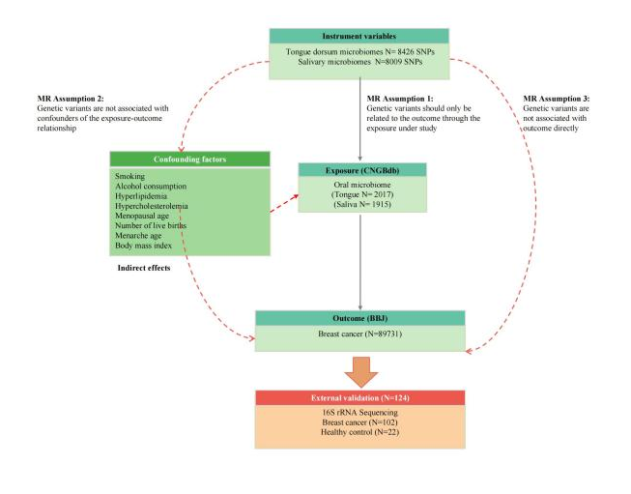
Figure 1. The flowchart of Mendelian randomization analysis and case-control study validation. IVW, inverse variance weighted; MR, Mendelian randomization; MVMR, multivariable Mendelian randomization;SNPs, single nucleotide polymorphisms; IVs, instrumental variables; CNGBdb, China National GeneBank DataBase; BBJ, BioBank Japan Project
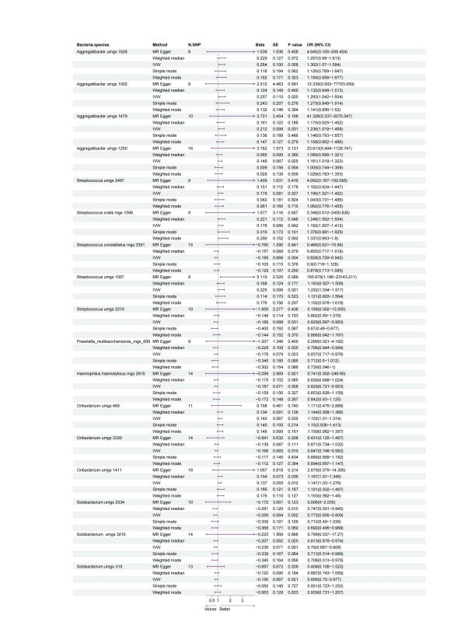
Figure 2. Forest plot of the association between togue mircrobiome species and breast cancer.
IVW, Inverse variance weighted; MR, Mendelian randomization; SNP, Single nucleotide polymorphisms

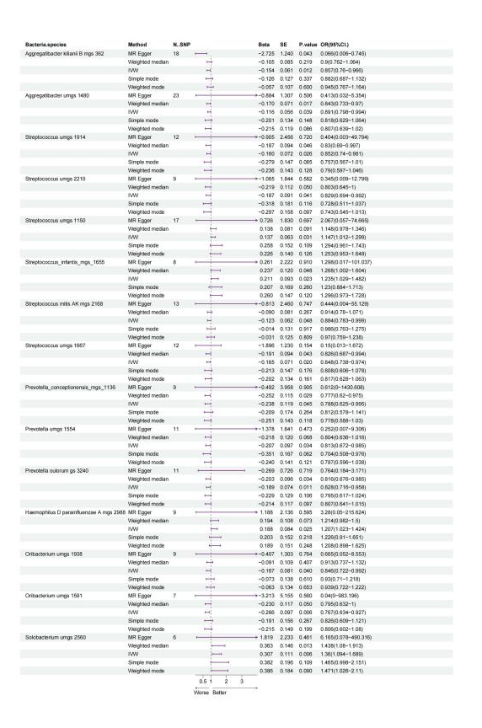
Figure 3. Forest plot of the association between saliva mircrobiome species and breast cancer.
IVW, Inverse variance weighted; MR, Mendelian randomization; SNP, Single nucleotide polymorphisms

Recent Publications (minimum 5)
[1] F.R.F. Teles, F. Alawi, R.M. Castilho, Y. Wang, Association or Causation? Exploring the Oral Microbiome and Cancer Links, J Dent Res, 99 (2020) 1411-1424.
[2] W. Heng, W. Wang, T. Dai, P. Jiang, Y. Lu, R. Li, M. Zhang, R. Xie, Y. Zhou, M. Zhao, N. Duan, Z. Ye, F. Yan, X. Wang, Oral Bacteriome and Mycobiome across Stages of Oral Carcinogenesis, Microbiol Spectr, 10 (2022) e0273722.
[3] X. Fan, A.V. Alekseyenko, J. Wu, B.A. Peters, E.J. Jacobs, S.M. Gapstur, M.P. Purdue, C.C. Abnet, R. Stolzenberg-Solomon, G. Miller, J. Ravel, R.B. Hayes, [4] J. Ahn, Human oral microbiome and prospective risk for pancreatic cancer: a population-based nested case-control study, Gut, 67 (2018) 120-127.
[5] Y. Lim, N. Fukuma, M. Totsika, L. Kenny, M. Morrison, C. Punyadeera, The Performance of an Oral Microbiome Biomarker Panel in Predicting Oral Cavity and Oropharyngeal Cancers, Front Cell Infect Microbiol, 8 (2018) 267.

