Immunohistochemical (IHC) Study of ER and PR Status in Breast Carcinoma in Women of Pakistan

Abstract:
Objective: To figure out determine the association between Estrogen (ER) and Progesterone (PR) expression status along with histological grade of tumor in Invasive Ductal Carcinoma (IDC) of breast in Pakistani patients.
Study Design: Experimental and observational study
Materials & Methods: 106 cases of various histologic types of breast cancer were included during two year’s period (January 2015 to December 2016) and conducted evaluated in at Histopathology Department of Chughtai Lahore Lab (Pvt.) Lahore Pakistan. We evaluated age, histologic tumor type, histologic tumor grade, ER estrogenic and PR progesterone receptors status by immunohistochemistry (IHC) along with information regarding tumor histologic grade of tumor in relation with status of estrogen receptor (ER) and progesterone receptor (PR) receptors status from breast cancer patients suffering from breast cancer.
Results: 80% of cases were evaluated as invasive ductal carcinoma. Remaining 20% cases included as other histologic tumor types. The age ranges from 23 years to 82 years. 21 patients <40 years with mean age of 32 years and 8 and 84 patients were more than >40 years of age with mean age of 55 years were recorded. Majority of the tumors were seen to be having grade II (56.6%) followed by grade III tumors (20.8%). However, no case was seen to be involved with grade I tumor. Positive expression of estrogen receptor (ER) and progesterone receptor (PR) expression are seen in 62%, 49% patients respectively.
Conclusion: In current study, age distribution among 106 patients concluded that women more than 40 years old had the highest higher incidence of breast carcinoma. Most dominant tumour type was invasive ductal carcinoma (IDC). Furthermore Estrogen (ER) and Progesterone (PR) positivity manifested more drift towards tumors of grade II tumours in comparison to tumors of grade I and grade III tumors.
Image
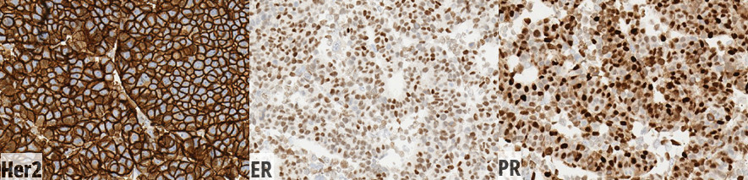
Strong positive Estrogen and Progesterone Receptor staining in tumor cells
References
1. Bansal M, Vega S, Yeaney GA, Wang X (2016) Bilateral chest wall sarcomas associated with silicone implant capsules in a patient with Li-Fraumeni syndrome. Journal of Case Reports and Images in Pathology.2:6-9.
2. Geethamala K, Murthy SV, Vani B, Rao S (2015) Histopathological Grade Versus Hormone Receptor Status In Breast Carcinoma-Treasure The Past. International Journal of Biomedical Research. 6(7):466-71.
3. Chakraborty A, Bose CK, Basak J, Sen AN, Mishra R, Mukhopadhyay A (2016) Determinants of lymph node status in women with breast cancer: A hospital based study from eastern India. The Indian Journal of Medical Research.143(Suppl 1):S45.
1.4. Mouttet D, Laé M, Caly M, Gentien D, Carpentier S, Peyro-Saint-Paul H, et al (2016) Estrogen-receptor, progesterone-receptor and her2 status determination in invasive breast cancer. concordance between immuno-histochemistry and mapquant™ microarray based assay. PloS one. 11(2):e0146474.
2.5. Przybylski J. Anna M. Badowska-Kozakiewicz1, Janusz Patera2, Maria Sobol1 (2015) Contemp Oncol (Pozn).19(3):220-5.

Biography
Muhammad Zohaib Qamar has his expertise and passion in improving the women health in Pakistan. His research is purely based upon breast cancer which is the most common disease occurring in women around the world. He has conducted his studies after years of experience in research, evaluation and efforts in the field of medical science. His research has concluded that invasive ductal carcinoma of grade 2 tumor has been found most commonly in elderly women with expression of ER/PR positivity. His study is very helpful for prognosis, early diagnosis and therapeutic purpose.
Email: zohaibqamar3@gmail.com

