Complex Radiological Findings in Congenital Pseudarthrosis of the Tibia
Prof Galina Diachkova, PhD, Laboratory of Radiology, Russian Ilizarov Scientific Centre, Russian Federation

Statement of the Problem: Congenital pseudoarthrosis of the tibia (CPT) remains one of the most complicated and rare condition, and this pathology still remains the subject of focus for many specialists, because complicated long and multi-stage surgical treatment and poor outcomes in 20-50% of cases. To study changes of bone and soft tissues in patients with congenital pseudoarthrosis by MSCT and MRI.  Methodology & Theoretical Orientation:: The work is based on the study of results of treatment and examination of 25 patients with CPT, among them 11 were females, 14–males. In 93% of patients CPT was located in the lower third of the tibia. In most of the cases, etiology of CPT was associated with neurofibromatosis type 1 (46%), in 23%-fibrous dysplasia and in 31%-was idiopathic. We studied condition of bone and soft tissues at the site of congenital pseudoarthrosis of the tibia before commencing treatment, using radiographic methods- multi slice computed tomography (MSCT), magnetic resonance imaging (MRI) in order to make prognosis of treatment outcome and recurrence of the disease.  Findings: 25 patients with congenital pseudoarthrosis of the tibia (CPT) in the age group 8 to 40 years were examined by above mentioned radiographic methods, multi slice computed tomography (MSCT), magnetic resonance imaging (MRI) before treatment and after recurrence. The peculiarities and changes in structure of tibial and fibular cortex, periosteum and muscles at the site of pseudoarthrosis. We derived at complex findings and changes that cause recurrence, of pseudarthrosis after deformity correction, or treatment. We developed criteria for evaluation of bone quality in patients with CPT.  Conclusion & Significance: Structural changes in the soft tissue and the bone at the site of CPT, detected by MRI and MSCT, allow for rather precise interpretation of condition of bone, periosteum, muscles during various stages of treatment and this information can be used to choose appropriate technique and methods of treatment. |  | 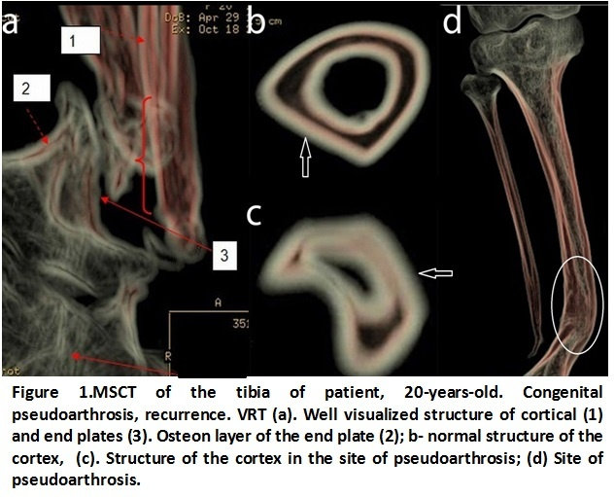  Recent Publications  1.Borzunov DY, Chevardin AY, Mitrofanov AI (2016) Management of congenital pseudarthrosis of the tibia with the Ilizarov method in a paediatric population: Influence of aetiological factors. Int Orthop 40: 331-339.  2.Khan T, Joseph B (2013) Controversies in the management of congenital pseudarthrosis of the tibia and fibula. Bone Joint J 95: 1027-1034.  3. Liu YX, Mei HB, Liu K, Wu JY (2016) Correlative study between X-ray type after healing of congenital pseudarthrosis of the tibia in Children and postoperative refracture. Zhonghua Wai Ke Za Zhi 54: 456-460.  4. Mahnken AH, Staatz G, Hermanns B, Gunther RW, Weber M  (2001) Congenital pseudarthrosis of the tibia in pediatric patients: MR imaging. AJR Am J Roentgenol 177: 1025-1029.  5.Pannier S (2011) Congenital pseudarthrosis of the tibia. Orthop Traumatol Surg Res 97: 750-761.
 | Biography
Professor G. Dyachkova has 45 years of experience in traumatology and orthopedics, radiology. With her participation, 15 new diagnostic methods based on multislice and magnetic resonance tomography were developed, comprehensive studies were carried out to study the quality of bone in patients with diseases of the musculoskeletal system, which made it possible to increase the effectiveness of radiology diagnostics in justifying Ilizarov treatment methods for patients with injuries and bone diseases, improve the quality of life of patients. Professor Dyachkova published more than 350 papers on various aspects of radiology, the organization of health care, and received 18 patents for new methods of treatment and diagnostics.
E-mail -dgv2003@list.ru
Notes/Comments:

