Upanayan Sanskār: A Vedic Ritual of Classical Conditioning of Brain

With specific reference to language, perception, learning, memory, attention, problem solving, reasoning and decision making

Ramaa Golwalkar PhD, Dnyānamudrā Centre For Techno-Creative Education, Nagpur, India

Abstract (300 word limit)
Statement of the Problem: The focus of this paper is to analyse the impact of Upanayan sanskār and Gāyatri Mantra (GM) on the brain body and mind with the initial hypothesis that both the ritual and the chant classically condition the brain provides favourable condition to tune the body and mind for better learning.
Indian culture being the oldest living culture in world known for its multi-disciplinary diverse approach towards teaching and learning its ancient education system. There are 16 different rituals prescribed in Vedas (dates back before circa 1900 B.C.E.) to be performed at 16 different stages of human life to make it worth living. These rituals are popularly known as sanskār namely process in all the regional languages in India. Upanayan sanskār is prescribed to be performed at the age of 8 and the child becomes entitled to chant Gāyatri Mantra (GM) and leaves his parents to stay with his Guru for formal education.
The Gāyatri Mantra (GM) is a hymn dedicated to Sun God (Savitru) composed in the meter ‘Gāyatri’, which is translated by S. Radhakrishnan (1953) as ‘We meditate on the adorable glory of the radiant sun; may he inspire our intelligence.’
This paper investigates the relationship between the Upanayan sanskār and the classical conditioning of the Indian Brains for perpetual intelligence of the Indian Society since last two millennia. The research is of ex-post-facto nature, based on the secondary data.
The findings lead to conclude that the positive effect of the sound waves created by chanting Gāyatri Mantra (GM) on the body, brain and mind which provides conducive conditions to enhance concentration, attention, learning abilities, language skills, and problem solving capabilities, strengthens the memory, logical reasoning and decision making competencies. Gāyatri Mantra (GM) is responsible for classical conditioning of the brain and mind through sound waves.

Image
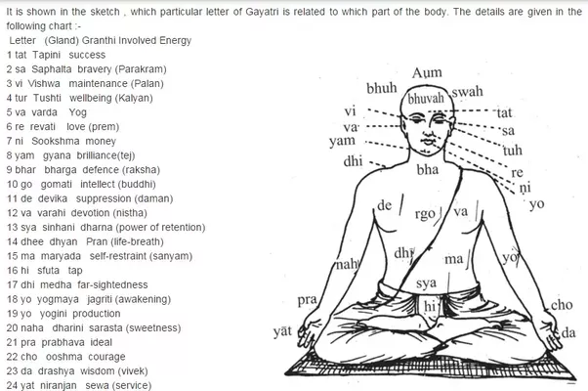

Recent Publications (minimum 5)
- FDI: Four Questions from We the people of India – International Conference on “Issues and Challenges in Retail Sector and Foreign Direct Investment in India and Across the World” organised by Symbiosis Centre for Management Studies (UG), Symbiosis International University, Pune (February 2013).
- Impact of Personal Communication Technology on the late adolescents in Pune with specific reference to the Spatial Management and it’s cultural nuances – National Seminar on ‘Metamorphosis of New Media and Digital Culture, organised by Department of Communication Studies, University of Pune, Pune (March 2013).
- Impact of Mobile phone on Communication Patterns of Late Adolescents in Pune – International Conference on Changing Landscape in Communication with New Media Technologies, Tirupati organised by Sri Padmavati Mahila Visvavidyalayam, Tirupati in collaboration with Scripps College of Communication and Institute of International Journalism, Ohio University, will be held during November 2013 at Tirupati.
- Shree Sooktam: A multidimensional study ( Deciphering Shree Sooktam as a social change communication model of Vedic civilisation) – National Conference organised by Brihan Maharashtra Prachya Vidya Parishad’s, Pune December 2013
- Comparative analysis of news consumption patterns of late adolescent news consumers in Pune with specific reference to Print and Electronic media vis-á-vis New media. – National Conference organised by Department of Communication Studies, Savitribai Phule University of Pune, February 2015
- An Analysis of Digital Era Human Communication with specific reference to Late Adolescents in Pune, Annual Research Journal of SCMS, Pune Vol. 5, March 2017 Symbiosis Centre for Management Studies, Pune Annual Research Journal of Symbiosis Centre for Management Studies, Pune, ISSN 2348–0661 Print.
- Title of the Book – New Media: New Frontiers of Communication (2017) Editor – Keshav Patel, Title of the chapter – New Media and Power-shift: An Overview Page -12 – 34, Publisher Eureka Publications, Pune. ISBN 978-81-935639-3-9

 Biography (150 word limit)
Ramaa Golwalkar is a Communicologist and Indologist pursuing her post-doctoral research from Deccan College Post Graduate and Research Institute Pune on the topic ‘Ritualistic Visual Symbols of Ancient Indian Communication System. She worked as Assistant Professor and trainer for media and communication at Symbiosis International University, Pune and various other prestigious educational institutes for culture and communication. She is a published writer and her books are widely referred by the journalism and mass communication students of Maharashtra State of India. Her weekly column on deciphering ancient Indian Symbols in the daily Tarun Bharat is well-received and appreciated by the common readers and elites
Email: ramagolwalkar@gmail.com
Phone Number: +91 9422114620
Track Name: Rama Golwalkar
Type of Presentation: PPT & Paper

Notes/Comments:

