Global Brain Pathologies in Alzheimers' Dementia: Constructs Targeting Distributed Oscillatory Processes
Denis Larrivee, PhD, Loyola University Chicago, USA

Abstract
Writing in 2006, on the occasion of the 100th anniversary of Alloys Alzheimer's first description of Alzheimer's Dementia (AD), Dr K Jellinger of the Institute of Clinical Neurobiology, Vienna noted 'that despite considerable progress in the clinical diagnosis, neuroimaging, genetics, molecular biology, neuropathology, defining risk factors, and treatment, the etiology of the disease is still unknown and, therefore, a causal treatment of AD will not be available in the near future.' The absence of causal therapies, despite the wide variety of investigative approaches undertaken to characterize its etiological roots seems, rather, to indicate that the models and experimental studies are identifying features that lie outside its critical etiological domain. Hence, new conceptions on what is progressively unraveled by AD are needed. Inferences are likely to come from studies on the brain's global regulation, since a key symptom of the disease is a pathological progression in the loss of the perceptual realization of self initiated action. Existing studies reveal, for example, that a fundamental brain network needed for the perception of the self, the default mode network (DMN), which is critical to monitoring the external environment, bodily states, and even emotions, is impaired in AD. Furthermore, functional MRI shows that activity in the posterior cingulate and right inferior temporal cortex and that in the bilateral inferior parietal cortex, are differentially affected, reflecting a weakening of causally influential relations amongst the DMN principal nuclei. Since an increasing number of studies show that self circuitries underlie global phenomena that mediate individual performance, this paper will explore two principal theses concerned with the relationship of these circuitries to global regulation. The first is the localized, cardinal neuron hypothesis of neural processing, initially advanced by Wiesel and Hubel for hierarchical, visual processing in the occipital lobes; the
second is the distributed, oscillatory, electropotential thesis of Wolf Singer. The theses are distinguished both structurally and operationally, with key distinctions resting in a focal vs distributed neural architecture and a sequential vs a dynamical form of infomation processing. Evidence will be presented favoring a distributed operational architecture that mediates global regulation and implications discussed for the causal etiology and therapy for AD.

Recent Publications
- Deco G, Jirsa V, Friston K (2013). The dynamical and structural basis of brain activity. In: Rabinovich MI, Friston KJ, Varona P (eds) Principles of Brain Dynamics. Boston: MIT Press.
- Buzsaki G, Draguhn A (2004). Neuronal oscillations in cortical networks. Science 304: 1926-1929.
- Hellyer P, et al (2014). The control of global brain dynamics: opposing actions of frontoparietal control and default mode networks on attention. J. Neurosci 134: 451-461.
- Rolls ET, Deco G. (2015). Networks for memory, perception, and decision making to how the syntax for language might be implemented in the brain. Brain Research 1621:316-334.
5. Palomera A et al (2017). Disrupted global metastability and static and dynamic brain connectivity across individuals in the Alzheimer's disease continuum. Scientific Reports. DOI: 10.1038/srep40268.
6. He Y et al (2007). Regional coherence changes in the early states of Alzheimer's disease: a combined structural and resting state functional MRI study. NeuroImage, 35:488-500.
7. Jellinger KA (2006). Alzheimer 100 - highlights in the history of Alzheimer research. J Neural Transmission 113(11):1603-1623.

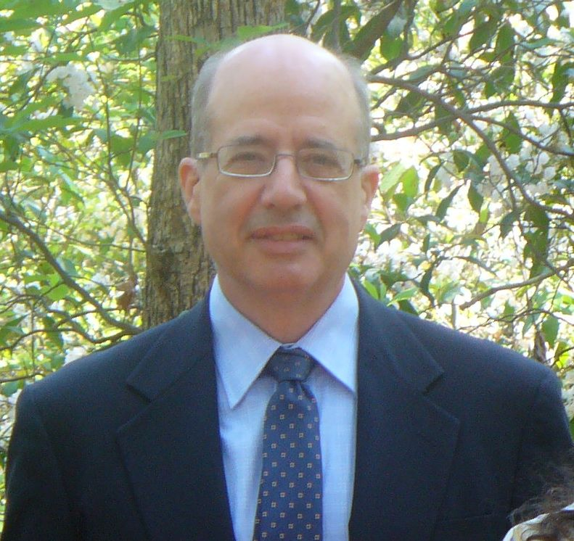Biography (150 word limit)
Dr. Denis Larrivee is a Visiting Scholar at Loyola University Chicago and has held professorships at the Weill Cornell University Medical College in New York City and Purdue University, West Lafayette, Indiana. A former fellow at Yale University's Medical School and Department of Biology he received the Association for Research in Vision and Opthalmology's first place award for studies on photoreceptor degenerative and developmental mechanisms. He is the current editor of a text entitled Brain Computer Interfacing and Brain Dynamics with InTech Publishing and an editorial board member of the journals Annals of Neurology and Neurological Sciences (USA) and EC Neurology (UK). An International Neuroethics Society Expert he is the author of more than 50 papers and book chapters in such varied journals/venues as Neurology and Neurological Sciences (USA), EC Neurology (UK), Journal of Neuroscience, Journal of Religion and Mental Health, and IEEE Explore.

Email: sallar1@aol.com
Track Name: Brain Disorders and Therapy/Track 1
Type of Presentation: Oral/Plenary Speaker

Notes/Comments:

