
OncoVision
Development of an IT platform for the broad availability
of molecular precision oncology

Prof.(SHB) MD Dirk Hempel, Steinbeishochschule Berlin, Neudegger Alle 10, 86609 Donauwörth, Germany
Dr.Josef Sceiber, BioVariance GmbH Konnersreuther Straße 6g 95652 Waldsassen, Germany
Dr. Sebastian Robert, Fraunhofer-Institut IOSB, Fraunhoferstraße 1, 76131 Karlsruhe, Germany

The OnkoVision project is the development of an AI-based molecular biological decision-making platform for various cancer diseases i.e. gastrointestinal tumors. The gastrointestinal tumors include colorectal carcinomas, liver carcinomas, carcinomas of the liver with hepatocellular carcinomas as well as bile duct carcinomas and carcinomas of the pancreas. The project's clinical partners have excellent expertise in the diagnosis and therapy of these diseases and are all members of certified colon, liver and pancreas cancer centers.
One part of the project consists of taking GI tumors as an example for the molecular genetic real world data of the patients treated in our network with regard to the somatic genetic alterations found, such as gene mutations, gene fusions, copy number variations (CNV), miRNA, lncRNA, DNA methylation, tumor mutational burdens and MSI as well regarding protein expression of tumors (Evaluate PDL1, ERBB2) and compare it with the sectional imaging and the clinical courses under the given therapy.
The planned platform is to automatically evaluate the existing data sets using AI, for example to identify and validate new prognostic and predictive biomarkers.
The relevant publications are also to be matched in the context of an AI-based database for the genetic generations found.
In addition, OnkoVision will be used in the group as a part of virtual molecular tumor boards. The existing network of the research project can be used for this. It will be examined to what extent the platform enables the broad availability of molecular tumor boards.
Due to the composition of the project group from university and non-university partners who have worked together in the past, existing logistical and organizational structures can be used. It can be assumed that this provides the best conditions for the group to achieve reliable results.

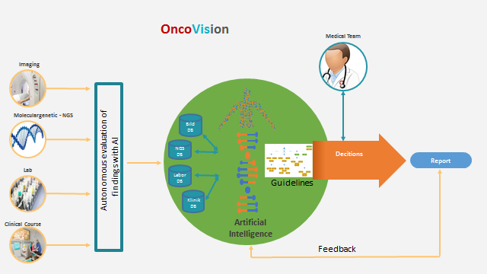

- D. Hempel, Y. Fischer, Oncoguide System - A Computerized Self-Learning Interactive Assistance System for the Diagnosis and Treatment of CML/MPN and MDS Ann Oncol (2016) 27 (suppl-6):43
- Patrick Philipp · Yvonne Fischer · Dirk Hempel · Jürgen Beyerer Framework for an Interactive Assistance in Diagnostic Processes Based on Probabilistic Modeling of Clinical Practice Guidelines DOI:10.1016/B978-0-12-804203-8.00026-2 ·
In book: Emerging Trends in Applications and Infrastructures for Computational Biology, Bioinformatics, and Systems Biology, Chapter: 26, pp.371-390
- Seeliger H, Camaj P, Ischenko I, Kleespies A, De Toni EN, Thieme SE, Blum H,Assmann G, Jauch KW, Bruns CJ.,EFEMP1 expression promotes in vivo tumor growth in human pancreatic adenocarcinoma., Mol Cancer Res 2009; 7: 189-98.
- Philipp P., Robert S, Hempel D., Beyerer J., Interactive Decision Support: A Framework to Improve Diagnostic Processes of Cancerous Diseases Using Bayesian Networks 10.1109/COGSIMA.2018.8423989 June 2018/Conference: 2018 IEEE Conference on Cognitive and Computational Aspects of Situation Management (CogSIMA)
- J Scheiber, How can we enable drug discovery informatics for personalized healthcare? Expert opinion on drug discovery 6 (3), 219-224

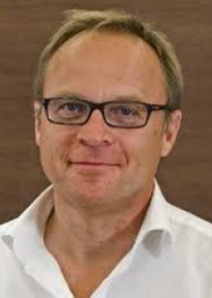

Curriculum vitae

1982–1989 Study human medicine in Rostock and LMU Munich

10/1987–11/1990 Thesis at the Institute of Immunology, LMU Munich.
Title: “Detection of epithelial tumor cells in the bone marrow in patients with gastric carcinoma. A
new prognostic marker"

06/1992 License to practice medicine in Munich

07/1992–12/1999 Fellow ship training as an internist and further training as internal oncologist / hematologist at the Central Clinic Augsburg, II. Medical Clinic

01/2000 Examination for hematologist / internal oncologist in Munich

since 01/2000 Management of the oncological centers in Donauwoerth and Dachau since 01/2000

03/2013 Head of the Steinbeis Transfer Institute for Clinical Hemato-oncology at the Steinbeis University Berlin

11/2013 Appointed junior professor at the Steinbeis University Berlin

10/2016 Chief Physician and Head of the Hematology Department Helios Amper Clinic Dachau

Notes/Comments:

