IN SILICO APPROACH TO BETTER UNDERSTAND THE ROLE OF ACTIVE SITE RESIDUE
Shivakumar Venkataraju
shivakumar.venkataraju@quantumzyme.com
Suvamay Jana
Naveen Kulkarni
Quantumzyme LLP, No. 110/8, Krishnappa Layout, Lalbagh Road, Bangalore - 560027, India

Chiral amines are the major building blocks of many life-saving drugs and it has been estimated that nearly 40-45% of the currently used pharmaceuticals contain chiral amine functional groups in their structure. However, the major challenges associated with the chemical synthesis of enantiopure amines are the use of toxic chemicals, formation of many by-products, and multi-step synthesis process. To address these limitations, cost-effective biocatalytic methods are emerging as potential alternatives for the synthesis of chiral amines in enantiomerically pure forms.
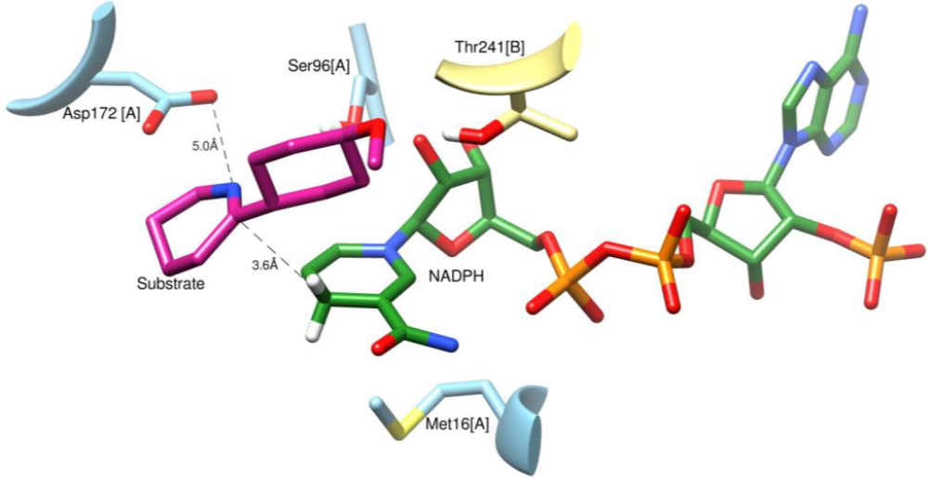
Imine reductases (IRED) are the class of enzymes that can synthesize chiral amines by reducing the cyclic prochiral imines in presence of NADPH cofactor. Especially for R-selective IREDs, NADPH acts as a hydride source and an active site aspartate residue acts as a proton donor during catalysis. The role of NADPH in imine reduction is well studied. However, the role of aspartate as a proton donor remains elusive. For example, in R-IRED from S. kanamyceticus (Q1EQE0), the mutation of Asp-187 in the active site completely abolished the activity. Though in a similar R-IRED from Streptomyces sp. (GF3587), the mutation of the homologous aspartate (Asp-172) reduced the enzyme activity. This essentially points out that there might be other amino acids involved directly or indirectly in proton transfer. In the current study, we employed classical molecular dynamics (MD) simulations to examine the role of several active site residues including the highly conserved aspartate in substrate binding and catalysis of R-IRED from Streptomyces sp. Based on our in silico approach, we have identified an additional histidine residue in the active site that maybe critical in catalysis along with Asp-172.

Figure 1 – Active site structure of Imine reductases

Key Words: Imine reductases, Protein engineering, Biocatalysis, Molecular dynamics

Professional Biography

Shivakumar has completed his MSc at the age of 24 years from JSS University Mysuru India and currently perusing Ph. D in Bioinformatics. Identification and engineering of industrial applicable enzymes for different objectives. Hands on experience in homology modelling, Molecular docking, Molecular dynamics simulations including various tools with technical skills with two to three years of experience. Understanding reaction mechanism of enzyme-substrate complex using different visualization tools and other methods which will helps to increase the activity and stability of enzyme using Qzyme workbench developed by Quantumzyme.


Email Id: shivakumar.venkataraju@quantumzyme.com

