Abstract Template
Abstract Title: Biotechnological strategies for the degradation
of poly(cis-1,4-isoprene) rubber
Rodrigo Andler¹

¹ First Author Affiliation (Universidad Católica del Maule, Chile)

Abstract (not more than 300 words)

Over the last years, the increasing global rubber production has become a serious environmental problem. According to the International Rubber Study Group, the total rubber production in the year 2017 reached 28,600,000 metric tons. In this scenario, recycling of rubber materials is necessary and biodegradation of rubber could be an environmentally friendly alternative. Several bacterial species have been described to cleave the backbone of poly(cis-1,4-isoprene), the main constituent of rubber. Recently, the actinomycete Gordonia polyisoprenivorans strain VH2 was cultivated with poly(cis-1,4-isoprene) rubber particles as sole carbon and energy source in fermenter scale. Using genetic tools, the rubber degrading strains can be modified to form products of interest. In this matter, rubber waste could be suitable as C-source for the synthesis of high valuable products. However, slow growth of bacteria makes the process not suitable in large scale in terms of productivity and further investigations are needed. As an alternative, rubber cleaving enzymes can be incubated in the presence of poly(cis-1,4-isoprene) rubber to achieve faster degradation rates. The following enzymes: RoxA, RoxB and Latex clearing protein (Lcp) have been described as catalyzers of the polymer. Lcp has been produced and partially purified using simple and cost-effective purification processes. Recently, Lcp was tested for biotechnological degradation approaches in the presence of solid particles of poly(cis-1,4-isoprene). Different strategies, including in vivo and in vitro processes, can be implemented to achieve partial or total degradation of the polymer. As a result, conformational changes on the surface of the polymer are detected and oligo(cis-1,4-isoprene) molecules of different molecular weights are formed.
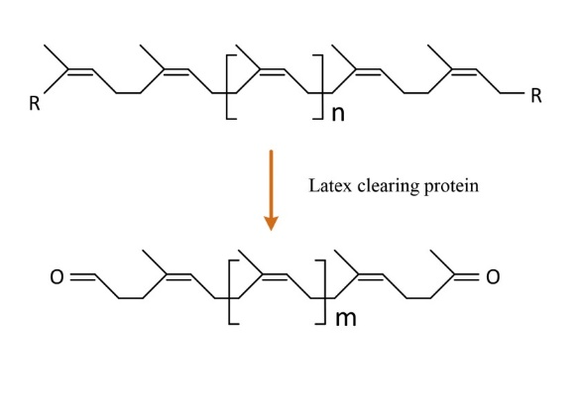
Fig 1. Cleavage mechanism of the backbone of poly(cis-1,4-isoprene) using Lcp

Keywords— Biodegradable polymer, In vitro degradation, Latex clearing protein, Rubber biodegradation

Professional Biography (100-150 words)

Dr. Rodrigo Andler has completed his PhD at the age of 31 years from University of Münster, Germany. Currently, he is a Professor at the Biotechnology Engineering School from the Catholic University of Maule, Chile. He has published several papers in different reputed journals in the field of rubber biodegradation.


Paste your Photograph here

Email Id: randler@ucm.cl

Any Comments:

