Biotechnology Congress 2019: 24th Edition of International Congress on Biotechnology, August 8-9, 2019, Paris, France

Title: Biotechnology is necessary for the development of health, basic need of daily life, reduction in poverty and hunger in the world.

Abstract:
References
- Biotechnology Archived 2012-11-07 at the Wayback Machine.. Portal.acs.org. Retrieved on 2013-03-20.

- What is biotechnology?. Europabio. Retrieved on 2013-03-20.

- "A decade of EU-funded GMO research (2001–2010)" (PDF). Directorate-General for Research and Innovation. Biotechnologies, Agriculture, Food. European Commission, European Union. 2010. doi:10.2777/97784. ISBN 978-92-79-16344-9. Retrieved February 8, 2016.

- Cole-Turner, Ronald (2003). "Biotechnology". Encyclopedia of Science and Religion. Retrieved 7 December 2014.

- Jump up to:ª ^{b} Thieman, W.J.; Palladino, M.A. (2008). Introduction to Biotechnology. Pearson/Benjamin Cummings. ISBN 0-321-49145-9.
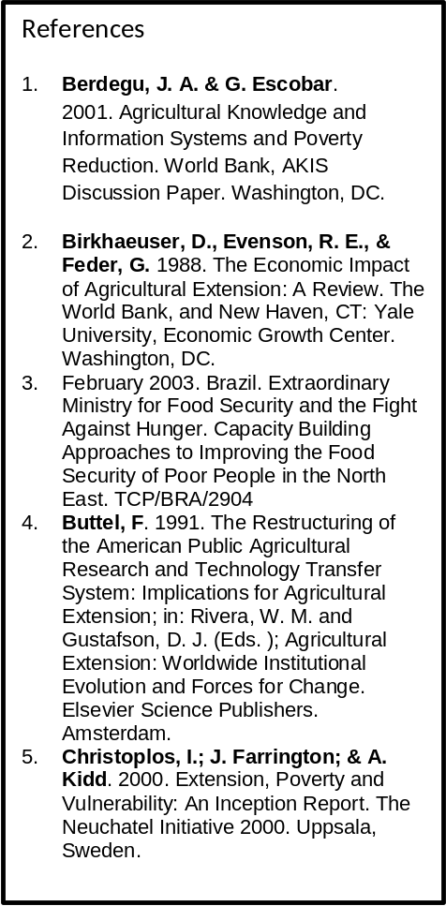

The aim of presentation consist of biotechnology, health, daily life, poverty and hunger were studied and reported that biotechnology is necessary for the development of health, basic need of daily life, reduction in poverty and hunger in the world. Biotechnology is the use of organisms in manufacturing processes to create products or to solve industrial or environmental problems. In other words, biotechnology is the use of the data and techniques of engineering and technology for the study and solution of problems concerning living organisms. Bioindustry firms can be organized into the eight different categories, industries including, Therapeutics: products such as pharmaceuticals and medical devices that cure or reduce the incidence of disease. Diagnostics: products that test for the presence of various health or disease states. Agricultural: products related to crop and livestock production. Bioremediation: products using biotechnology-designed bioremediation organisms to clean up oil or other spills. Energy: products that use bacteria and other biological processes to create new sources of energy. Materials: products that incorporate the use of new materials, including chemicals that are created by the blending of biological, nanotechnology and other emerging technological processes. Bioindustry suppliers: specialized materials, equipment or services provided to other bioindustry firms. Such products include reagents, specialized software, and technical instruments for gene splicing. Bioinformatics: bioinformatics is an information science using products and services associated with advanced computer based tools including analytical software, data bases, gene models, protein pathway simulations, data mining, and e-commerce. The study further reported that the different industries of biotechnology are necessary for the development of health, basic need of daily life, absorbing millions of technical and nontechnical peoples, generate income, create employment, reduce poverty and hunger in the world.


Muhammad Usman, Moderator of Biochemistry 2017 Felicitate Prof. Jaleel K Ahmed with Keynote Certificate on Sept, 29 at Dubai

Biography: Mr. Muhammad Usman, Former Director General of Agricultural Research System, Government of Pakistan who retired from service after a spotless career of about 35 years with senior level experience on research and development of integrated agricultural production, industries, biotechnology and bioenergy on a sustainable way.

Presenting paper in FCF, Geneva,
Switzerland on 31st Oct, 2012
Mr. Usman is basically an agricultural scientist with specialization of agricultural, food and biochemistry working on the yield and quality of various products and published several research papers.

Mr. Usman is consider as the senior most scientist in the world, always participated in the international conferences as a keynote speech, renowned speaker, organizing committee member as well as moderator of the conferences around the world.

Mr. Usman established “Prominent Agro Based Industries, Agro Based Industries and Consultancy SDN BHD” in Malaysia and “Foundation for Rural Development in Pakistan”, with primarily aims to work on integrated agricultural project for Rural Development through improvement in agriculture and consultancy services to the formers at Malaysia.

