Biotechnology Congress 2019: 24th Edition of International Conference on Biotechnology April 15-16, 2019, Paris France

Theme: Highlighting latest advancements and application of Biotechnology for future challenges
Title: Biotechnology plays an important role in the Development of Health, basic need of daily life, reduction in poverty and hunger in the world.
References
- Biotechnology Archived 2012-11-07 at the Wayback Machine.. Portal.acs.org. Retrieved on 2013-03-20.

- What is biotechnology?. Europabio. Retrieved on 2013-03-20.

- "A decade of EU-funded GMO research (2001–2010)" (PDF). Directorate-General for Research and Innovation. Biotechnologies, Agriculture, Food. European Commission, European Union. 2010. doi:10.2777/97784. ISBN 978-92-79-16344-9. Retrieved February 8, 2016.

- Cole-Turner, Ronald (2003). "Biotechnology". Encyclopedia of Science and Religion. Retrieved 7 December 2014.

- Jump up to:ª ^{b} Thieman, W.J.; Palladino, M.A. (2008). Introduction to Biotechnology. Pearson/Benjamin Cummings. ISBN 0-321-49145-9.
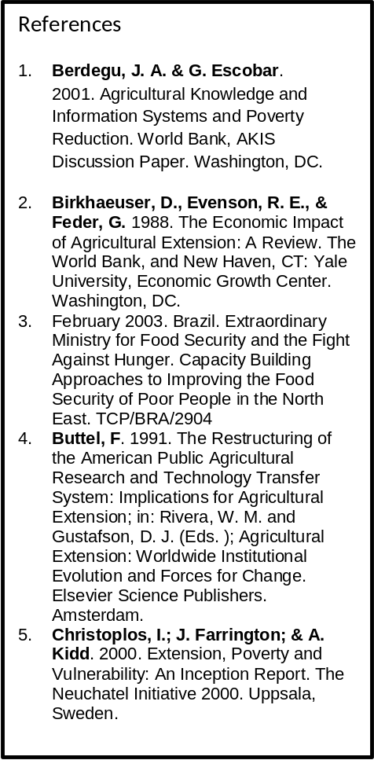

Abstract:
The aim of presentation consist of biotechnology, health, daily life, poverty and hunger were studied and reported that bio technology is the major tool for the development of health, basic need of daily life, reduction in poverty and hunger in the world. Biotechnology is the use of organisms in manufacturing processes to create products or to solve industrial or environmental problems. In other words, biotechnology is the use of the data and techniques of engineering and technology for the study and solution of problems concerning living organisms. The study reported that the science of biotechnology is an industry and can be broken down into sub disciplines called red, white, green, and blue. Red biotechnology involves medical processes such as getting organisms to produce new drugs. White biotechnology involves industrial processes such as the production of new chemicals or the development of new fuels for vehicles. Green biotechnology applies to agriculture and involves such processes as the development of pest-resistant grains or the accelerated evolution of disease-resistant animals. Blue biotechnology, rarely mentioned, encompasses processes in marine and aquatic environments, such as controlling the proliferation of noxious water-borne organisms. Currently, there are more than 250 biotechnology health care products and vaccines, more than 13.3 million farmers around the world use agricultural biotechnology to increase yields, prevent damage from insects and pests, more than 50 bio refineries produce biofuels and chemicals from renewable biomass, which can help reduce greenhouse gas emissions. The study further reported that the different industries of biotechnology absorbing millions of technical and nontechnical peoples, generate income, create employment, reduce poverty and hunger in the world.



Biography: Mr. Muhammad Usman, Former Director General of Agricultural Research System, Government of Pakistan who retired from service after a spotless career of about 35 years with senior level experience on research and development of integrated agricultural production, industries, biotechnology and bioenergy on a sustainable way.

Muhammad Usman, Moderator of Biochemistry 2017 Felicitate Prof. Jaleel K Ahmed with Keynote Certificate on Sept, 29 at Dubai

Presenting paper in FCF, Geneva,
Switzerland on 31st Oct, 2012

Mr. Usman is basically an agricultural scientist with specialization of agricultural, food and biochemistry working on the yield and quality of various products and published several research papers.

Mr. Usman is consider as the senior most scientist in the world, always participated in the international conferences as a keynote speech, renowned speaker, organizing committee member as well as moderator of the conferences around the world.

Mr. Usman established “Prominent Agro Based Industries, Agro Based Industries and Consultancy SDN BHD” in Malaysia and “Foundation for Rural Development in Pakistan”, with primarily aims to work on integrated agricultural project for Rural Development through improvement in agriculture and consultancy services to the formers at Malaysia.

