Theme: Highlighting Latest Advancements and Applications of Biotechnology for Future Challenges
Title: Biotechnology plays an important role in the development of health, basic need of daily life, reduction in poverty and hunger in the world.

Abstract:
References
- Biotechnology Archived 2012-11-07 at the Wayback Machine.. Portal.acs.org. Retrieved on 2013-03-20.

- What is biotechnology?. Europabio. Retrieved on 2013-03-20.

- "A decade of EU-funded GMO research (2001–2010)" (PDF). Directorate-General for Research and Innovation. Biotechnologies, Agriculture, Food. European Commission, European Union. 2010. doi:10.2777/97784. ISBN 978-92-79-16344-9. Retrieved February 8, 2016.

- Cole-Turner, Ronald (2003). "Biotechnology". Encyclopedia of Science and Religion. Retrieved 7 December 2014.

- Jump up to:ª ^{b} Thieman, W.J.; Palladino, M.A. (2008). Introduction to Biotechnology. Pearson/Benjamin Cummings. ISBN 0-321-49145-9.
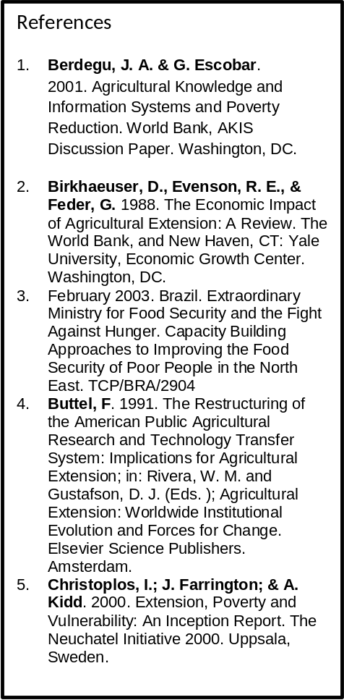

The aim of presentation consist of biotechnology, major types, health, daily life, poverty and hunger were studied and reported that the major types of bio technology plays an important role in the development of health, basic need of daily life, reduction in poverty and hunger in the world. Biotechnology is the use of organisms in manufacturing processes to create products or to solve industrial or environmental problems. The different classis including. Modern Biotechnology: is the recent research based technology. It performs a range of activities in the areas of molecular and cellular biology, recombinant DNA technology, biochemistry, immunology, etc. Gene Technology: is the subset of biotechnology. It involves scientific manipulation of living organisms at genetic level to produce new vaccines, hormones, and monoclonal hormones. BioAgri is the biotechnology applied to the various field of agriculture.
BioIndustrial Sector, also known as White Biotechnology, uses cells or components of cells like enzyme, organic amino acids and yeast to produce industrially useful products.
BioInformatics can be defined as the use of techniques like informatics, computer science, applied mathematics and biochemistry for solving biological problems at molecular, cell and DNA level.
Biopharmaceuticals are organic proteins made by biological processes and have diagnostic/medical uses.
BioServices sector comprises of clinical research, contract manufacturing and contract researches. It involves contact research, contrast manufacturing and clinical research. The study further reported and concluded that the different industries of biotechnology plays an important role in the development of health, basic need of daily life, absorbing millions of technical and nontechnical peoples, generate income, create employment, reduce poverty and hunger in the world.


Muhammad Usman, Moderator of Biochemistry 2017 Felicitate Prof. Jaleel K Ahmed with Keynote Certificate on Sept, 29 at Dubai


Biography: Mr. Muhammad Usman, Former Director General of Agricultural Research System, Government of Pakistan who retired from service after a spotless career of about 35 years with senior level experience on research and development of integrated agricultural production, industries, biotechnology and bioenergy on a sustainable way.

Presenting paper in FCF, Geneva,
Switzerland on 31st Oct, 2012

Mr. Usman is basically an agricultural scientist with specialization of agricultural, food and biochemistry working on the yield and quality of various products and published several research papers.

Mr. Usman is consider as the senior most scientist in the world, always participated in the international conferences as a keynote speech, renowned speaker, organizing committee member as well as moderator of the conferences around the world.

Mr. Usman established “Prominent Agro Based Industries, Agro Based Industries and Consultancy SDN BHD” in Malaysia and “Foundation for Rural Development in Pakistan”, with primarily aims to work on integrated agricultural project for Rural Development through improvement in agriculture and consultancy services to the formers at Malaysia.

