Evaluation of inoculation strategies with Megasphaera elsdenii and Clostridium beijerinckii using lactic acid-rich effluent in a sequencing batch reactor.
M.Sc. Edith Villanueva-Galindo, UNAM, México.
Dr Marisol Pérez-Rangel, UNAM, México.
Dr Iván Moreno-Andrade, UNAM, México.

Abstract
H₂ might be considered to replace fossil fuels since water is the only product when H₂ is combusted. H₂ can be obtained through dark fermentation from renewable feedstocks such as food waste (FW). However, H₂ production is likely to be inhibited due to the native microbial community of FW such as lactic acid bacteria (LAB). Therefore, this study evaluated H₂ production using lactic acid (LA) as a precursor. Anaerobic sequencing batch reactors were operated in duplicate using serum bottles (80 mL working volume) at 37 °C, 150 rpm, hydraulic retention time of 69 hours, initial pH of 6.0 and an exchange volume of 70%. LA rich effluent from fermented FW was evaluated as a substrate at an initial average concentration of 15.3 ± 1.2 g/L. Two inoculation strategies were evaluated: at the start-up of the reactors (IT-1), and at the start-up and every third cycle (IT-3). The inoculation consisted of a strain mixture of M. elsdenii and C. beijerinckii in a proportion of 68% and 32%, respectively, of the total volume of inoculation (10% of the working volume). Besides the strains, thermal pretreated sludge was provided as inoculum at 5 g volatile solids/L during the start-up of IT-1 and IT-3. A control was performed, in which only the effluent was added to the reactor. The highest H₂ production was obtained with the control, showing a maximum value of 1039.7 mL H₂/L_{reactor}. Conversely, for condition IT-1 and IT-3, H₂ was produced during the initial cycles, followed by its decay and subsequent CH₄ production in the following cycles, achieving 766.2 ± 40.4 mL CH₄/L_{reactor} and 941.2 ± 72.7, respectively (Figure 1). The presence of acetate might indicate its simultaneous production and consumption by other microorganism. Consequently, other metabolic pathways took place, leading to CH₄ production through the consumption of H₂ or acetate.

Image
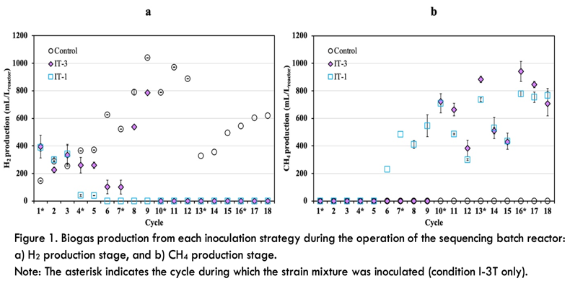
Recent Publications
- García-Depraect O, Martínez-Mendoza L, Muñoz R (2022) Two stage anaerobic digestion of food waste: Enhanced bioenergy production rate by steering lactate-type fermentation during hydrolysis-acidogenesis. Bioresource Technology 358:127358.
- Luo L, Lim R, Pradhan N (2024) Lactic acid-based fermentative hydrogen production from kitchen waste: Mechanisms and taxonomic insights. Chemical Engineering 488:150854.
- Martínez-Fraile C, Muñoz R, Simorte M, Sanz I, García-Depraect O (2024) Biohydrogen production by lactate-driven dark fermentation of real organic wastes derived from solid waste treatment plants. Bioresource Technology 403:130846.
- Ngamnurak P, Reungsang, A, Plangklang P (2025) Improved biohydrogen production from lactic acid bacteria contaminating substrates by enriched hydrogen-producing consortium with lactate-fermentation pathway. Carbon Resources Conversion 8(1):100295.
5. Villanueva-Galindo E, Pérez-Rangel M, Moreno-Andrade I (2024) Evaluation of individual and combined effect of lactic acid-consuming bacteria on mesophilic hydrogen production from lactic acid effluent from food waste treatment. Bioresource Technology 408:131224.



Biography
M.Sc Edith Villanueva Galindo is currently in the final year of her ph.D. in Environmental Engineering at the Institute of Engineering of the National Autonomous University of Mexico (UNAM). Villanueva holds a degree in Renewable Energy Engineering and obtained a master´s degree in Environmental Engineering from UNAM. Her doctoral research focuses on the valorization of organic waste for hydrogen production through biological process, such as dark fermentation, the use of lactic acid as a precursor for hydrogen production, and the analysis of the microbial interactions during lactate-driven dark fermentation. Her expertise includes topics such as dark fermentation from organic solid waste, sequencing batch operation, bioaugmentation with pure strains, lactic acid production and microbial interactions analysis, which have resulted in publications in Bioresource technology (https://doi.org/10.1016/j.biortech.2024.131224), the International Journal of Hydrogen Energy (https://doi.org/10.1016/j.ijhydene.2020.11.092, https://doi.org/10.1016/j.ijhydene.2023.12.202, https://doi.org/10.1016/j.ijhydene.2022.11.339) and Biomass Conversion and Biorefinery (https://doi.org/10.1007/s13399-024-05563-9).
Email:
bvillanuevag@iingen.unam.mx

