Peptidome profiling of Bubalus bubalis urine and its assessment of its antimicrobial activity against mastitis-causing pathogens
Anju Nagpal, PhD, National Dairy Research Institute, Karnal

Abstract (300 word limit)
Urinary proteins have been studied quite exhaustively in the past, however, the small sized peptides have remained neglected for a long time in dairy cattle. These peptides are the products of systemic protein turnover, which are excreted out of the body and hence can serve as an important biomarker for various pathophysiologies. These peptides in other species of bovine have been reported to possess several bioactive properties. To investigate the urinary peptides in buffalo and simultaneously their bioactivities, we generated a peptidome profile from the urine of Murrah Buffaloes (n = 10). Urine samples were processed using <10 kDa MWCO filter and filtrate obtained was used for peptide extraction using Solid Phase Extraction (SPE). The nLC-MS/MS of the aqueous phase from ten animals resulted in the identification of 8165 peptides originating from 6041 parent proteins. We further analyzed these peptide sequences to identify bioactive peptides and classify them into anti-cancerous, anti-hypertensive, anti-microbial, and anti-inflammatory groups with a special emphasis on antimicrobial properties. With this in mind, we simultaneously conducted experiments to evaluate the antimicrobial properties of urinary aqueous extract on three pathogenic bacterial strains: S. aureus, E. coli, and S. agalactiae. The urinary peptides observed in the study are the result of the activity of possibly 76 proteases. The Gene ontology of these proteases showed the significant enrichment of the antibacterial peptide production. The total urinary peptide showed antimicrobial activity against the aforementioned pathogenic bacterial strains with no significant inhibitory effects against a buffalo mammary epithelial cell line. Just like our previous study in cows, the present study suggests the prime role of the antimicrobial peptides in the maintenance of the sterility of the urinary tract in buffalo by virtue of their amino acid composition.help this recognition.

Image
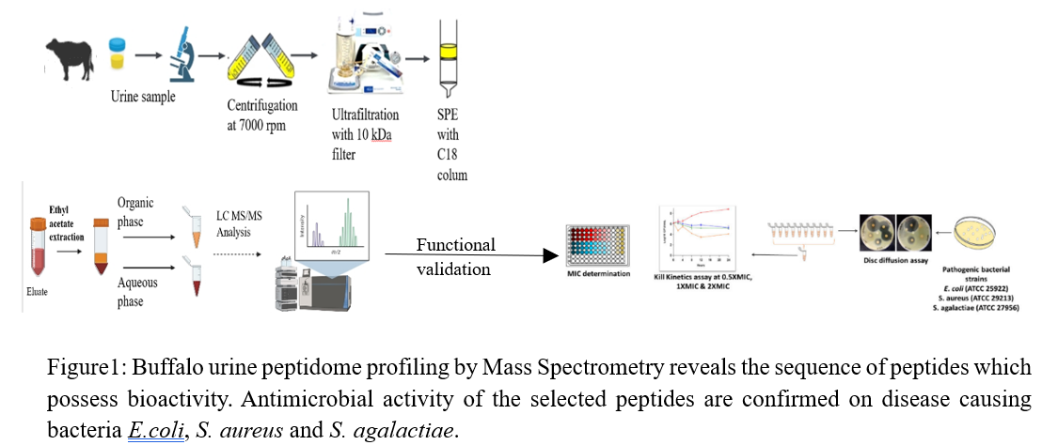
Recent Publications (minimum 5)
- He, T., Pejchinovski, M., Mullen, W., Beige, J., Mischak, H., & Jankowski, V. (2021). Peptides in plasma, urine, and dialysate: toward unravelling renal peptide handling. PROTEOMICS–Clinical Applications, 15(1), 2000029.
- Martens, D. S., Thijs, L., Latosinska, A., Trenson, S., Siwy, J., Zhang, Z. Y., ... & Maestre, G. E. (2021). Urinary peptidomic profiles to address age-related disabilities: a prospective population study. The Lancet Healthy Longevity, 2(11), e690-e703.
- Frantzi, M., Van Kessel, K. E., Zwarthoff, E. C., Marquez, M., Rava, M., Malats, N., ... & Anagnou, N. P. (2016). Development and validation of urine-based peptide biomarker panels for detecting bladder cancer in a multi-center study. Clinical Cancer Research, 22(16), 4077-4086.
- Bathla, S., Rawat, P., Baithalu, R., Yadav, M. L., Naru, J., Tiwari, A., ... & Mohanty, A. K. (2015). Profiling of urinary proteins in Karan Fries cows reveals more than 1550 proteins. Journal of proteomics, 127, 193-201.
5. Good, D. M., Zürbig, P., Argiles, A., Bauer, H. W., Behrens, G., Coon, J. J., ... & Schmitt-Kopplin, P. (2010). Naturally occurring human urinary peptides for use in diagnosis of chronic kidney disease. Molecular & cellular proteomics, 9(11), 2424-2437.

Photograph

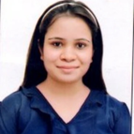Biography (150 word limit)
Anju Nagpal possess expertise in mutating peptide sequences such that their specific bioactivity increases. She has been working on antimicrobial peptides since five years and has designed peptides which show significant antimicrobial activities against disease causing microbes. She is constantly working to improve the potency of peptides and check its synergetic effect to address the problem of antimicrobial resistance at large. She has conducted the study on cell culture model and clinical trials on mice are underway. She is open to collaborate with research teams with similar research interest.
Email: imanjunagpal@gmail.com

