REDUCED COMPLEXITY, RCO: a leaf sculptor within the Brassicaceae family
Mohsen Hajheidari, PhD, MPIPZ, Germany

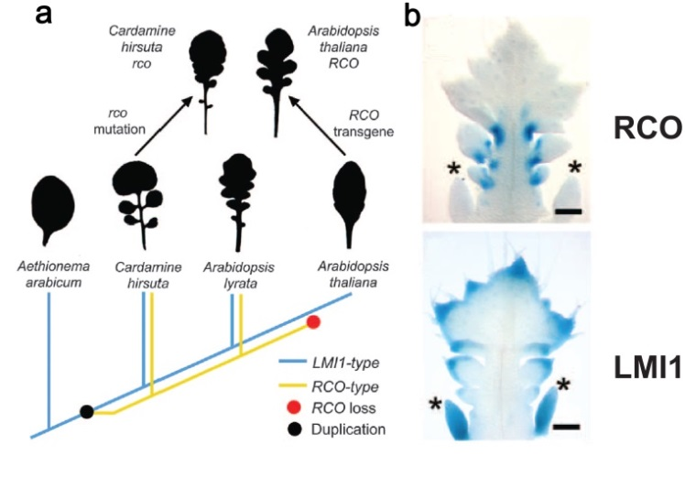
We are currently experiencing unprecedented climate change, which is a serious threat to our natural resources and food security at a time of rapid population increase. The sustainable food security requires a constant increase of genetic potential in crops. In order to increase the genetic potential of crops, exploring the genetic resources beyond major crops is a necessity. Leaf size and shape have an important effect on physiological processes such as photosynthesis and transpiration and thus on plant biomass. Therefore how morphological diversity of plant leaves is regulated constitutes an important branch of plant biology. In order to understand the genetic basis of morphological diversity in leaves, we have introduced a new model system C. hirsuta, which has dissected leaves with distinct leaflets, and it is a close relative of A. thaliana, which has simple leaves. Using comparative genetic approaches we discovered that a tandem duplication of the LATE MERISTEM IDENTITY 1 (LMI1) gene has given rise to two new copies in C. hirsuta. Diversification of the regulatory elements and coding sequence in one of the copies led to emergence of a novel transcription factor called Reduced Complexity, RCO. The RCO gene was lost in A. thaliana, contributing to leaf simplification in this species. In contrast to LMI1, which is expressed in the margins of leaflets, RCO is expressed at the base of leaflets and promotes leaflet formation through local growth regulation, at least in part by reprogramming the local phytohormone homeostasis. RCO expression is limited to leaves and its function is independent of shoot apical meristem development. Our data demonstrated that RCO is capable of improving photosynthetic efficiency, suggesting its contribution to adaptive evolution of leaf morphology. RCO studies could provide a basis for improvement of photosynthetic efficiency in crops.

Figure 1:. Evolution of RCO and its consequences for diversification of leaf shape in crucifers. (a) The genome of Aethionema arabicum, a simple-leaf early divergent crucifer, contains a single LMI1-type gene. RCO-type genes arose from duplication of an LMI1-type gene after the divergence of Aethionema from core Brassicaceae. The genomes of dissected-leaf C. hirsuta and lobedleaf A. lyrata contain both LMI1-type and RCO-type genes. In the lineage that gave rise to A. thaliana, the RCO-type gene was secondarily lost, contributing to evolution of a simple leaf. (b) The RCO and LMI1 expression pattern in C. hirsuta.

- Hajheidari M et al. (2016) Coupled enhancer and coding sequence evolution of a homeobox gene shaped leaf. Genes & Development 30: 2370-2375.
- Gan X et al. (2016) The Cardamine hirsuta genome offers insight into the evolution of morphological diversity. Nature Plants DOI: 10.1038/NPLANTS.2016.167.
- Vlad D et al. (2013) Leaf shape evolution through duplication, regulatory diversification, and loss of a homeobox gene. Science 343: 780-783.
- Hajheidari M et al. (2013) Emerging roles for RNA polymerase II CTD in Arabidopsis. Trends in Plant Science 18:633-643.
- Hajheidari M et al. (2012) CDKF;1 and CDKD protein kinases regulate phosphorylation of serine residues in the C-terminal domain of Arabidopsis RNA polymerase II. Plant Cell 24:1626-1642.
.


Mohsen Hajheidari obtained his master’s degree in Plant Breeding at the University of Razi, Iran. Before undertaking his Ph.D in the group of Csaba Koncz in the Department of Plant Developmental Biology at the Max Planck Institute for Plant Breeding Research (MPIPZ), he was a scientific member at the Agricultural Biotechnology Research Institute of Iran. He completed his Ph.D. in Genetics in 2010 at the University of Cologne as an International Max Planck Research School (IMPRS) student. Following a postdoctoral study in the group of Csaba Koncz, he joined the group of Miltos Tsiantis in the Department of Comparative Development and Genetics in 2013. He is currently using comparative genetic approaches to uncover the genetic bases of leaf morphological complexity in plants. His goal is to combine evolutionary and computational approaches with comparative genetics and molecular physiology to further decipher plant-environment interaction.
Email: hajheida@mpipz.mpg.de

Notes/Comments:

