De-novo transcriptome assembly for gene identification and molecular marker discovery in Capsicum annuum L exposed at high-intensity UV-B irradiation
Luis Lightbourn, PhD, Instituto de Investigacion Lightbourn, Mexico
Luis Amarillas, PhD, Instituto de Investigacion Lightbourn, Mexico
Talia Martinez, PhD, Instituto de Investigacion Lightbourn, Mexico
Josefina Leon, PhD, CIAD, Mexico

Abstract
Statement of the Problem: Exposure to high-intensity UV-B irradiation induces the expression of many genes normally involved in defense, wounding, or general stress responses. However detailed processes of the linkage between light UV-B signaling and the upregulation of gene expression remain unclear. Therefore, the mechanism by which UV-B stress triggers the intracellular defense signaling pathway remains poorly understood. Moreover, according to our knowledge, no studies have analyzed the overall changes in global gene expression in bell pepper leaves exposed to UV-B. Molecular biological analyses have allowed us to draw a picture of UV stress responses in plants, and determination of the transcriptome has had a significant impact on this research field. Methodology & Theoretical Orientation: Therefore, deep sequencing, transcriptome assembly, and differential expression analysis were performed to investigate the regulatory mechanisms of Capsicum annuum in response to UV-B exposure. A global transcriptome analysis of the response to high-intensity UV-B irradiation was conducted and target genes regulated by UV-B were identified. Findings: We conducted a high-throughput screening analysis. After 1 h, 273 genes showed significantly different expression between control and treated plants, among these 111 were up-regulated and 162 were down-regulated; these were involved in several putative metabolic pathways related to biotic stress. After gene annotation and gene ontology enrichment analysis it was possible to determine that the UV-B radiation induced the expression of genes with functions in UV protection, including antioxidant enzymes, G proteins, primary and secondary metabolism, and transcription factors (Figure 1). Conclusion & Significance: Transcriptome profiling highlights possible signaling pathways and molecules for future research. These results opened ways of exploring the molecular mechanisms underlying the effects of UV-B irradiation on Capsicum and have great implications for further studies.

Image
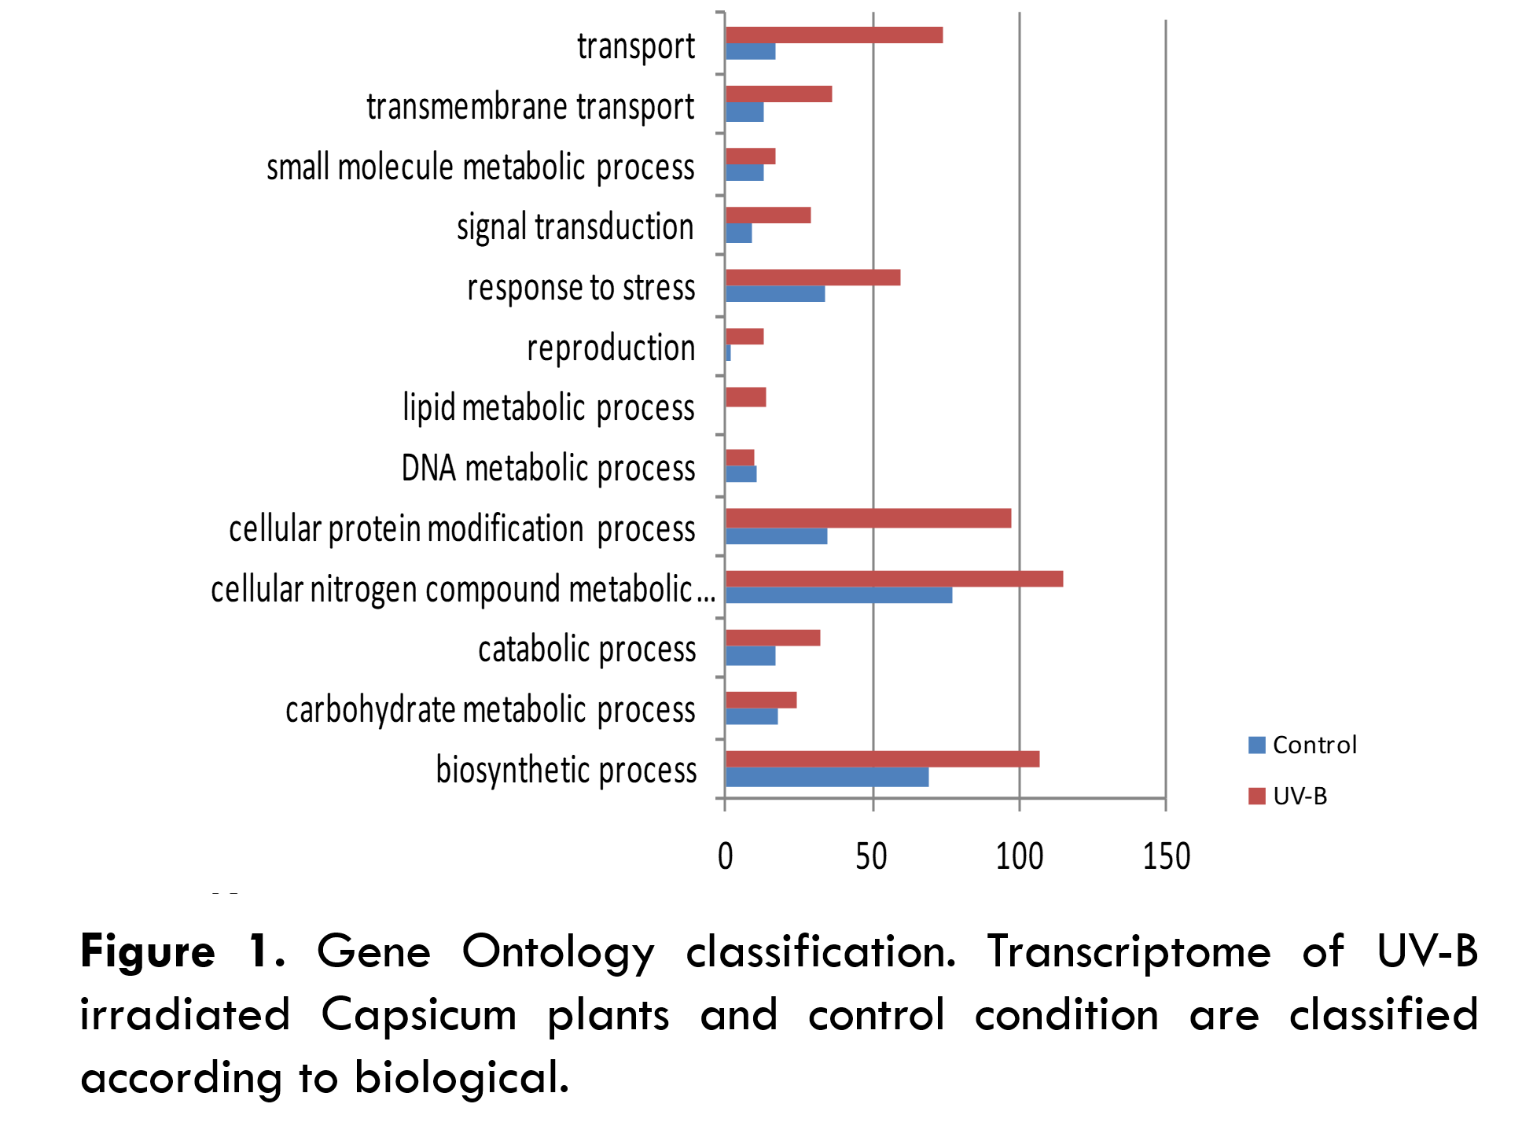
Recent publications
- Czemmel S, Höll J, Loyola R, Arce-Johnson P, Alcalde J, Matus J, Bogs J (2017). Transcriptome-Wide Identification of Novel UV-B- and Light Modulated Flavonol Pathway Genes Controlled by VviMYBF1. Frontiers in Plant Science, 8.
- Hoffmann A, Noga G, Hunsche M (2015). High blue light improves acclimation and photosynthetic recovery of pepper plants exposed to UV stress. Environmental and Experimental Botany, 109, 254-263.
- W, Ye J. (2017). Combined effects of O3 and UV radiation on secondary metabolites and endogenous hormones of soybean leaves. PLOS ONE, 12(8), e0183147.
- Robson T, Klem K, Urban O, Jansen M (2014). Re-interpreting plant morphological responses to UV-B radiation. Plant, Cell & Environment, 38(5), 856-866.
- Verdaguer D, Jansen M, Llorens L, Morales L, Neugart S (2017). UV-A radiation effects on higher plants: Exploring the known unknown. Plant Science, 255, 72-81.

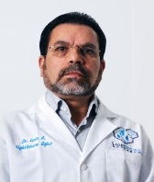
Biography
Luis Lightbourn, president of the Instituto de Investigación Lightbourn located at Mexico, he is an expert in plant biotechnology, genomics, cell biology and has over 30 years of experience in plant biochemistry and molecular biology. Throughout his research career he has focused on how light regulates plant growth and development. In particular, he has made a major contribution to understanding the molecular responses of plants to ultraviolet radiation. Doctor Lightbourn has a range of expertise that has attracted invitations to contribute to a wide range of activities, including assessment of research strategy, industry consultation and government advice.
Email: lalr@institutolightbourn.edu.mx; lalr@bioteksa.com

