Enhanced polyhydroxyalkanoate (PHA) production from agricultural waste by using halophilic microorganism
Sheng-Hsin Chou, Assistant Engineer, Institute of Nuclear Energy Research, Taoyuan City, Taiwan
Ting-Yen Huang, Postdoctoral Fellow, Tatung University, Taipei City, Taiwan
C. Will Chen, Professor, Tatung University, Taipei City, Taiwan
Gia-Luen Guo, Engineer, Institute of Nuclear Energy Research, Taoyuan City, Taiwan

Abstract
Polyhydroxyalkanoates (PHA) is a type of bioplastic with excellent biodegradability and biocompatibility. Therefore, PHA has been attractively used as the environmentally-friendly plastic container, heat-resistant biodegradable plastic, and can be further used as a carrier for long-acting and sustained-release microbial preparations, thus having high economic value. The study was aimed to develop a novel PHA production technology by using the lignocellulosic hydrolysate. Both of the xylose and glucose in lignocellulosic hydrolysate was as a carbon source for halophilic Haloferax mediterranei to produce PHA. To increase PHA production and reduce the PHA fermentation cost, several fermentation procedures were designed and performed with feeding medium contained the carbon sources. The PHA content produced by different feedstocks, such as sawdust hydrolyzed solution, bagasse hydrolyzed solution, xylose and glucose, were shown to be 44.3 %, 46.0 %, 38.7 % and 40.2 %, respectively. The maximal cell mass concentration was up to 11.92 g/L and the highest PHA concentration was achieved to 5.48g/L with bagasse hydrolyzed solution. Thus, it is promise to use agricultural waste as the carbon source to carry out PHA fermentations by Haloferax mediterranei and further validation is potential to extend the diverse application of PHA biomaterials.

Image
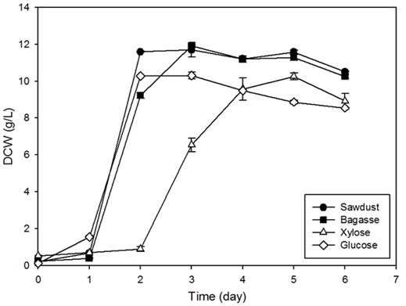
Growth curves of strain H. mediterranei with different carbon sources.
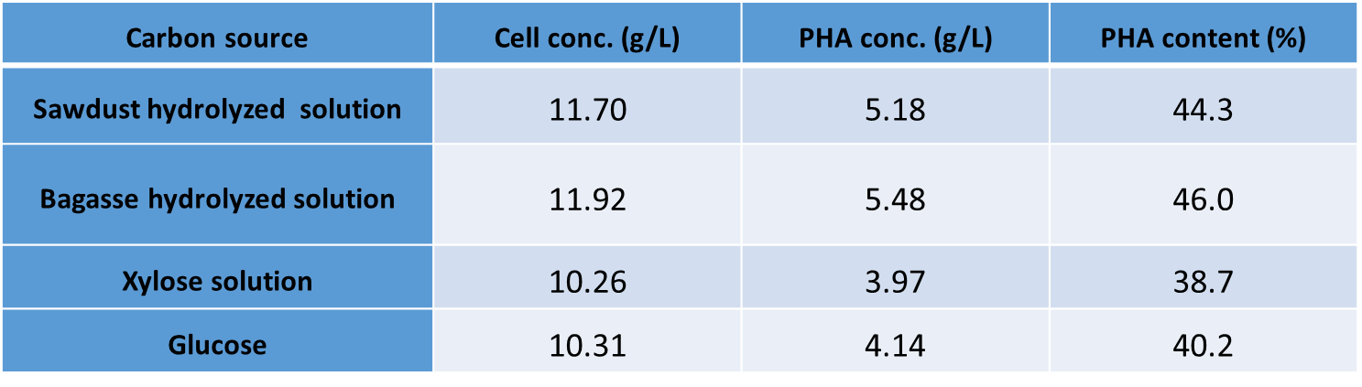
Cell conc. and PHA conc. with different carbon sources by H. mediterranei.
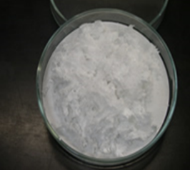
PHAs powder extracted from bacterial isolate.

 Sheng-Hsin Chou
Institute of Nuclear Energy Research. Taoyuan, Taiwan
Assistant Engineer, October 2007 up to now.
Established comprehensive R&D capability based on biochemical process – from jar-test laboratory, unit process development facility to 1 TPD pilot plant. The pilot plant would be also served as a platform for validation of scalabilities of novel technologies developed for produce biofuel and bioplastic.
Email: shchou@iner.gov.tw

Notes/Comments:

