A Bioartificial Rat Heart Tissue: Perfusion Decellularization and Characterization
B. Ozlu¹, M. Ergin¹, S. Budak¹, S. Tunali², N. Yildirim³, C. Erisken^{1,4}
Presenting Author: Cevat Erisken, cevat.erisken@nu.edu.kz
¹Department of Biomedical Engineering, TOBB University of Economics and Technology, Ankara, Turkey,
²School of Medicine, TOBB University of Economics and Technology, Ankara, Turkey,
³Faculty of Veterinary Medicine, Ankara University, Ankara, Turkey,
⁴Department of Chemical and Materials Engineering, Nazarbayev University, Nur-Sultan, Kazakhstan

Introduction: Heart-related defects are still prone to progress irreversibly, and can eventually lead to heart failure. A personalized extracellular matrix (ECM) based bioartificial heart created by allografts/xenografts can retain the original 3D architecture, in addition to preserved heart ECM. This study aimed at developing a procedure for decellularizing heart tissue harvested from rats, and evaluating decellularization efficiency in terms of residual nuclear content and structural properties.
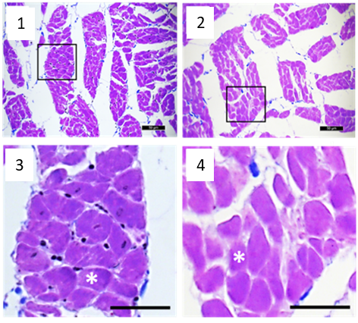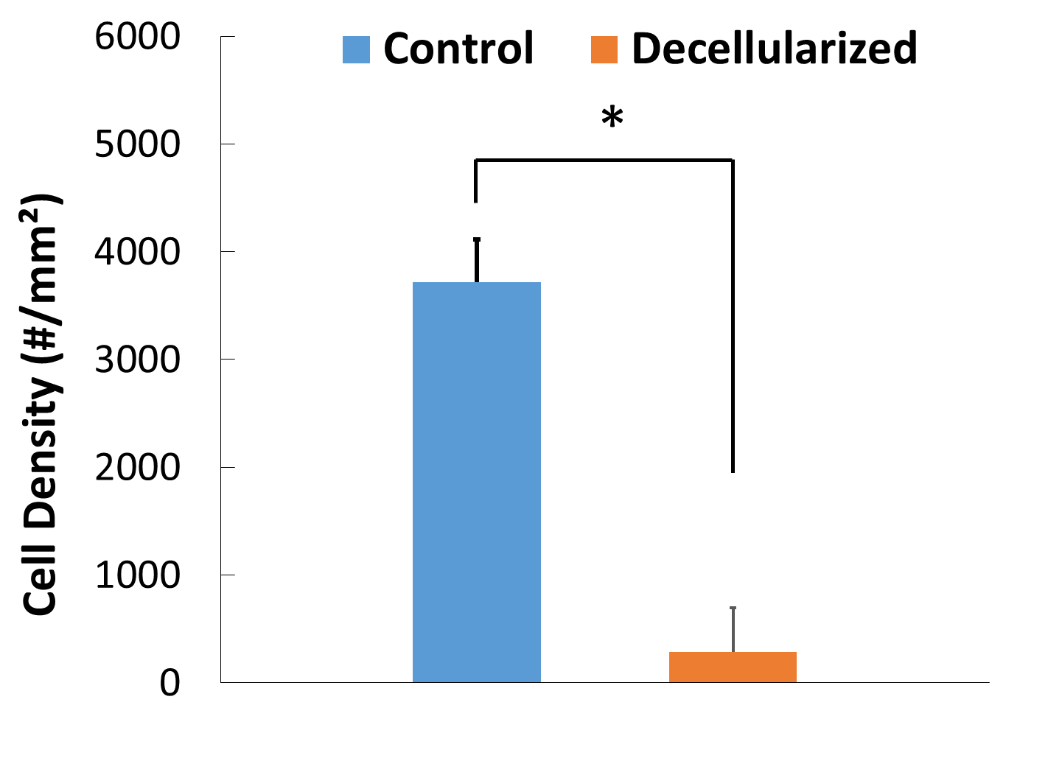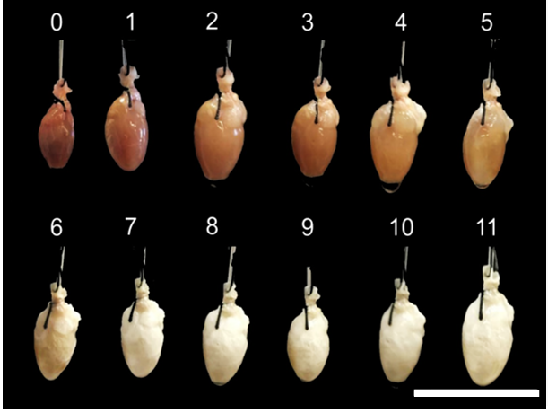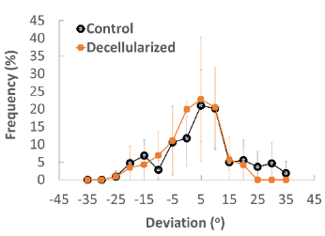
Figure 1: (A) Crossman’s modified triple stained sections, (B) DNA removal efficiency, (C) hearts at different stages of perfusion, and (D) muscle fiber alignment.
A
B
C
D
Methods: A modiﬁed version of a previously published[1] decellularization protocol was followed in this study. A total of 4 rat hearts (7 week-old, female Wistar Rats) were harvested, three of them were perfused as described below, and the forth served as a positive control. Briefly, rats were euthanized, and hearts were removed from the chest. A blunt needle was inserted into the ascending aorta and sutured to allow for retrograde coronary perfusion using chemical and biological agents (surfactants, acids, bases, and enzymes) combined with physical stimulation.

Results: Removal of nuclear material (92.4%) was conﬁrmed by histological examination (Fig1A,B). Tissue sections showed no or little visible cell nuclei in decellularized heart, whereas the native heart showed dense cellularity. Intact structure of decellularized heart was verified by the structure of whole heart (Fig 1C), as well as similarity between decellularized and native cardiac muscles in terms of fiber alignment (Fig 1D). Furthermore, no significant difference was detected between native and decellularized heart in terms of fiber diameter.

Discussion & Conclusion: Our findings demonstrate that a heart bioartificial scaffold can be efficiently decellularized with chemical and biological agents, coupled with aortic perfusion as a physical stimulation. Technique described here could be used for other species upon necessary modifications. Previous studies commonly provided evidence for the presence of intact endocardium, myocardium and epicardium.[1,2] We recommend that fiber alignment and diameter should be included in the characterization of biological heart scaffolds as these could serves as valuable tools for evaluating structural preservation of decellularized heart. The bioartificial scaffold formed here can be functionalized with patient’s own material, and utilized in regenerative engineering.

Acknowledgement: No funding was received for this study.

References:
[1] Lu, TY et al. Nat Comm. 2013; 4: 2307.
[2] Wainwright JM et al. Tissue Eng C Methods. 2010, 16(3):525-532.

Keywords—decellularization, heart, perfusion, rat

Professional Biography

Cevat Erisken completed his PhD at Stevens Institute of Technology, Hoboken, NJ, USA and served for Columbia University in the City of New York as an Assistant Professor. Currently, Dr Erisken is a faculty member in the Department of Chemical and Materials Engineering at Nazarbayev University, KZ, and has been conducting research on biomaterials and regenerative medicine. Dr. Erisken is known with his seminal paper published in Biomaterials reporting generation of a nanostructure with gradients of biomolecules to demonstrate directed differentiation of stem cells into chondrocytes in a location dependent manner, which mimics the chondrocyte distribution in the native osteochondral interface. His current research revolves around soft-to-hard tissue regeneration including cartilage-bone, tendon-bone, and ligament-bone; design and fabrication of polymer based and extracellular matrix based scaffolds; and controlled release of therapeutics from polymer based delivery systems. He has published more than 20 articles in reputed journals, lectured at universities and presented at international conferences. He is also serving as an editorial board member of several journals and has served as an expert evaluator in Horizon 2020 program of the European Commission.

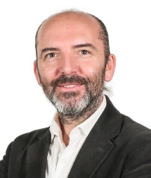
Email: cevat.erisken@nu.edu.kz

