Title: Importance of serum „Thymus and Activation-Regulated Chemokine" (TARC) determination in classical Hodgkin lymphoma’s (cHL) patients
Name: Krisztina Kőhalmy
National Institute of Oncology, Department of Biochemistry, Hungary

Abstract (300 word limit)
Statement of the Problem: Thymus and Activation-Regulated Chemokine (TARC or CCL17) is highly expressed by Hodgkin and Reed-Sternberg cells and secreted into the serum. Therefore it can be a useful tumor marker of classical Hodgkin lymphoma (cHL). Our aim has been to study the value of serum TARC concentrations in the course of treatment and follow up in patients with cHL. Methodology & Theoretical Orientation: We enrolled 613 patients diagnosed with cHL who were treated by the National Institute of Oncology, Hungary between 2011 and 2018. Serum TARC levels were determined with a quantitative sandwich enzyme immunoassay technique (R&D Systems, Biotechne, Minneapolis, MN). Measurements were carried out in periods of 3 months following diagnosis and of 6 months after 3 years. In 241 cases, serum TARC concentration was determined before therapy, as well. Total number of measurements was 2015. Receiver Operating Characteristic (ROC) curve analysis was performed for comparison of healthy controls (n=168) and patients with active disease status before treatment (n=241). The cut-off value was 637 pg/ml with 90.9% sensitivity and 98.2% specificity. During follow-up the median serum TARC value was 14350 pg/ml in patients with active disease status. In case of complete remission it was 401 pg/ml. ROC curve analysis of active versus complete remission groups showed a high, 85.6% sensitivity and 93.7% specificity with a 936 pg/ml cut-off value. Conclusion & Significance: Our data confirmed the usefulness of TARC determination in the course of treatment and follow-up. TARC may be a potential marker for early response assessment and may be able to predict potential relapse of the disease. Determination of serum TARC concentrations with high sensitivity and cost-efficacy, is highly recommened for monitoring and at diagnosis of cHL patients.

Image
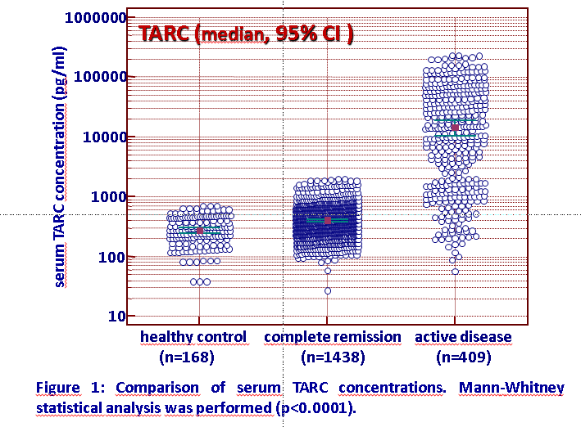
Recent Publications
- B Vincze, B Kapuvári, N Udvarhelyi, Zs Horváth, Z Mátrai, F Czeyda-Pommersheim, K Kőhalmy et al (2015) Serum estrone concentration, estrone sulfate/estrone ratio and BMI are associated with human epidermal growth factor receptor 2 and progesterone receptor status in postmenopausal primary breast cancer patients suffering invasive ductal carcinoma. SpringerPlus 4:387, 2-11.
- K Kőhalmy, J Kovács, B Balázs, T Pulay, I Pete, B Vincze (2016) Determination of serum inhibin B levels in ovarian cancer patients with granulosa cell tumors. PCS, Global Obstetrics and Gynaecology Congress, p 142
- Vincze B, Molnár Zs, Kovács J, Kapuvári B, Kőhalmy K et al (2016) Study the importance of serum TARC value in classical Hodgkin lymphoma. Focus Medicinae 4:18, 21-24.
- Kapuvári B, Molnár Zs, Kovács J, Kőhalmy K et al (2017) Determination of serum TARC concentrations in classical Hodgkin lymphoma’s (cHL) patients. Hungarian Oncology 61:23.
- K Kőhalmy, L Géczi, Zs Küronya, O Horváth, B Vincze (2019) Determination of serum parameters and circulating biomarkers in prostate cancer related to progression and efficacy of therapy. Hungarian Oncology


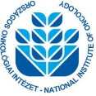
Paste your Photograph Here
Biography (150 word limit)
Krisztina Kőhalmy is the Head of the Biochemical Department in National Institute of Oncology, Hungary (1st July, 2019). She has an MSc in Chemistry and Phd in Biology. She studies Clinical Biochemistry. She is member of the European Association for Cancer Research (EACR) and the Hungarian Oncological Association.
Email: kohalmyk@oncol.hu

Notes/Comments:

