Analysis and potential of manufactured biodiesel from neem oil using gas chromatograph-mass spectroscopy (GC-MS) and Fourier transform infrared spectrophotometer (FTIR) techniques.
Aliyu A, Manovic V, Leeke G, Cranfield University, UK

Abstract
Biodiesel from neem seed was manufactured and the percentages of methyl esters as well as the functional groups present were analysed using gas chromatograph-mass spectroscopy (GC-MS) and Fourier transform infrared spectrophotometer (FTIR) techniques respectively. The outcome of the analysis shows that the percentages of methyl esters before and after manufactured biodiesel were in total of 3.0% and 71.5% respectively which confirmed that neem oil was successfully converted into biodiesel. The presence of alcohol and alkanes in the manufactured biodiesel affirms the use of non-edible neem oil methyl ester as one of the most prominent alternative to petroleum based diesel. The physico-chemical properties of manufactured biodiesel was also carried out. The results were in agreement with the American Society for Testing and Materials (ASTM) Standard for sulphur content, viscosity, cetane number, acid value, colour and specific gravity. In addition, features such as environmental acceptability, domestic availability, technical feasibility and fulfilment of global energy demand are also associated with the product. These makes it suitable for use in compression ignition engines.

Image
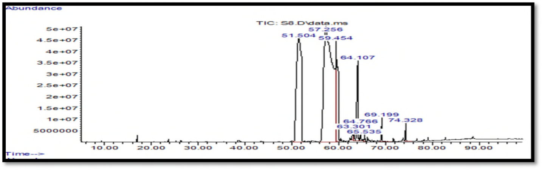
Figure 1: GC-MS Chromatogram of neem biodiesel
Publications
- Aliyu AO, Aliyu A (2008) Role of Engineering and Science in Sustainable Development in the 21st Century. SBN: 978-8141-11-0
- Abaka AU, Mohammad L, Aliyu A (2010) Renewable Energy for Sustainable Development. 3rd NAEE/IAEE International conference.
- Aliyu AO, Aliyu A (2010) Energy Statistics: The basis for Energy Sustainable Development in Nigeria. 3rd NAEE/IAEE International conference.
- Aliyu A (2002) Design of a process plant for the recovery of a spentleclanche dry cell using hydrometallurgical method. FUTMX, Nigeria.
- Yusuf MBS, Aliyu A, Mohammad L (2010) Renewable Energy for Sustainable Agriculture in Nigeria prospects and challenges. FUTO International Renewable and Alternative Energy conferences.

Biography
Engr. Aliyu was a production manager of soap production company and was letter employed as staff of Energy Commission of Nigeria, an Agency under Federal Government of Nigeria charged with strategic planning and co-ordination of National Policies in the field of Energy in all its ramifications. This includes research and promotion of clean and renewable energy and capacity building and technology transfer. He is a member of the following professional bodies; International Association of Engineers, World Society of Sustainable Energy Technologies, The Nigerian National Committee of the World Energy Council, The Council for the Regulation of Engineering in Nigeria among others. Presently, A PhD Student in Energy and Power at Cranfield University, United Kingdom. .
Email:Abdulkabir.aliyu@cranfield.ac.uk

Notes/Comments:

