Development of a cleaner technology for pulp and paper industry: Isolation and application of a bacterium producing cocktail of lignolytic and hemicellulolytic enzymes
Steffy* PhD Research Scholar and
Dr. Naveen Gupta, Assistant Professor, Department of Microbiology, Panjab University, Chandigarh, India

Abstract
Bioprocessing of pulps using microbial enzymes for biobleaching is one of the most suitable biological applications for the pulp and paper industry. Lignolytic (laccase,) enzymes helps directly in the removal of lignin from the pulp and hemicellulolytic (xylanase, mannanase) enzymes increases the access of bleaching chemicals to the lignin layer by opening the pulp structure. Bacterial enzymes are preferred as they can work at high temperature and pH at which the pulp is processed in industry. A number of these enzymes from bacteria have been explored individually for pulp biobleaching. Some report have also reported the use of combination of these enzymes but produced by different bacteria which make their application economically unviable. Therefore there is a need to isolate a bacterial strain producing a cocktail of hemicellulolytic and lignolytic enzymes and standardizing a procedure for their application in pulp and paper industry to make the whole process of paper making eco friendly.
In present study, Bacillus sp. LXM 55 MTCC 12897 was isolated from effluent of paper mill which produced a cocktail of lignolytic (Laccase) and hemicellulotic (Xylanase+Mannanase). All the enzymes were found to be active in the temperature and pH range which was suiable for their application in pulp and paper industry. Conditions were standardized for the over production of enzymes in solid state fermentation by using classical and statistical methods. Significant reduction in chlorine use was achieved by pretreating the pulp with cocktail of enzymes. Therefore this cocktail of enzymes is highly suitable candidate for developing a cleaner and economical process for
Pulp bleaching.

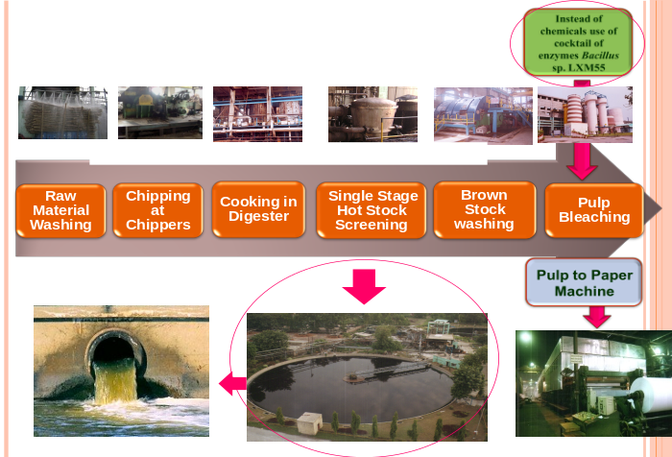
Fig 1: Pulp making process and use of cocktail enzyme from Bacillus sp. LXM 55 for pulp biobleaching
References
- Bajpai P, Anand A, Sharma N, Mishra SP, Bajpai PK and Lachenal D (2006) Enzymes improve ECF bleaching of pulp. Bioresources 1: 34-44.
- Chauhan PS, Soni SK, Sharma P, Saini A and Gupta N (2014) A Mannanase from Bacillus nealsonii PN-11: Statistical optimization of production and Application in Biobleaching of pulp in combination with xyalanse. International Journal of Pharma and Bio Sciences 5: 237-251.
- Gupta V, Garg S, Capalash N, Gupta N and Sharma P (2015) Production of thermo-alkali-stable laccase and xylanase by co-culturing of Bacillus sp. and B. halodurans for biobleaching of kraft pulp and deinking of waste paper. Bioprocess and Biosystem Engineering 38: 947-956.
- Sharma P, Sood C, Singh G and Capalash N (2015) An eco-friendly process for biobleaching of eucalyptus kraft pulp with xylanase producing Bacillus halodurans. Journal of Cleaner Production 87: 966-970.
- Sondhi S, Sharma P, George N, Chauhan PS, Puri N and Gupta N (2015) An extracellular thermo-alkali-stable laccase from Bacillus tequilensis SN4, with a potential to biobleach softwood pulp. 3 Biotech, 5: 175-185.

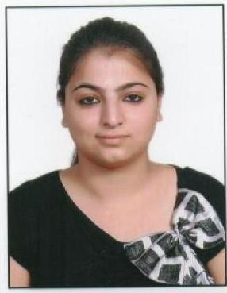 Biography
Steffy is a PhD research scholar in Department of Microbiology at Panjab University, Chandigarh, India. She has received her bachelor degree in Biotechnology from Doaba College, Guru Nanak Dev University, India. She holds a master’s degree in Microbiology that focuses on isolation and screening of silica solubilizing thermophilic fungi for enhancing paddy straw digestibility and biogas production. During her master’s she has explored the microbiologically techniques to check the improvement of degradability of paddy straw and efficient amount of biogas production.
Her current doctoral research based on isolation of a bacterium producing cocktail of lignolytic and hemicellulolytic enzymes and its application on pulp and paper industry. She is keen to spread her knowledge in the field of biobleaching in pulp and paper industry in an economical and eco-friendly manner and provide green technology in near future.
Email: steffyangural91@gmail.com

