Hot-water extraction prior to soda-AQ pulping of miscanthus X giganteus from IFBR perspective

Saleem Ullah, Hannu Pakkanen, Joni Lehto and Raimo Alén
Department of Chemistry, University of Jyväskylä, Finland

Abstract
Agricultural residues, such as miscanthus, show a great potential for lignocellulosic biorefinery due to their relatively high polysaccharide content and minor nutritional value for human consumption. In this study miscanthus stalks were investigated from the IFBR (integrated forest biorefinery) perspective to assess their potential use for biorefinery purposes. Hot-water extraction (HWE) of miscanthus stalks was carried out under varying conditions to determine the effect of maximum temperature (140°C and 150°C) and P-factor on miscanthus dry solids mass.
Biography

Mr. Saleem Ullah (M.Sc.) is undertaking at the University of Jyväskylä postgraduate studies aiming at a doctor´s degree (Doctor of Philosophy) in Chemistry. His research topic dealing with various biorefinery concepts on the utilization of non-wood feedstocks. His main research interests are chromatographic and spectroscopic analyses of the produced material streams (hydrolysates and pulping liquors containing hemicelluloses, lignin, extractives, and their degradation products), and pulping
chemistry. Research keywords: Aliphatic carboxylic acids, Analytical chemistry, Biorefining of non-wood feedstock, Chromatography, Hemicelluloses, Lignin, Pre-treatments, Pulping chemistry, Wood chemistry, etc.
Email:saleem.s.ullah@jyu.fi

Delignification by the conventional soda-anthraquinone (soda-AQ) pulping of one untreated and two hot-water extracted miscanthus stalk samples were also performed. Hot-water extraction removed effectively hemicelluloses and the dry mass of miscanthus decreased with the increase in temperature and P-factor. The highest yield reduction (10.0 %) was obtained at 150°C with a P-factor of 200. HWE liquors (hydrolysates) were analyzed in terms of pH as well as the amount of volatile acids (formic and acetic acid), furans (furfural and HMF) and dissolved carbohydrates. The pH of HWE liquors decreased with the increase in P-factor and temperature, especially furan concentrations were relatively higher. The screened pulp yield increased after the HWE stage and the highest yield for the hot-water treated feedstock was obtained at 140○C with a P-factor of 50, corresponding to 53.2 % yield of the charged material. In case of black liquors, volatile acids and residual alkali were determined. In general the results indicated that HWE prior to soda-AQ pulping had some positive effects.

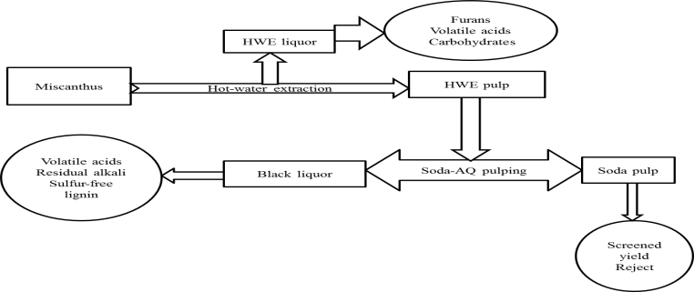

Figure 1: Overall process flow diagram.

Recent Publications
- Conde-Mejia C, Jiménez-Gutiérrez A, El-Halwagi M (2012) A comparison of pretreatment methods for bioethanol production from lignocellulosic materials. Process Safety and Environmental Protection 90:189–202.
- Carvalheiro F, Duarte LC, Gírio FM (2008) Hemicellulose biorefineries: a review on biomass pretreatments. Journal of Scientific and Industrial Research 67:849-864.
- Chirat C, Lachenal D, Sanglard M (2012) Extraction of xylans from hardwood chips prior to kraft cooking. Process Biochemistry 47:381-385.
- Cordeiro N, Ashori A, Hamzeh Y, Faria M (2013) Effects of hot water pre-extraction on surface properties of bagasse soda pulp. Materials Science and Engineering 33:613-617.
- Hammett AL, Youngs RL, Sun X, Chandra M (2001) Non-wood fiber as an alternative to wood fiber in China’s pulp and paper industry. Holzforschung 55: 219–224.
- Lehto J, Alén R, Malkavaara P (2014) Multivariate coRelation between analytical data for various organics dissolved during autohydrolysis of silver birch (Betulap pendula) chips and treatment conditions. BioResources 9:4958-4970.
- Moshkelani M, Marinova M, Perrier M, Paris J (2013) The forest biorefinery and its implementation in the pulp and paper industry: Energy overview. Applied Thermal Engineering 50:1427-1436.
- POTŮČEK F, MILICHOVSKÝ M (2011) RAPSEED straw as a possible source of non- wood materials. Cellulose Chemistry and Technology 45:23-28.

