Recent advances in enzymatic biofuel cells
Serge Cosnier, Univ. Grenoble Alpes, CNRS, Department of Molecular Chemistry, France

The need for clean methods of producing electricity for medical applications has stimulated the emergence of biofuel cells as a new generation of fuel cells. This subcategory of fuel cells, mainly rely on redox enzymes, which are very efficient and selective biocatalysts that can advantageously replace rare and expensive platinum-based catalysts in classic fuel cell devices. Enzymes provide exceptional specificities towards their substrates, thus enabling the assembly of both the anode and cathode electrodes of a biofuel cell without the need for membranes. Recent advances in the design of biocathodes based on electrically wired enzymes onto carbon nanotube coatings for the reduction of oxygen will be reported. In particular, a new generation of flexible buckypaper electrodes was produced by using linear polynorbornene polymers containing multiple pyrene groups as crosslinker. Robust buckypapers using copolymers containing both pyrene and activated ester groups for cross-linking and tethering, respectively, will be applied to the covalent binding of redox groups or enzymes. Moreover, buckypapers based on bilirubin oxidase and FAD-dependent glucose dehydrogenase, were developed for the direct electron transfer and the mediated electron transfer, respectively. The resulting biofuel cell based on the O2/glucose system, provides the highest volumetric power reported until now, namely 24.07 mW cm-3. Finally, an innovative approach based on the electrical wiring of enzymes in solution by redox glyconanoparticles resulting from the self-assembly of bio-sourced block copolymers will be presented. We demonstrate the self-assembly, characterization and bioelectrocatalysis of redox-active cyclodextrin-coated nanoparticles. The nanoparticles (diameter: 195 nm) were used as electron shuttles between electrode and bilirubin oxidase providing enhanced current densities for enzymatic O2 reduction.
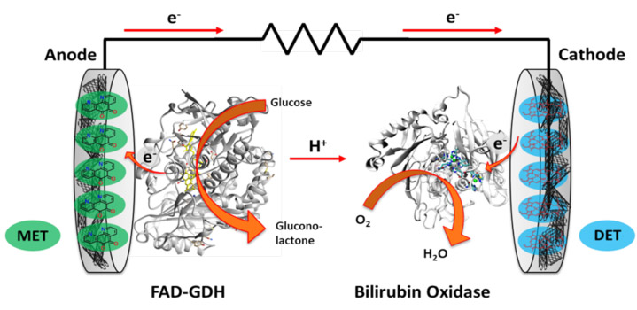

Figure 1: Schematic representation of a biofuel cell
- Cosnier S, Gross A, Le Goff A, Holzinger M (2016) Recent advances on enzymatic glucose/oxygen and hydrogen/oxygen biofuel cells: Achievements and limitations. J. Power Sources 325: 252-263.
- Lalaoui N, Holzinger M, Le Goff A, Cosnier S (2016) Diazonium functionalization of carbon nanotubes for specific orientation of multicopper oxidases: controlling electron entry points and oxygen diffusion to the enzyme. Chem. Eur. J., 22 :10494-10500.
- Gross A, Robin M, Nedellec Y, O’Reilly R, Shan D, Cosnier S (2016) Robust bifunctional buckypapers from carbon nanotubes and polynorbornene copolymers for flexible engineering of enzymatic bioelectrodes. Carbon, 107 (2016) 542-547.
- Gross A, Chen X, Giroud F, Abreu C, Le Goff A, Holzinger M, Cosnier S (2017) A high power buckypaper biofuel cell: exploiting 1,10-phenanthroline-5,6-dione with FAD-dependent dehydrogenase for catalytically-powerful glucose oxidation ACS Catalysis, 7 :4408-4416.
5. Gross A, Chen X, Giroud F, Travelet C, R. Borsali R, Cosnier S (2017) Redox-active glyconanoparticles as electron shuttles for mediated electron transfer with bilirubin oxidase in solution J. Am. Chem. Soc., doi:10.1021/jacs.7b09442.

Dr Serge Cosnier is Research Director at CNRS and head of the Department of Molecular Chemistry at the Grenoble Alpes University (France). His activity is focused on electrochemical biosensors, biofuel cells, electrogenerated polymers, molecular electrochemistry and carbon nanotubes.. Dr Cosnier has authored over 340 publications (h-index 56), 2 books and 18 book chapters and was the President of the French Group of Bioelectrochemistry (2001-2014). In 2009, he received the Katsumi Niki Prize of the International Society of Electrochemistry and was appointed as Fellow of this Society (2010). In 2013, Dr Cosnier became a member of the Academia Europaea. Finally, he is the recipient of the 2016 China-France Chemistry Award from the Chinese Chemical Society and the Chemical Society of France..
Email: Serge.Cosnier@univ-grenoble-alpes.fr

Notes/Comments

