A new biological process for CO₂ valorization
Azariel Ruiz-Valencia, PhD student, Institut Européen des Membranes, UMR 5635 (CNRS-ENSCM-UM), FRANCE
Laurence Soussan*, Associated Professor, Institut Européen des Membranes, UMR 5635 (CNRS-ENSCM-UM), FRANCE

Abstract
Statement of the Problem: CO₂ is one of the major greenhouse gases accumulating in the atmosphere, with anthropogenic emission of about 35 Gt/y. Among processes that are being developed to help reducing CO₂, biological processes are promising as they seem to be more efficient and less energy consuming. Under certain conditions, some microorganisms can use CO₂ as a carbon source for fuel production. This work presents a new microbiological process for CO₂ reduction into formate, which is being patented. Compared to other biological process, an intracellular energy source is used for the reaction, meaning that no external energy adding such as H₂, photons or cofactor is required. The biocatalyst is a consortium of two environmental bacteria growing on methane. In this work, labelled ¹³CO₂ was implemented to evidence the CO₂ reduction catalyzed by the bacteria. Methodology: The bacterial culture was done on a mineral medium. Once growth phase ended, cells were harvested and resuspended in a phosphate buffer (pH 7,0). Reaction was performed in a 50 mL sealed vial filled with 5 mL of bacterial suspension and a mixture of ¹³CO₂:air; independent duplicates were done. The suspension was analyzed by 500-MHz NMR spectroscopy; pH and OD₆₀₀ were also measured. Findings: Both pH and OD₆₀₀ decreased during the first hours (by about 10% and 30% respectively), then remained constant. All along the reaction, both CO₂ and HCO₃⁻ were visible in the NMR spectrum at δ=124,6 and δ=160,2 ppm respectively, as shown in fig.1; later at t=7 days, a peak with δ=170,9 ppm appeared, which corresponds to formate (fig.1b). Conclusion and perspective: CO₂ reduction into formate is achieved by the bacterial consortium. Quantification of the formate produced and CO₂ consumed will be carried out respectively by ionic and gas chromatography.

Image
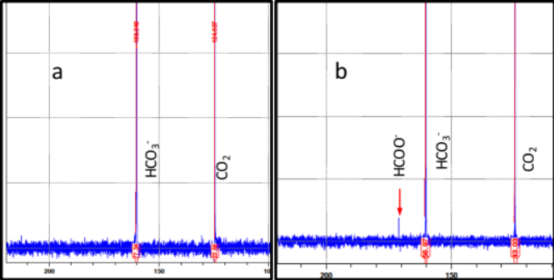
Figure 1. NMR spectrum for CO₂ reduction at the beginning of the reaction (a) and after 7 days (b).

Recent Publications
- Izumi Y (2013) Recent advances in the photocatalytic conversion of carbon dioxide to fuels with water and/or hydrogen using solar energy and beyond. Coordination Chemistry Reviews, 257(1):171-186.
- Hartmann T, Leimkühler S (2013) The oxygen‐tolerant and NAD+‐dependent formate dehydrogenase from Rhodobacter capsulatus is able to catalyze the reduction of CO₂ to formate. FEBS Journal, 280(23):6083-6096.
- Appel AM, Bercaw JE, Bocarsly AB, Dobbek H, DuBois DL, Dupuis M, Ferry JG, Fujita E, Hille R, Kenis PJ (2013) Frontiers, opportunities, and challenges in biochemical and chemical catalysis of CO₂ fixation. Chemical Review, 113(8):6621-6658.
- Aresta M, Dibenedetto A, Angelini A (2013) The changing paradigm in CO2 utilization. Journal of CO2 Utilization, 3:65-73.
- Enthaler S, von Langermann J, Schmidt T (2010) Carbon dioxide and formic acid—the couple for environmental-friendly hydrogen storage? Energy & Environmental Science, 3(9):1207-1217.

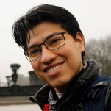
Biography
Azariel Ruiz-Valencia is a PhD student at the European Institute of Membranes. He has been studying by different approaches how microorganisms can help environment, and now his research focuses specifically on the use of microorganisms to convert carbon dioxide into valuable chemicals. He obtained his Master degree at Tuxtla Gutiérrez Institute Technologic.

Corresponding author*: Laurence.Soussan@enscm.fr

Notes/Comments:
A. Ruiz Valencia built the study and made the experiments; D. Benmeziane contributed to A. Ruiz Valencia’s work; E. Petit was in charge of NMR analysis; V. Bonniol is in charge of ionic chromatography analysis; S. Pecastaings and C. Roques were in charge of biochemical analysis; M.P. Belleville, J. Sanchez-Marcano and D. Paolucci helped on bioprocess aspects; L. Soussan proposed, built and supervised the study; A. Ruiz Valencia, D. Benmeziane, M.P. Belleville, J. Sanchez-Marcano, D. Paolucci and L. Soussan discussed the results.

