Tackling Carbon Catabolite Repression in Parageobacillus thermoglucosidasius
Jinghui Liang, MSCA-FIRE PhD Fellow, University of Bath, UK

Abstract (300 word limit)

The genus Parageobacillus are thermophilic gram-positive bacteria of industrial interest for lignocellulosic biomass fermentation. Though Parageobacillus spp. are facultative anaerobes microbes capable of fermenting a wide range of C6 and C5 sugars, carbon catabolite repression (CCR) has been a bottleneck in the complete utilization of mixed-sugar substrates, constraining microbial growth rate and productivity. This study aims to remove CCR from Parageobacillus thermoglucosidasius DSM2542 with devising methods in order to optimize its industrial performance.

Firstly, in gram-positive bacteria, CCR is mediated via the PTS system through transcriptional regulation of catabolic gene expression. With a preferred PTS sugar in the substrate, high glycolytic activity leads to the accumulation of glucose-6-phosphate and fructose-1,6-biophosphate, resulting in the regulatory phosphorylation of HPr and Crh on Ser46 residue by HPrK16. The activated HPr (Ser-P) and Crh (Ser-P) bind to CcpA to form a HPr-Ser46-P/CcpA or Crh-Ser46-P/CcpA complex which can bind to cre elements located 5’ or within the catabolic genes, and CCR occurs when the genes are down-regulated. However, it has been found that it is difficult to generate an HPrS46A and CrhAS46A double mutant, and therefore alternative methods are required to remove CCR from DSM2542.

Secondly, quantitative RT-PCR was used to identify the xylose transportation system, which demonstrated that arabinose transporter might be involved in xylose transportation. Therefore, modifying the cre sites within the arabinose transporter could potentially relieve xylose and arabinose utilization from CCR.

Lastly, it has been proved that a cocktail containing glucose analogue could remove catabolite repression from P. thermoglucosidasius via adapted evolution within a month.

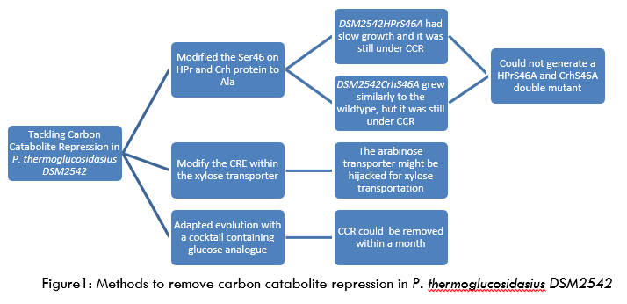
Image

Recent Publications (minimum 5)



Biography (150 word limit)
Jinghui graduated in 2016 from the University of Science and Technology in Beijing with a Bachelors in biotechnology. During her degree, she undertook two exchange programmes, first at Taiwan Fu Jen Catholic University, then at the University of Dundee. After graduation, she joined the CDT in Sustainable Chemical Technologies in University of Bath as an MSCA-FIRE Fellow. Her PhD research is on the development of bacterial strains for mixed-sugar fermentation with Prof. David Leak. Outside of research, she is also passionate about entrepreneurship.
Email: jjl51@bath.ac.uk

Notes/Comments:

