Abstract Template
Abstract Title: Quantifying the comparative value of carbon abatement pathways over different investment timing scenarios
Jenny R. Frank¹, Tristan R. Brown¹, Robert W. Malmsheimer¹

¹ Department of Forest and Natural Resources Management (State University of New York College of Environmental Science and Forestry)

Abstract (not more than 300 words)
The objective of this study is to quantify the comparative impact that different investment timing scenarios have on the value of carbon abatement pathways. This project is motivated by the global need to forestall and ultimately prevent the onset of catastrophic climate change via the rapid reduction of anthropogenic greenhouse gas (GHG) emissions. This project examines two comparable renewable energy pathways that are at different stages of development and commercialization. The first pathway, the utilization of biomass-based diesel (BBD) from lipid feedstocks in internal combustion engine heavy-duty trucks (BBD HDV), is a mature technology that has been commercialized and achieves well-defined carbon abatement costs. The second pathway, battery-electric (BE) HDTs powered entirely by renewable electricity, is an immature technology that has a potentially lower carbon abatement cost but is still at least several years away from commercialization. Both pathways are capable of displacing demand for petroleum-derived diesel fuel, albeit via substantially different processes.
The purpose of comparing a developed, fully commercialized pathway with an immature, uncommercialized pathway is to quantify the trade-off between investing in a currently available carbon abatement route and investing later in a future route that has a greater carbon abatement potential. BBD is widely produced and available at commercial-scale volumes today while BE HDTs, particularly long-haul versions, are not commercialized at present and not expected to be commercialized for at least several years.
This study calculates net present values (NPV) for both pathway scenarios based on techno-economic analysis in which the beneficial value of carbon abatement is represented as a revenue stream via an internalized social cost of carbon (SCC). A secondary output will be the calculation of the future year (if any) in which the BE HDT pathway’s NPV surpasses that of the BBD HDT pathway. The SCC is the marginal external cost of emitting a megagram of carbon dioxide-equivalent (CO2e). For the purposes of this project it is employed to represent the benefit of reducing CO2e emissions relative to a petroleum-derived diesel fuel baseline.

Carbon abatement, investment timing, social cost of carbon, net present value

Professional Biography (100-150 words)
Jenny Frank is a PhD student in the Sustainable Energy Management program within the Department of Forest and Natural Resources Management at SUNY College of Environmental Science and Forestry. Her research focuses on the integration of stochastic methodology into techno-economic analyses for renewable energy pathways.

Tristan Brown is an assistant professor of energy resource economics at SUNY College of Environmental Science and Forestry. He has a PhD from Iowa State University and a JD from the University of Missouri. His research focuses on quantifying the competitiveness of renewable energy pathways via techno-economic analysis and how this can be improved by energy policy.
Robert Malmsheimer (PhD, JD) is a Professor of Forest Policy and Law. His research examines how carbon accounting policies affect natural resources. He is a Fellow in the Society of American Foresters and a recipient of The Sir William Schlick Award, the preeminent award in U.S. forest policy.


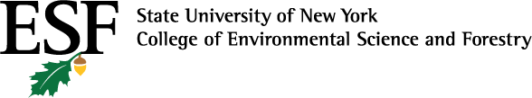

Email Id: Jrfran01@syr.edu
Any Comments:
Full Name: Jenny R. Frank
Current Affiliation (Hospital/University/Organization): SUNY ESF


Email Id: trbro100@esf.edu
Any Comments:
Full Name: Tristan R. Brown
Current Affiliation (Hospital/University/Organization): SUNY ESF
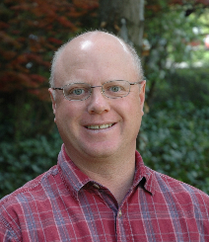
Email Id: rwmalmsh@esf.edu
Any Comments:
Full Name: Robert W. Malmsheimer
Current Affiliation (Hospital/University/Organization): SUNY ESF

