Abstract Title: Cytotoxic Effect and Upregulation of cfus and cjun in Human Cancer
Cells of Dungon-late (Heritiera littoralis) Fruit Extracts
Julie S. Berame, Nikko Lawsin, Kathlyn Jadloc

¹ Biology Department, Caraga State Universit, Philippines
²Biology Department, Siliman University, Philippines
³Polythecnic College, Philippines

Abstract

The study looked into the cytotoxic activity of a mangrove plant (Heritiera littoralis) against four (4) human cancer cell lines (THP-1, HCT-116, H69PR, and MCT-7). Cytotoxicity was determined using IC₅₀ and quantified using Presto Blue Assay. Cell lines that exhibit inhibition were further analyzed for early apoptotic gene expression using qRT-PCR. Results showed that the fruit extract has the cytotoxic effect on human colorectal carcinoma (HCT-116) IC₅₀ = 3.905 + 0.066, human small cell lung cancer (H69PR) IC₅₀ = 4.363 + 0.038 and human breast adenocarcinoma (MCF-7) IC₅₀ = 3.851 + 0.041 with no effect on Acute monocytic Leukemia (THP-1) and on normal cell lines. The study showed that the fruit extract has a bio-active material that inhibits cancer cell by upregulating pro-apoptotic genes, the cfos and cjun.

Keywords: Heriteria littoralis, HCT-116, H69PR, MCT-7, cytotoxicity, cfos and cjun expression

Professional Biography

Julie S. Berame is an Assist. Professor III at Caraga State University of the Biology/Science Education Department, Philippines. He received his MSciEd. in 2007 at Philippine Normal University and Ph.D. in Education at Father Saturnino Urios University in 2016 (Full Government Scholar) and his second Ph.D. in Science Education major in Biology (Full CHED Scholar) at De La Salle University, Manila. From 2016 up to present, he worked as an active researcher in social sciences in the universities. He has published more than 10 research papers in reputed international journals and indexed journals such as ISI, Scopus and others. He is also serving as eminent reviewer of many international journals.

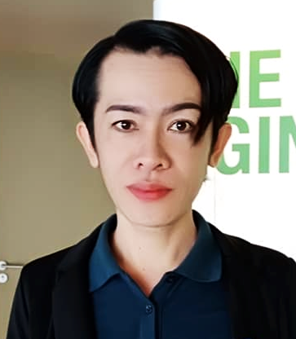

Email Id: Janveel@yahoo.com

Any Comments:

Dear Editor,
Good day!
Attached our newly conducted research paper on the cytotoxic effect and upregulation of cfus and cjun in human cancer cells of Dungon-late (Heritiera littoralis) fruit extracts. With this, we wanted to present the findings into international proceeding on your upcoming EuroSciCon Congress in Paris, France on August 2019, but due to an expensive costs of the proceedings and airfares, we would humbly request for funding of our paper to present on the said conference.
We know that the findings of our research may somehow contribute in the scientific community and for further studies this may contribute valuable findings and significance.
Thank you very much and God Bless!

Sincerely,

Julie S. Berame, PhD

