Abstract Template
Abstract Title: AHPD is an innovative biotechnology for direct biomethane production from wastewater; AHPD can be combined with AH₂PD for biotic CO₂ fixation with hydrogen in one single step green gas reactor.
Ir. C.E. Zagt

First Author Affiliation (Bareau BV, the Netherlands)

Abstract (not more than 300 words)

Autogenerative High Pressure Digestion (AHPD) generates 20 bar of biotic pressure in a closed vessel by anaerobic CH₄ and CO₂ production from organic waste, waste water and WWTP sludge. According to Henry’s law CO₂ will dissolve into the water phase, resulting in 90% of CH₄ in the production gas phase: green natural gas quality. The AHPD process specifically selects hydrogenotrophic methanogenic archaea, that will reduce the dissolved CO₂ by adding hydrogen: the so called AH₂PD process (“bio-Sabatier”). The AHPD/AH₂PD processes can easily and economically be combined in a continuous green gas production plant for waste water treatment. Therefore it can be used to stabilize the sustainable power grid, as hydrogen is produced from excess power. The existing natural gas grid will subsequently be used for large scale seasonal power storage, much more efficient than electrical batteries. AHPD/AH₂PD was intensively tested with a single stack large scale pilot plant in cooperation with several Dutch universities, waterboards and energy companies.

Keywords— Water treatment, biomethane, bio-Sabatier, power grid stabilization.

Professional Biography (100-150 words)

Ir. C.E. Zagt (MSc) has completed his MSc biotechnology at Wageningen University, the Netherlands. He is the director of Bareau Group, a R&D and green gas production organization. He has developed and brought into operation several innovative technologies for waste water treatment and sustainable energy production.

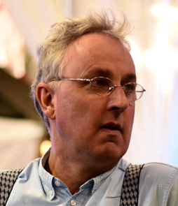
Email Id: kirsten.zagt@bareau.nl

Any Comments:

