Abstract Title: The role of the Environmental Sustainable solutions on Bioeconomics and Wellness of the planet.
Panagiotis S. Kollas (Bioeconomy Lab, University of Piraeus)

Abstract (not more than 300 words)

In our era the Climate Change is a Reality as a result huge catastrophes are happening with different forms (fires, tsunami, floods, etc). All of them lead the global society and the countries to take policies and reforms for protecting the environment and to design, develop and follow environmental sustainable solutions. Benefit Recycling, Composting, Energy efficiency is part of these solutions with major goal the reduction of CO2 and other emissions as a result to protect the biosphere and the planet worldwide. This process is the only way for creating a new economy, that is called bioeconomy where Human behaviour and the new habits of life will lead on the totally respect of the planet, and we will lead on the totally Wellness.

With the term Wellness of the planet we mean the absolutely harmony on the life of ALL in the planet and the succeed on the sustainable balance (Soil, Air, Oceans, Mammals, Human Beings, Animals, and other micro and macro organisms).

Keywords—bioeconomy, wellness, sustainability

Professional Biography (100-150 words)

Panagiotis Kollas is a new entrepreneur and a Scholar from the program SELECTUSA of the United States, through his participation to the Global Investment Summit of USA in 2015. Since then, he has founded the Global Corporation UNISCRAP PBC, a Public Benefit Corporation in the field of Environment.
As a Public Benefit Company, aims in the creation of Social, Environmental and Economic Impact, through innovation, investigation and growth in the USA, in matters of Resource Management. It is active in the United States and south-east Europe, with purpose to become a Global Company for young people, wherever they are in a united world without boundaries.

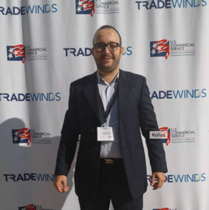
Paste your Photograph here

Email Id: p.kollas@uniscrap.co

Any Comments:

