Modelling the impact of hypoxia on endometriosis: a systematic literature review
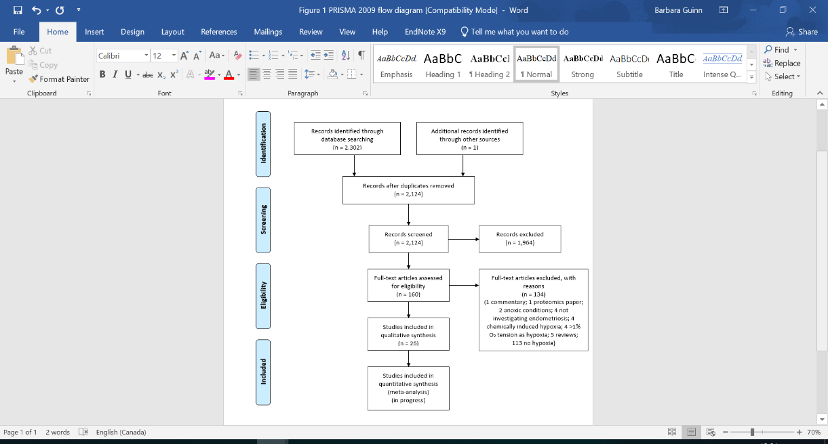
Ms Leah Cooksey, BSc, MSc, University of Hull, UK
Ms Réka Borbély, BSc, University of Hull, UK
Ms Damilola Oyinlola, BSc, University of Hull, UK
Mr Kevin Phillips, MB ChB, FRCOG, Hull University Teaching Hospitals NHS Trust, UK
Dr Barbara Guinn, BSc PhD FRSB, University of Hull, UK

Abstract
Statement of the Problem: Endometriosis is a condition characterised by ectopic stroma and endometrial glands present outside of the uterus (1). It is one of the most common conditions that affect women of reproductive age, with an estimated 1 in 10 affected worldwide. 30-50% of women diagnosed with infertility suffer from endometriosis and similarly high numbers suffer pain that impacts their physical, social or mental health (2). A growing body of research has shown the key role that hypoxia plays in the development of endometriosis (3). We wanted to identify biomarkers that would enable the earlier diagnosis of endometriosis and facilitate our understanding of how this difficult to diagnose and treat disease develops. Methodology & Theoretical Orientation: A systematic literature review (SLR) was performed using the terms “endometriosis AND hypoxia”. We identified primary observational studies that had investigated the effect of hypoxia ($≤$2% oxygen) on gene expression in healthy compared with diseased tissue (endometriosis). Searches of four/five databases (PubMed, CINAHL/Medline, Web of Science, Scopus) identified 2302 articles (Figure 1) that were screened against an inclusion criteria by two independent investigators. Findings: Of the 26 articles that met the inclusion criteria, 40 genes and their products showed differential expression in hypoxic conditions ($≤$2% oxygen) in diseased compared to healthy tissue. Conclusion & Significance: The SLR allowed the identification of a short list of genes and their products that were differentially expressed between endometriosis and healthy tissues in the presence of hypoxia. We will now compare this list of gene products to gene products that are differentially expressed between healthy and diseased tissue in the presence and absence of hypoxia in an in vitro model of early stage endometriosis. This will help to prioritise the gene products that can act as early biomarkers of endometriosis for further analysis.

Figure 1. Flow chart representing the steps performed in the systematic literature review (SLR). The SLR was performed in accordance with Preferred Reporting Items for Systematic Review (PRISMA) guidelines (4,5). Articles were identified through a search of four/five databases and articles that met the inclusion criteria led to the identification of 40 genes and proteins whose expression is altered in endometriosis when compared healthy tissue in the presence of hypoxia.

Publications
- Holt VL, Trabert, B, Upson, K. (2013) Chapter 18 - Endometriosis. Academic Press.
- Rogers PAW., D'Hooghe TM, Fazleabas A, et al (2009) Priorities for endometriosis research: Recommendations from an international consensus workshop. Reproductive Sciences (Thousand Oaks, Calif.), 16 (4), 335-346.
- Li W-N, Wu M-H, Tsai S-J. (2021) The role of hypoxia in the development and progression of endometriosis. Reproduction. 161: 1.
- Moher D, Shamseer L, Clarke M, et al. (2015) Preferred Reporting Items for Systematic Review and Meta-Analysis Protocols (PRISMA-P) 2015 statement. Syst Rev. 4(1):1
- Shamseer L, Moher D, Clarke M, … the PRISMA-P Group. (2015)Preferred Reporting Items for Systematic Review and Meta-Analysis Protocols (PRISMA-P) 2015: elaboration and explanation. BMJ 2015.349:g7647


Biography
This Photo by Unknown Author is licensed under CC BY
Dr Barbara Guinn has worked on the identification of antigens as targets for therapy, biomarkers of disease state, stage and survival, and to enable the better understanding of the biological basis of disease for more than 20 years. Through the use of a wide range of techniques, including those based in molecular, immunological and proteomic strategies, her group have been able to identify biomarkers in a range of difficult to treat and poorly understood diseases. Her work has led to the repurposing of drugs for new patient groups and the development of new vaccine strategies for rare and difficult to treat diseases. The identification of biomarkers that facilitate a better understanding of the disease processes (both at the molecular and protein level) and earlier diagnosis will benefit patients by facilitating the application of the correct treatment when it can be most effective. More details about the work of the Guinn Lab can be found through @GuinnLab or through https://www.hull.ac.uk/staff-directory/barbara-guinn
Email: B.Guinn@hull.ac.uk

Notes/Comments:

