Stem cells tools to counterbalance immunoinflammatory changes in autism spectrum disorders
Dario Siniscalco, Anna Lisa Brigida, Nicola Antonucci

¹Department of Experimental Medicine, University of Campania, Naples, Italy
²Italian Group for Studying Autism, Brescia, Italy
³Biomedical Centre for Autism Research and Treatment, Bari, Italy

Abstract (not more than 300 words)

Autism spectrum disorders (ASD) are characterized by persistent deficits in social communication and interaction, and restricted, repetitive patterns of behavior, interests, or activities. The core symptoms of ASD concern the cognitive, emotional, and neurobehavioural domains.
These disorders are complex, severe heterogeneous neurodevelopmental pathologies with well characterized immune system abnormalities. Complex genetic/epigenetic and environmental interactions contribute to ASD pathogenesis. Autism is characterized by immune system dysregulation and inflammatory conditions. This alteration includes differential monocyte and macrophage responses, changes in gene expression levels. Recently, several studies highlight a key involvement of complex macromolecular systems in autism pathophysiology, i.e. endocannabinoid and caspase systems.
Nowadays, cell therapies have been proposed and applied to ASD. Several stem cell types have been proposed in restoring immune imbalance. At least three key-action mechanisms of stem cells could be useful for ASD therapy: paracrine effect (the secretome tool: cytokines, chemokines, and growth factors released by stem cells and responsible of repair/restoration of injured tissues); immunomodulatory properties; cell-to-cell contact activation mechanism, by which stem cells are able to switch proinflammatory cells to anti-inflammatory ones. Preclinical studies highlight potential benefit and important advances for the use of cellular therapy in ASD. Several clinical trials have been performed to demonstrate safety and efficacy of stem cells in ASD.

Keywords—autism spectrum disorder, gene expression, monocytes, stem cells.

Professional Biography (100-150 words)

Dr. Dario Siniscalco is biochemist for the Department of Experimental Medicine of the University of Campania, Italy. He graduated in Chemistry from the University of Naples “Federico II” in 2000 and received his Ph.D. in Pharmacological Sciences from the Second University of Naples in 2004. He completed his neuropathology fellowship at University of Alabama at Birmingham, USA before joining the Second University of Naples staff in 2006. He is registered member of the following scientific societies: Order of the Chemists of Campania, National Council for Chemistry, International Association of Neurorestoratology, Italian Pharmacological Society. He is one of the founder of Stem Cell Research Italy association.

In 2010, in collaboration with dr. Nicola Antonucci, he founded a research group to study cellular and molecular changes in autism spectrum disorders. Author or co-author of 95 scientific peer-reviewed papers and 12 book chapters. His works received more than 2200 citations so far (h-index 30). Presented 95 communications/abstracts to national and international conferences. He is serving as an editorial board member and reviewer of more than 75 international journals.

His main research interests: gene expression and molecular regulation in autism spectrum disorders; use of stem cells as therapeutic tool in autism; role of monocyte/macrophage activation in autism.
Full publication list is here: http://orcid.org/0000-0002-3779-2596

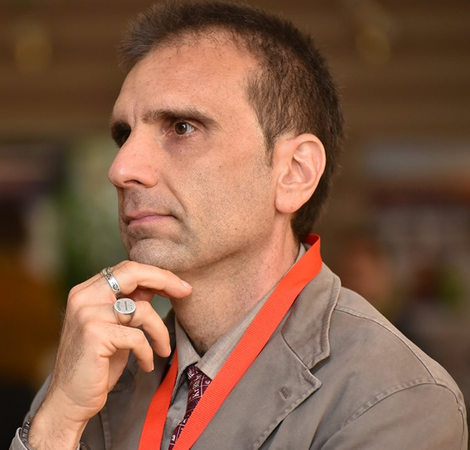
Paste your Photograph here

Email Id:

Any Comments:

