Mammoths, Deer, and a Dog: Fossil and (Sub) Recent Allochthonous Remains from the Northeastern Croatia (Podravina Region), with the First Radiocarbon Dating of the Croatian Woolly Mammoths (Mammuthus primigenius)
Jadranka Mauch Lenardić, Institute for Quaternary Paleontology and Geology, Croatian Academy of Sciences and Arts
Siniša Radović, Institute for Quaternary Paleontology and Geology, Croatian Academy of Sciences and Arts
Ankica Oros Sršen, Institute for Quaternary Paleontology and Geology, Croatian Academy of Sciences and Arts
Nada Horvatinčić, Division of Experimental Physics, Laboratory for Low-level Radioactivities, Ruđer Bošković Institute,
Petar Kostešić, Clinic for surgery, orthopaedics and ophthalmology, Faculty of Veterinary Medicine, University of Zagreb
Vladimir Bermanec, Department of Geology, Division of Mineralogy and Petrology, Faculty of Science, University of Zagreb
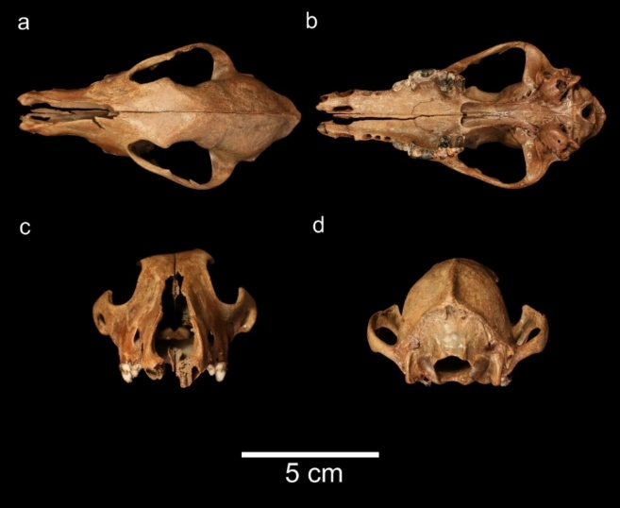
Figure. Canis familiaris skull from the Sekuline site: (a) dorsal, (b) basal, (c) anterior, (d) nuchal view
Abstract: Eight anatomically and taxonomically different finds are presented in this paper, and they belong to four taxa: woolly mammoth (Mammuthus primigenius), giant deer (Megaloceros giganteus), red deer (Cervus elaphus), and dog (Canis familiaris). All specimens represent allochthonous Late Pleistocene and Holocene animal remains, and all were dredged during the gravel exploitation at the Sekuline site near Molve (Podravina region, SW Pannonian basin, NE Croatia). Mammoth remains (bone and tusk fragments) were radiocarbon dated, and these are the first absolute dates on mammoths in Croatia. One upper last left deciduous premolar (dP4 sin.) also belongs to the same species. Ascribed to a dog is one well-preserved skull with a peculiar abscess scar on the maxillary bone as the result of an inflammatory process on the carnassial (P4) premolar. The Late Pleistocene cervid remains are giant deer, while the other cervid finds were determined to be red deer of the Holocene age. Morphometrical and taphonomical data are presented for each specimen. Such fossil and recent bone/tooth aggregates are characteristic of fluvial deposits and selective collecting. Although lacking stratigraphic provenance, these finds help to fulfil the gaps in palaeoenvironmental, palaeoecological, and palaeoclimate reconstructions of Podravina and its neighbouring areas.

Recent publications:
1. Mauch Lenardić, J. Miocene to Late Pleistocene proboscideans of Croatia. Quat. Int. 2012, 276–277, 120–128.
2. Mauch Lenardić, J.; Oros Sršen, A.; Radović, S. Quaternary fauna of the Eastern Adriatic (Croatia) with the special review on the Late Pleistocene sites. Quat. Int. 2017, in press.
3. Lister, A.M.; Edwards, C.J.; Nock, D.A.W.; Bunce, M.; van Pijlen, I.A.; Bradley, D.G.; Thomas, M.G.; Barnes, I. The phylogenetic position of the “giant deer” Megaloceros giganteus. Nature 2005
4. Mihelić, D.; Pavić, M.; Hincak, Z. A Craniometrical Analysis of the Early Bronze Age Dogs from Vučedol Site (East Slavonia, Croatia). Coll. Antropol. 2013, 37, 239–244.
5. Germonpré, M.; Fedorov, S.; Danilov, P.; Galeta, P.; Jimenez, E.-L.; Sablin, M.; Losey, R.J. Palaeolithic and prehistoric dogs and Pleistocene wolves from Yakutia: Identification of isolated skulls. J. Archaeol. Sci. 2017

Jadranka Mauch Lenardić is a paleontologist and works at the Institute for Quaternary paleontology and geology of the Croatian Academy of Sciences and Arts in Zagreb. For many years her main research topics are proboscideans (mammoths, elephants) and small mammals, especially voles, from numerous Pleistocene Croatian localities. The basis of such researches are different morphometrical analyses of skeletal, mostly dental fossil remains. Jadranka investigates paleoecological, paleobiogeographical, microevolutional and other relationships of these animal groups. She published 50 scientific and professional papers in domestic and foreign journals, and presented her results on more than 30 scientific meetings.

