Outcomes of Total Hip Arthroplasty in Patients with Sickle Cell Disease: A Retrospective Single-Center Study

Authors
Ohood Al Rawahi, MD¹*;Mohammed Al Habsi, MD²;Osama Al Sinani, MD²;Humaid Al Farii, MD³;Mohammed Al Mutani, MD⁴;Sultan Al Maskari, MD⁵
*Corresponding author

Background:
Total hip arthroplasty (THA) in patients with sickle cell disease (SCD) presents unique surgical and perioperative challenges and has historically been associated with increased complication rates. With advances in implant design and perioperative optimization, contemporary outcome data are needed. This study evaluates clinical characteristics, perioperative management, and functional outcomes of THA in SCD patients treated at a tertiary referral center in Oman.
Methods:
A retrospective analysis was performed of all SCD patients who underwent THA at Sultan Qaboos University Hospital between January 2009 and December 2024. A total of 107 patients (109 hips), including two bilateral cases, were identified. Data collected included demographics, surgical approach, implant fixation and bearing surface, preoperative hemoglobin S (HbS%) levels, and transfusion strategy. Functional outcomes were assessed using the Harris Hip Score (HHS) and Oxford Hip Score (OHS). Minimum follow-up was six months.
Results:
Of the 109 hips, 96 were primary THA procedures. The cohort included 107 Omani patients, with a female predominance (51.4%). Patient age ranged from 16 to 69 years. The posterior approach was most frequently utilized. Preoperative exchange transfusion was performed in approximately 75 patients according to hematology recommendations, while selected patients with hemoglobin levels below 8 g/dL received simple transfusion. Mean preoperative HbS% was 60.1%. Most procedures were non-cemented THAs (92 hips), with ceramic-on-ceramic bearing surfaces used in 74 cases. Reported postoperative complications included wound-related issues, acute chest syndrome, periprosthetic fracture, thromboembolic events, limb length discrepancy, and sciatic nerve neuropathy. Mean postoperative HHS was 90.43, and mean OHS was 41.36.
Conclusion:
THA in patients with sickle cell disease can achieve excellent functional outcomes when performed in a specialized center. The use of contemporary implants combined with individualized, hematology-guided perioperative optimization allows safe and effective management of this high-risk population.
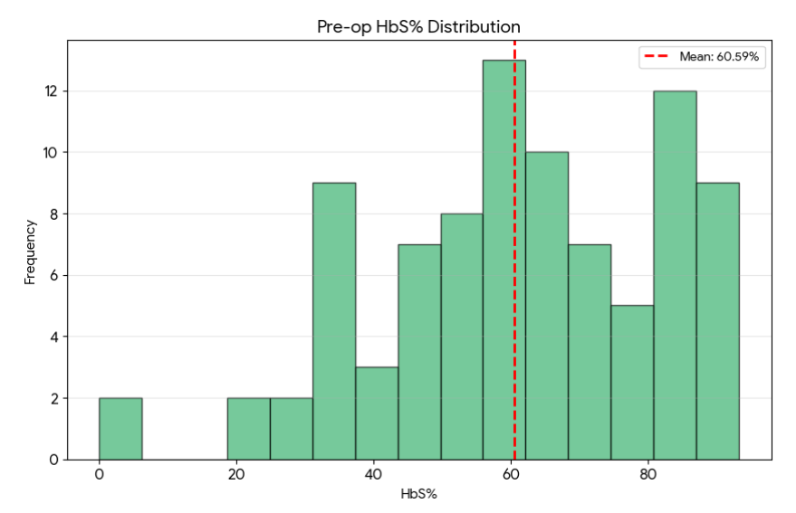

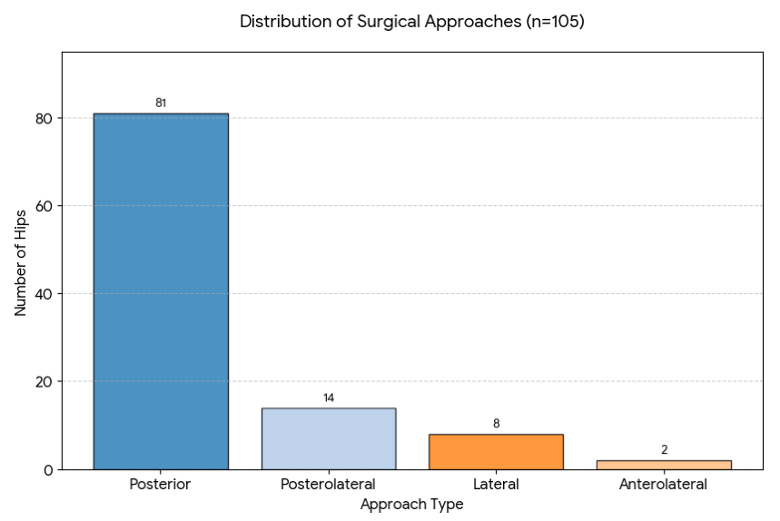

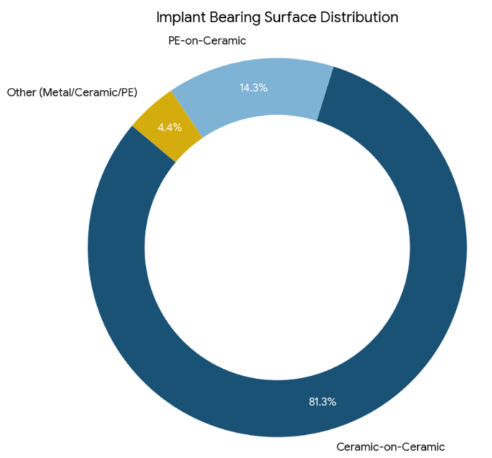

References
- Kenanidis E, Kapriniotis K, Anagnostis P, et al. Total hip arthroplasty in sickle cell disease: a systematic review. EFORT Open Rev. 2020;5:180–188.
- Fassihi SC, Lee R, Quan T, et al. Total hip arthroplasty in patients with sickle cell disease: a comprehensive systematic review. J Arthroplasty. 2020;35:2286–2295.
- Mohabey A, Joseph FK, DeJoseph J, et al. Total hip arthroplasty in sickle cell disease: a systematic review and meta-analysis of functional outcomes and complications. J Clin Orthop Trauma. 2025.
- Alfaya FF, Ghazy RM, Hammouda EA, et al. Complications of total hip arthroplasty in sickle cell disease: a systematic review and meta-analysis. J Clin Med. 2024;13:4129.
- AlOmran AS. Survival of total hip arthroplasty in patients with sickle cell disease. Arch Orthop Trauma Surg.2023;143:7213–72

Affiliations
¹ Orthopaedic Surgery Residency Program, Oman Medical Specialty Board (OMSB), Muscat, Oman
² College of Medicine and Health Sciences, Sultan Qaboos University, Muscat, Oman
³ Department of Orthopaedics (Spine and Oncology), Sultan Qaboos University Hospital, Muscat, Oman
⁴ Division of Arthroplasty, Department of Orthopaedics, Sultan Qaboos University Hospital, Muscat, Oman
⁵ Department of Orthopaedics (Arthroplasty), Al Hayat International Hospital, Muscat, Oman

Photograph



Biography
Ohood AL Rawahi is PGY-4 orthopaedic surgery resident at the Oman Medical Specialty Board, Muscat, Oman. She obtained her medical degree from the National University of Science and Technology and She is currently undergoing postgraduate training in orthopaedic surgery. Her academic and clinical interests focus on adult reconstruction,particularly hip arthroplasty, and outcomes research in complex patient populations She is activelyinvolved in clinical research and audit related to arthroplasty and multidisciplinary perioperative optimization.

