Simultaneous bilateral total knee arthroplasty is cardinally important in patients with severe varus knees
Dr Rashid Ganji, MD, Mashhad, Iran

Abstract (300 word limit)
There is controversy regarding whether it is more advantageous to perform simultaneous bilateral total knee arthroplasty (SBTKA) or staged TKAs. On the one hand, SBTKA has advantages such as better recovery, shorter hospital stay, less costs, and requiring anesthesia once. On the other hand, some surgeons believe that SBTKA has a higher chance of complications (e.g. mortality, cardiovascular morbidity, etc.) and mandates careful patient selection.
An important yet neglected point in this regard is that patients with severe bilateral deformity who have balanced gait should be exclusively treated with SBTKA. Staged TKA approach in such patients might result in an imbalanced gait and more difficulty walking, which in turn leads to further complications, i.e. falling, hip fractures, and peri-prosthetic fractures. Moreover, patients put more pressure and weight on the operated knee, which reduces the longevity of prosthesis.
Performing unilateral TKA and postponing the other side for later stages would reduce the patient satisfaction and might end in abandoning the treatment and forgoing the second TKA. This often results in aggravated osteoarthritis in the non-operated knee and complications like loosening in the operated one.
Overall, 672 patients were operated, of whom 86.7% were female. The mean age was 66.78±7.21 years. Of 672 patients, 63 (36.62%) had bilateral severe (>15 deg) deformity and were operated bilaterally. Unilateral TKA was done in 156 (25.63%) patients, among whom 54 (34.6%) needed TKA for both sides according to physical exam and imaging. However, only 15 (27.7%) referred for the second TKA in the following 2 years.
In conclusion, it seems necessary to perform SBTKA in patients with severe deformities as stated above, even if the patients are high-risk. If there is no possibility of SBTKA, it might be better to reconsider performing TKA than to perform staged unilateral TKA in patients suffering from such deformities.

Image

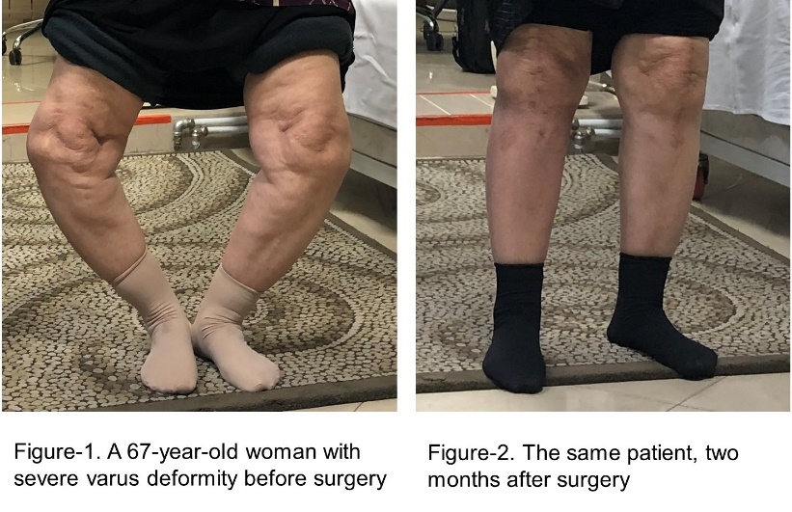
Recent Publications
Ebrahimzadeh MH, Vahedi E, Ganji R, Bozorgnia S. Skeletal sarcoma on the site of retained war bullet fragments and a literature review on long-term complications of retained war shells. Archives of Bone and Joint Surgery. 2013 Dec;1(2):107.

Photograph

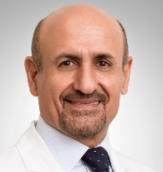
Biography
Accomplished and result driven Orthopedic Surgeon, Dr. Rashid Ganji, with 21+ years of experience diagnosing patients and performing orthopedic surgeries, providing the best services and contributing to the speedy recovery of the patients. Extensive knowledge of various diseases and injuries commonly affecting the musculoskeletal systems, providing cutting-edge diagnosis, and implementing adequate treatments techniques; and stay up-to-date on the latest techniques and technologies in the field of total knee replacement. Utilizing compassionate demeanor and personable approach to consider patient needs and comfort level during diagnosis, treatment, surgeries, and works to ensure they have the best possible experience. Highly organized and motivated, with a renowned ability to motivate, inspire, and provide direction to staff members for an efficient and smooth running team. Well-versed in the laws and ethics guiding the field of medicine and surgery, and adhere strictly to all established surgical techniques and procedures during operations.
Email: r.ganjimd@gmail.com

Notes/Comments:

