Augmentation compression plating with bone grafting in aseptic non union
shaft femur with nail in situ: a study of 20 cases
Dr Amit Lakhani, MS orthopaedics
Dr Ena Sharma, MDS
Dr R S Boparai, MS orthopaedics
Dr Shashi Mohan Bhatnagar MS orthopedics
Department of Orthopaedics, Maharishi markandeshwar Medical College & Hospital, India

Objective: Nonunion of shaft femur is a common complication. Augmentation plating with retained nail is a novel method to
treat these cases.

Method: Twenty patients(18 male and two female) of mean age 37.5 years were treated by this method.

Results: Union was achieved in all cases mean 7 months.
Conclusion: Augmentation plating with retained nail is an ideal treatment option for aseptic non union shaft femur as this procedure requires less operative time and less blood loss as compare to exchange nailing. Patients are able to bear weight due to retained nail and plating helps to achieve compression at fracture site .
Image
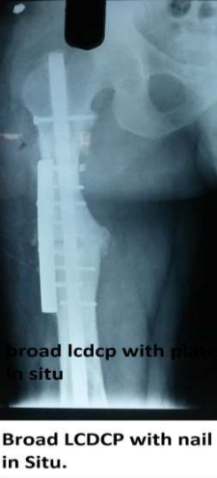
Recent Publications (minimum 5)
1.Dimitriou, R., Jones, E., McGonagle, D., and Giannoudis,
P.V. Bone regeneration: current concepts and future directions. BMC Med. 2011; 9: 66

2.. Salih S1, Blakey C, Chan D2, McGregor-Riley JC2, Royston
SL2, Gowlett S3, Moore D3, Dennison MG4. The callusfracture sign: a radiological predictor of progression to hypertrophic non-union in diaphyseal tibial fracturesStrategies Trauma Limb Reconstr. 2015 Nov;10(3):149-53. doi:
10.1007/s11751-015-0238-y. Epub 2015 Nov 24.

3. Steinhausen E, Glombitza M, Böhm HJ, Hax PM, Rixen D. Nonunions.
From diagnosis to healing. Unfallchirurg. 2013 Jul;116(7):633-47; quiz 648-9. doi: 10.1007/s00113-013-2413-2.

4. Slette EL1, Mikula JD1, Turnbull TL1, Hackett TR2. Treatment of Midshaft Clavicle Fractures: Application of Local Autograft With Concurrent Plate Fixation. Arthrosc Tech. 2016 May 30;5(3):e557-62. doi: 10.1016/j.eats.2016.02.008. eCollection 2016.

5. Gross JB1, Diligent J1, Bensoussan D2, Galois L1, Stoltz JF2, Mainard DPercutaneous autologous bone marrow injection for treatment of delayed and non-union of long bone: a retrospective study of 45 cases. Biomed Mater Eng. 2015;25(1Suppl):187.
Photograph

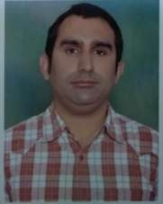

Dr Amit lakhani ( MS orthopaedics, FAGE ), Professor in MMMCH, Solan having 8 years plus experience of teaching undergraduate and post graduate , has done more than 800 arthoplasties and 1000 arthroscopies with his eminent hardwork and sincerity. Attended various national and international conferences,Workshops. Has been selected for scholarships on international platform by EUROSPINE ( Orthoregeneration) at Finland and ESSKA ( Orthoregeneration of spine ) at Spain. Has been invited many times by GOVT of INDIA on various programme like “Able the Disable “, “Handling geriatric orthopaedics patients”. Main area of interest is Sports Medicine and arthroscopy. Has been in Editorial board panel in various international journals. Though working in rural set of himachal Pradesh his aim is to provide best patient care to the people of himachal and other rural areas with his new and intricate surgical and non surgical techniques.

Email: dramitlakhani@gmail.com

Notes/Comments:

