Revision Of Unicompartmental To Total Knee Arthroplasty Using Robotic Technology.
Dr. Charles Wallace, MRCS, University College Hospital London
Dr. Peter Moriarty, MRCS, University College Hospital London

Abstract (300 word limit)
Background
Robotic arm assisted total knee arthroplasty (TKA) is associated with improved accuracy of achieving the planned femoral and tibial implant positioning, joint line restoration, limb alignment, and posterior tibial slope compared with conventional jig-based TKA. Conversion of a unicompartmental knee arthroplasty (UKA) to TKA can potentially be challenging due to the bone loss involved. This often requires an augment on the medial side to ensure restoration of the joint line to the primary level. We report a technique using robotic arm assisted surgery to revise uni-compartmental knee arthroplasty to total knee arthroplasty. This has not been presented in meetings to date.
Case Presentation
We present 4 cases where medial UKA were converted to TKA.
In order to register the patient's’ anatomy intra – operatively, an accurate bony model is generated from a CT scan. The CT-scan is taken according to a specific CT-protocol which yields a very accurate 3D reconstruction of the knee.
Bone registration was performed by mapping osseous landmarks displayed on the computer screen to verify the anatomy and establish the bony geometry with the UKA implant in-situ. Intraoperative kinematic data were used to further fine-tune bone resection and implant positioning using the robotic computer software. An intraoperative surgeon-controlled robotic arm (Mako Surgical, Kalamazoo, Michigan) with visual, tactile, and audio feedback was then used to execute the planned femoral and tibial bone resections.
Clinical Outcomes
Using robotic-arm technology in revision knee surgery has improved the accuracy of implant positioning, ligament balance and coronal limb alignment. It also has the added benefit of taking less bone off both the tibial and the femoral surfaces, as the software measures bone cuts extremely accurately and does not use the uni-compartmental implant as part of its calculations. This has resulted in no augments being required for these revision cases.
Discussion
We report a novel method using robotic-arm technology in three patients to revise a UKA to a TKA. We have found that we can achieve a more accurate, well-balanced knee revision with the use of robotic technology. As robotic technology continues to grow in knee revision surgery, we believe many will find it superior to conventional knee revision surgery.

Image

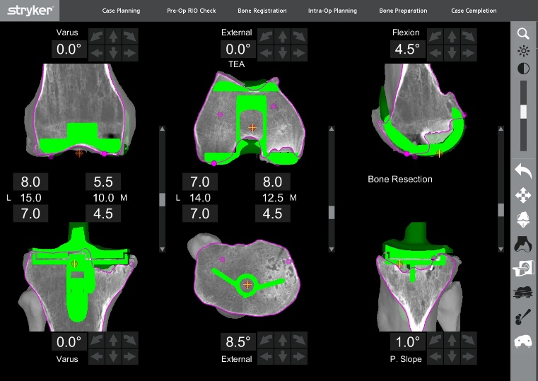

Recent Publications (minimum 5)
- Babar Kayani et. al (2019), Posterior cruciate ligament resection in total knee arthroplasty: the effect on flexion-extension gaps, mediolateral laxity, and fixed flexion deformity, The Bone & Joint Journal
- S. Konan et. al (2018), Robotic-arm assisted total knee arthroplasty is associated with improved early functional recovery and reduced time to hospital discharge compared with conventional jig-based total knee arthroplasty: a prospective cohort study, The Bone & Joint Journal
- F.S. Haddad (2018), The learning curve associated with robotic-arm assisted unicompartmental knee arthroplasty: a prospective cohort study, The Bone & Joint Journal

- Malkani AL, et. al (2019), New Technology for Total Knee Arthroplasty Provides Excellent Patient-Reported Outcomes: A Minimum Two-Year Analysis. Surg Technol Int
- Sires JD, Craik JD, Wilson CJ (2019) Accuracy of Bone Resection in MAKO Total Knee Robotic-Assisted Surgery. J Knee Surg

Biography (150 word limit)
Mr. Wallace currently works at the University College Hospital London, as a Specialist Registrar in Trauma and Orthopedics. He is dedicated to both further Orthopaedic research and quality improvement projects and being a part of NHS Improvement. Email: charlesnwallace@gmail.com

Notes/Comments:

