Total hip arthroplasty with cortical bone grafting for neck of femur fracture in fibrous dysplasia.
Dr. Lim WK, Dr. Selvanathan N, Dr. Azhar M, Dr. Nor Saadah K, Dr. Fauzey A, Dr. Chopra S, Malaysia.
Abstract
Fibrous dysplasia interferes with normal development and constitution of bones, resulting in weakened structural support and poor healing. Healing potential is poor when femoral neck fractures in such a setting are treated conservatively. We performed hybrid total hip arthroplasty using a cemented stem for a40 year old patient, with no prior diagnosis or treatment for his monostotic fibrous dysplasia. Challenges faced intra-operatively include a thin bone cortexand deformedanatomy. Total hip replacement was performed with cortical bone grafting for an iatrogenic cortical perforation. The synergistic effect of this treatment modality yielded satisfactory result, asthe patient was able to regain ambulation and return to work potential.
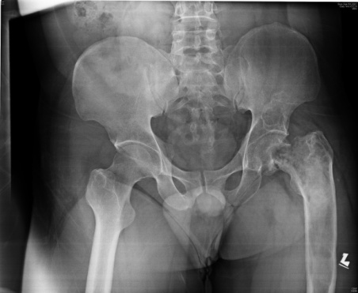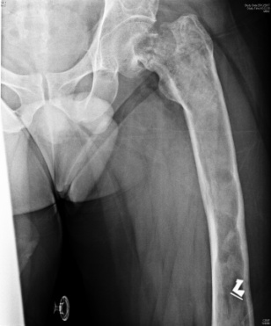
Image 2
Image 1
Image 1 and 2 shows the pre-operative x-ray, showing neck of femur fracture with shepherd crook deformity

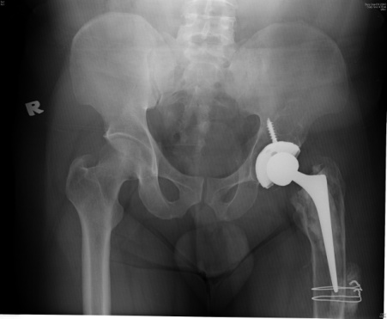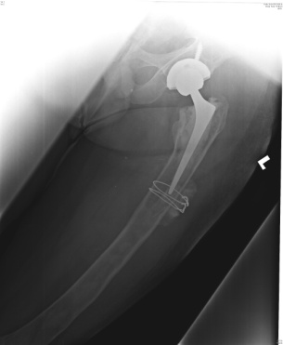
Image 3 and 4 shows post-operative x-ray of patient after Total Hip Arthroplasty. Cerclage wires are holding bone grafts in place
Image 4
Image 3

References
1. Tsuchiya H, et al. Shepherd's crook deformity with an intracapsular femoral neck fracture in fibrous dysplasia. ClinOrthopRelat Res. 1995 Jan;(310):160-4.
2. Amaravati RS, et al. Fracture neck of femur with avascular necrosis of head in fibrous dysplasia. Indian J Orthop 2004;38:134-6.
3. Sierra RJ, et al. Total hip arthroplasty in patients with underlying fibrous dysplasia. Orthopedics. 2009 May;32(5):320.

4. Schwartsmann CR, et al. Dynamic Hip Screw for the Treatment of Femoral Neck Fractures: A Prospective Study with 96 Patients. ISRN Orthop. 2014; 2014: 257871.
5. Dicaprio MR, et al. Fibrous dysplasia. Pathophysiology, evaluation and treatment.J Bone Joint Surg Am. 2005 Aug;87(8):1848-64.

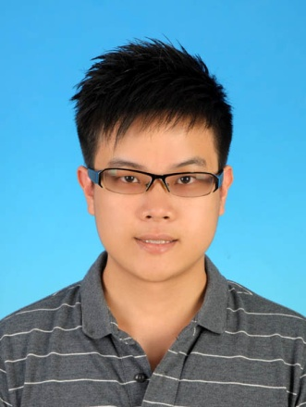
Dr. Lim and team operates the arthroplasty center of northern Malaysia, taking in referrals across the region. The team pay the highest dedication and interest towards arthroplasty, and keeps the patients' outcome and interests at heart. Treatments were designed and catered to each individual patient's needs, intended for symptomatic relief and regain of ambulatory function at soonest possible.

