3D printing porous tantalum metal module for treatment of DDH

Dewei Zhao, Liangliang Cheng, Benjie Wang, et al. Affiliated Zhongshan Hospital of Dalian University

Objective: To explore a new type of individualized treatment technical process to repair acetabulum defect of developmental dysplasia of the hip (DDH) with 3D printing porous tantalum metal module, and to evaluate the early clinical outcome of patients.
Methods: CT scanning were performed on the DDH patients’ hip, constructed the three-dimensional model by MIMICS and 3-MATIC software, and extracted the acetabulum model and femur model respectively; constructed the three-dimensional model for the acetabulum defect reversely, adopted the materialise magics software to make the porosity-oriented and optimized process for the model; made the finite-element analysis on the acetabulum model with ANSYS software to guarantee the uniform distribution of the joint stress after repair; printed the porous titanium module for the designed three-dimensional model of the acetabulum defect by rapid prototyping, and made the metal spraying of tantalum; done the operation with the personalized acetabulum module and evaluated the clinical follow-up.
Results: The porous metal module produced by 3D printing technology could match with the hip joint of patients optimally and thus achieved primary stability; the clinical follow-up showed: patients’ pain was relieved significantly; the function of joints was improved significantly; the implanted prosthesis did not loose and the bone in-growth in the model prosthesis was found according to the radiological evaluation. Conclusion: The 3D-printing porous tantalum metal module shows good clinical effect for the treatment of DDH patients. Personalized acetabulum module matches with the hip joint of patients greatly, which effectively improves the coverage of acetabulum for the femur head and avoids the traditional periacetabular osteotomy; meanwhile, the porous structural design and the tantalum metal coating is beneficial for the in-


Dewei Zhao, MD, Professor, president of Affiliated Zhongshan Hospital of Dalian University, president of Chinese Association of Microsurgery Surgeons. He dedicates in the treatment of osteonecrosis of femoral head (ONFH) for nearly three decades. Based on anatomical and clinical study, he has made original series surgical techniques for reconstruction of the necrotic femoral head, and these techniques can be applied in every stage of ONFH. He is the editor of 9 academic journals. He has published more than 200 papers in basic and clinical research of ONFH, the new finding of cihrculation of femoral head, new metal biomaterials and their clinical application. His work especially important for younger patients with symptomatic ONFH.
Email:zhaodewei2016@163.com; zhaodewei2000@163.com

growth of bone in the metal module, which enhances the long-term stability.
Image
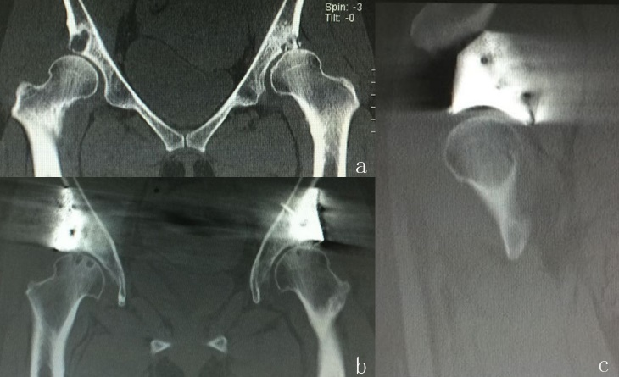
Figure 1: The DDH patient’s preoperative coronal image of CT scanning; b. the coronal image of CT scanning after operation; c.the sagittal image of CT scanning after operation.
Recent Publications
- Zhao D, Qiu X, Wang B, et al. Epiphyseal arterial network and inferior retinacular artery seem critical to femoral head perfusion in adults with femoral neck fractures.Clin Orthop Relat Res. 2017 Mar 17.
- Kamada T, Mashima N, Nakashima Y, et al.Mid-term clinical and radiographic outcomes of porous tantalum modular acetabular components for hip dysplasia. J Arthroplasty. 2015 Apr;30(4):607-10.
- Paton RW.Screening in Developmental Dysplasia of the Hip (DDH).Surgeon. 2017 Jun 12.
- Clohisy JC. Developmental Dysplasia of the Hip: Contemporary Concepts and Treatment Innovations. J Arthroplasty. 2017 May 19.
- Tarpada SP, Girdler SJ, Morris MT.Developmental dysplasia of the hip: a history of innovation.J Pediatr Orthop B. 2017 May 19.

