SECONDARY PATELLAR RESURFACING FOLLOWING TOTAL KNEE ARTHROPLASTY

PREFACE: The dilemma whether to resurface the patella during TKA is still controversial. Routine patellar resurfacing during the procedure continues to be debated on. In order to solve this question weather to resurface or not - the term: "selective resurfacing" was fabricated. But how should we decide whom is prone for AKP –and should go through SPR? The goal of our study was to analyze the results of SPR procedures indicated by patellofemoral syndrome, and find common denominators to predict those patients prone for AKP.

PATIENTS & METHODS: Between January 2000 and January 2012, 1,776 primary TKA procedures were performed in our institute. We retrospectively evaluated the clinical records of 33 patients subjected to a SPR.
Based on the modified Ranawat scale, patients were asked to assess their satisfaction from the procedure & AKS scoring. Radiographically, We have checked & measured the joint line, insall-salvati ratio, lateral patellar tilt, congruence angle and patellar thickness.(see FIGURE I)

RESULTS: All 25 patients from the satisfied and the partially satisfied groups showed overall improvement of both components of the AKS score after SPR.
We have found excellent correlation between the subjective patient reports post operatively - to both clinical & functional changes. range of motion - None of the patients showed a decrease in their post op range of motion.
The mean improvement was 11.6° degrees. Additionally, we have found that there is preference to older age & correlation to BMI. (see FIGURE II + III)

CONCLUSIONS: Patellar resurfacing was the final procedure in the majority of patients. Patient satisfaction was limited following the procedure but further surgery did not appear to be needed. After comprehensive investigation & analysis of clinical, radiological & Demographic data, based on our results & supported by the literature
patellar resurfacing is a viable option for resolving knee pain after TKR.

FIGURE I
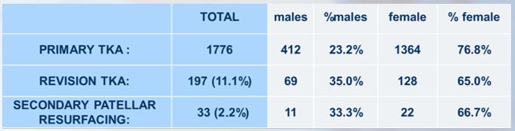

FIGURE II
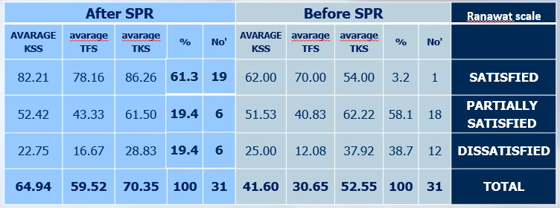

FIGURE III
