Type III open metacarpal shaft fracture with segmental bone loss: Usage of iliac crest bone grafting as a viable reconstructive option – A case report

José Miguel Costa, Andréia Moreira, João Quelhas, José Machado, Pedro Mendes Santos, Patrícia Martins, Ricardo Vila Real, Unidade Local de Saúde de Matosinhos, Hospital Pedro Hispano, Matosinhos, Porto, PortugalUnidade Local de Saúde de Matosinhos, Hospital Pedro Hispano, Porto, Portugal

Abstract

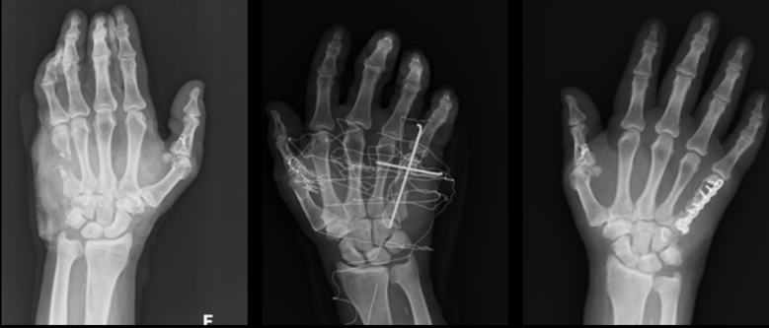
Problem Statement: Open metacarpal fractures can be associated with segmental bone loss, particularly those produced by traumatic events with mechanical cutting devices. We present a case of a Type III open metacarpal shaft fracture with segmental bone loss caused by an electric circular saw. Zone IV injury of the medial dorsal aspect of the left hand with severe soft tissue defects were evident during initial evaluation. The first stage surgical procedure revealed a complete section of the extensor digiti minimi (EDM) and of the radial artery associated with an open fracture of the fifth metacarpal. Radiographs showed a highly comminuted fracture of the fifth metacarpal associated with segmental bone loss. Due to high risk of infection and lack of soft tissue viability, radical debridement and fracture fixation with K-wire was done in order to preserve the metacarpal length. Three weeks later, as a second stage procedure, autologous iliac crest corticocancellous bone graft was harvested and was included in the open reduction and internal fixation of the fifth metacarpal bone defect using a compression plate. Tenodesis of the EDM to the extensor digitorum communis (EDC) was also done. Six months later, callus formation was observed in a follow-up CT scan and the patient revealed limited fifth finger flexion with maintained strength, exhibiting no limitations in his daily activities. Conclusion & Significance: In complex metacarpal fractures with segmental bone loss, early bone grafting and internal fixation are crucial for restoring the normal integrity of the skeleton. Overall intrinsic muscle function is preserved, promoting better outcomes of active range of motion, grip strength and decreased morbidity often associated with these devastating injuries. This type of fracture can raise questions about the indications and treatment options available, when is the best time for bone grafting and what are the complications of iliac bone grafting for metacarpal defects.
Image

Photograph

Biography (150 word limit)
I’m a first-year orthopedic resident in Unidade Local de Saúde in Matosinhos, Porto, Portugal with interest in Orthopaedic Traumatology, specially in hand trauma.
Email: josemiguelssacosta@gmail.com

Notes/Comments:

