Contemporary Archaeology

Stefano Rossi
(Aion Cultura – Cortona MAEC, Italy)

In 2014 I proposed to start a project of a new approach to archeology and stratigraphical excavation as a research method in Cortona (AR) thanks to experimental and simulative archaeology.
The idea is to understand if it is possible to investigate our contemporary society through material culture and our methods of study like stratigraphical research and excavation.
If, during an excavation, we can find a context of objects in different raw materials, and these ones show us a general reading of the circumstances why those findings are in such environment, we are in the right direction. And of course we the chance to know that context in advance because it is contemporary and therefore already acquired by direct knowledge. Then we can directly check the veracity of the conclusions of our archaeological research.
The same if we collect a series of objects of the same category and make a classification of them in a typological catalog, will they tell us the truth?
Moreover, this “experiment” would finally confirm the scientific nature of archaeological research.
Finally in 2018, to achieve this test we have set up at Parco archeologico del Sodo in Cortona (AR) an experimental archaelogical field where to dig contemporary layers. A first group used some students of secondary school involved in a simulated excavation lesson, to verify which kind of situation, stratigraphy and objects we could find and then to draw conclusions to proceed further.
The results were so interesting to encourage us to continue on this direction and to expand our investigation on several fronts.

Another group will be engaged in the classification of some classes of materials, such as bottles, to try to define a cultural aspect of the contemporaneity.

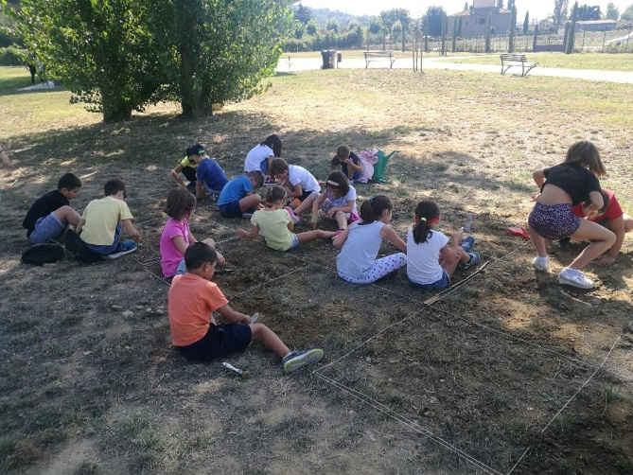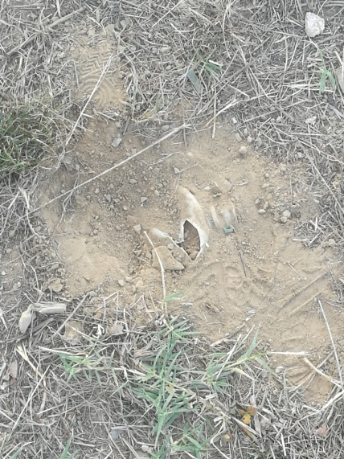

Keywords – Contemporaneity, Method, Excavations, Experiments

Professional Biography
Stefano Rossi completed his degree (Prehistoric Archaeology) in 1993 and Special School of Archaeology (Prehistory and Proto-history) in 2000 at University of Florence, and several Masters. He is member of IIPP (Italian Institute of Prehistory), Accademia Etrusca di Cortona and ICOM. He founded and works for a private society (Aion Cultura) from 1995 in Cortona (Arezzo), for which he is the coordinator of archaeological projects. He is active mainly at Museo dell’Accademia Etrusca e ella Città di Cortona – MAEC, in which is responsable of the managing for archaeological sector. He is involved daily with educational in museums and communication with a large audience. His research area is Bronze Age, Etruscans, Excavations, Educational, Museums, Exhibitions, Relations between contemporaneity and ancient world. He dug about 50 excavations, most of them as coordinator or director. He has published more than 20 scientific papers and popular books. He gave several lectures for different Universities.
Recent Publications
Published Papers
- L’Elba e l’Arcipelago Toscano. Le avventure archeologiche di Ilvo, Roste e Velia. Guida per ragazzi. Pisa 2010
- La preistoria. La vita quotidiana nella Toscana antica, AMAT, Firenze 2013
- Metodologia ordinativa dei motivi decorativi applicata alla ceramica vascolare dell’età del Bronzo finale nell’ Italia medio-tirrenica in “Atti XLII Riun Sc I.I.P.P. Arte preistorica in Italia – Trento 2007” Trento 2014
- La collezione etrusca del MAEC. Guida breve, Cortona 2018
In Press Papers
- L’alimentazione nella preistoria: il cibo dal Paleolitico all’Età del Ferro

