Antibiotic resistant genes in aquaculture: sources, pathways, sinks and how to avoid them
Hans-Uwe Dahms Ph.D., D.Sc.

Kaohsiung Medical University, Dept. of Biomedical Science and Environmental Biology No. 100, Shin-Chuan 1st Road, Kaohsiung 80708 & Department of Marine Biotechnology and Resources, National Sun Yat-sen University, No. 70, Lienhai Road, Kaohsiung 80424, Taiwan, R.O.C.; NSYSU; e-mail: hansd@kmu.edu.tw

Abstract

More than 250 million cases of gastroenteritis, respiratory diseases and more than 5 million cases of hepatitis are reported annually worldwide. This indicates that infectious diseases are on the rise. Reasons for this are an ever increasing world population and the ease of travelling that enhances the risk of disease spread. An unprecedented rise of antibiotic resistance of most pathogenic microbes and viruses provides another serious health risk. We show that the aquaculture environment with freshwater, brackish and seawater components provide a serious source of antibiotic resistant pathogens. Here, some pathogens even get more virulent than in their human host. This way environmental health as a branch of public health gets unexpected importance with several facets of the natural and man-made environment that affects human health. Three basic disciplines generally contribute to the area of aquaculture environmental health: environmental epidemiology, toxicology, and exposure science. Information from these three disciplines can be combined to conduct a risk assessment for specific physical, chemical, or biological hazards. Such risk factors, separate or in combination, determine whether an exposure poses significant risks to human health. This can in turn be used to develop and implement environmental health policies that regulate chemical emissions, or impose standards for proper sanitation in aquaculture. This way environmental health management can become a tool of preventive medicine. Preventive medicine as a branch of public health attempts to prevent diseases such as infectious diseases, as opposed to disease treatment. We will provide examples here from antibiotic resistance of human pathogenic bacteria that were transfected from life feed used in aquaculture facilities. These are posing threats to organisms raised in aquaculture themselves, to food and drinking water safety, and the healthy functioning of adjacent ecosystems and humans alike.

Keywords— Aquaculture, Antibiotic resistance gene, Life feed transmission, Wastewater.

Graphical Abstract
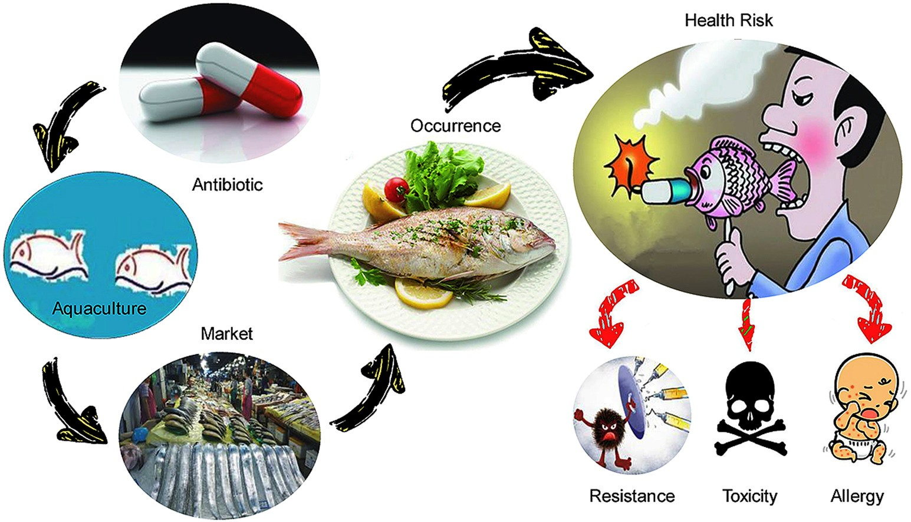

Professional Biography (100-150 words)

Dr. Hans-Uwe Dahms is a professor at Kaohsiung Medical University. He is interested in stress responses in general and within aquatic systems in particular. He and his colleagues and students integratively study pollution and the toxicology of stressors from physical, chemical, and biological sources. He is equally interested in climate change, the spread of diseases, antibiotic-resistance, food and drink safety from water sources, and integrative approaches in environmental and public health monitoring, risk assessment and management. He advised more than 25 Ph.D. students in their research and published more than 280 papers in scientific journals. He served as a reviewer for more than 70 SCI journals, as editorial board member of 12 reputed scientific journals, academic editor of PLosONE, and as editor in chief of FRONTIERS in Marine Pollution.



Email Id: hansd@kmu.edu.tw

