Development and evaluation of an Immunochromatography test for the establish new rapid diagnosis kit for detection of acute fish viral diseases
Mohammad Jalil Zorriehzahra¹

¹ Aquatic Animal health & Diseases Dept., Iranian Fisheries Science Research Institute (IFSRI), Agricultural Research Education and Extension Organization (AREEO), Tehthe ran, I.R. Iran

Abstract

The development of rapid disease diagnostic methods has been necessary since the increasing number of bacterial and viral pathogens leading to threatening diseases in human and animal populations. Rapid, accurate diagnosis of disease and fast detection of infected patients are critical for effective control, prevention and eradication of new hazardous outbreaks. Prompt action in the early stages of any disease problem can have an enormous impact on the scale of the global outbreaks. As a result, the design of rapid, accurate and sensitive methods has been considered by researchers to replace with other complex and costly immunoassay methods like Radioimmunoassay and ELISA in recent years. ICG test is used for the qualitative and quantitative detection of a wide variety of antigens and antibodies in hospitals, clinics, physician offices, and clinical laboratories. ICG assay is based on the flow of the infected sample along a cellulose membrane via capillary action. Major advantages found in this technology are inexpensive, simple to use, portable, short assay time (10-15 minutes), does not require skilled operators and complicated equipment. So, regarding the importance of mentioned approach, we decided to evaluate the feasibility of our rapid diagnostic kit production in order to detect some Aquatic viral diseases such as VNN and Iridovirus and compare its sensitivity and specificity with other conventional methods such as immunohistochemistry (IHC) and Reverse transcription-polymerase chain reaction (RT-PCR). Currently, we designed and established a new Rapid Diagnosis Kit in Immunochromatography model for fast detection of Viral Nervous Necrosis (VNN) as the first time in the country.

Keywords: Rapid diagnostic kit, fish viral diseases, Iran

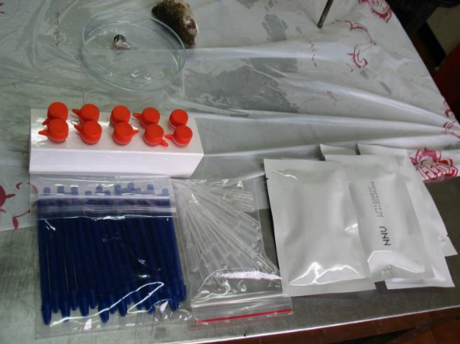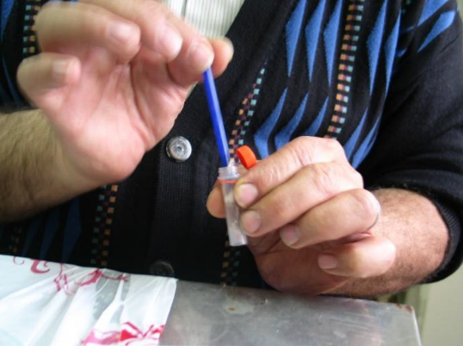

Professional Biography:

Zorriehzahra has completed his DVM at the age of 27 years from Tehran University and PhD studies from UPM University Faculty of Veterinary Medicine. He is the head of Aquatic Animal Health & Diseases Dept., Iranian Fisheries Science Research Institute (IFSRI), a premier Fisheries Science Research service Institute. He has published more than 120 papers in reputed journals, 10 professional books and has been serving as an editorial board member of repute.

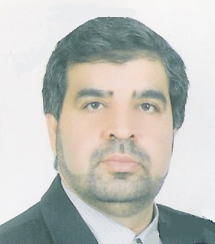

Email: zorrieh@yahoo.com

Any Comments:
I can prepare and present a practical workshop with mentioned above topic for respected audiences in the Conference

