Biological aspects of Razorfish Centriscus cristatus from the waters of Perhentian, Malaysia
Khoo Mei Ling^{1*}, Mazlan Abd. Ghaffar²
& Simon Kumar Das¹
¹Universiti Kebangsaan Malaysia, Malaysia
²Universiti Malaysia Terengganu, Malaysia

Abstract (300 word limit)

Statement of Problem: Razorfishes (Centriscidae) are known for their unique shape and swimming behaviour, which makes them one of the popular marine ornamental fish species being traded. Unfortunately, supplies for this fish are heavily dependent on wild-catch and biological information regarding this fishes is extremely scarce, thus increasing the chance of overharvesting to be exploited. Methodology: A study has been conducted to investigate the biological aspects of razorfish Centriscus cristatus in waters of Pulau Perhentian, Terengganu, Malaysia. Samples were collected using the bottom otter trawl and several traits such as meristics and morphometric measurements, length weight relationship, length frequency, feeding habits and reproduction biology were looked at. Results and discussion: Results showed that there were no difference in the meristics and morphometric measurements found between the male and females, except the presence of 13 stripes on the dorsal part of the body starting from the back of the eye to the anal fin in the males and females are lack of these stripes. C. cristatus showed a negative allometric growth (W= aL^{b}, where b= 2.395, n=151). Although C. cristatus lack of a stomach, their average relative gut length is 0.68, making them carnivores. Food items mostly found in the gut of C. cristatus were zooplanktons such as Ceratium sp. and Tintinopsis, although most guts were found empty in this study. The gonad of C. cristatus appears to be monolobus, with a mixture of different stages of ovum present and the fecundity ranging from 487 to 3344. Conclusion and significance: Information on razorfishes (Centriscidae) are lacking even though they are one of the sought-after species in marine ornamental trades, therefore these results provided valuable insights to aid in further research to develop effective management and aquaculture plans for this fish.
Image
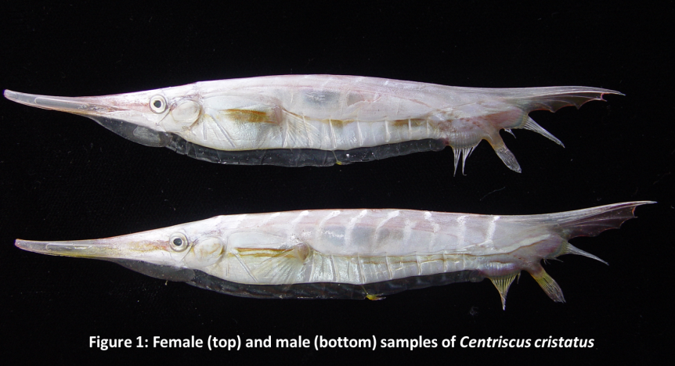
Recent Publications (minimum 5)
- Khoo ML, Das SK & Mazlan AG (2019) Gastric Emptying and the Enzymatic Activity in the Stomach of Amphiprion ocellaris Fed on Artificial Diet. Sains Malaysiana 48(1): 1–6
- Khoo ML, Das SK & Mazlan AG (2018) Growth pattern, diet and reproductive biology of the clownfish Amphiprion ocellaris in waters of Pulau Tioman, Malaysia. Egyptian Journal of Aquatic Research 44: 233–239.
- Ismail MS, Khoo ML, Masazurah AR, Dzulfikkar BM & Hadzley H. (2017) Checklist and Distribution of Jellyfish in the Coastal Waters of Peninsular Malaysia. Malaysian Fisheries Journal 16: 9-18
- Khoo ML, Das SK, Mazlan AG (2016). Gastric Evacuation in Clownfish (Amphiprion ocellaris) Fed on Artificial Diets. Wulfenia Journal 23: 267- 279.
- Khoo ML & Mazlan AG (2014) Estimation of gastric emptying time (GET) in clownfish (Amphiprion ocellaris) using X-radiography technique. AIP Conference Proceedings 1614: 624-628
- Khoo ML & Mazlan AG (2013). Diurnal patterns of the effective quantum yield of the magnificent sea anemone Heteractis magnifica in Pulau Tioman, Malaysia. Galaxea, Journal of Coral Reef Studies (Special Issue) 15: 133-137

Biography (150 word limit)
Khoo Mei Ling has her expertise in feeding and reproductive biology of fishes, particularly in marine ornamental fishes. She has been working on the biological aspects of marine ornamental fishes such as clownfishes throughout her studies and has gone for internship during her studies at the Tunku Abdul Rahman Aquarium that belongs to the Fisheries Research Institute of Malaysia. She graduated in 2017 and works at the TAR Aquarium as a research assistant for a few months, where she was given the project to culture clownfish Amphiprion ocellaris in captivity before being recruited by the National University of Malaysia (UKM). She is currently a lecturer in National University of Malaysia (UKM).
*Email: meilingkhoo@ukm.edu.my

Notes/Comments:

