Cage fish farming in the lakes and reservoir of Nepal
Md. Akbal Husen, Ph.D., Fishery Research Station, Pokhara, Kaski, Nepal

Abstract
This paper has highlighted the cage fish culture practices, constraints and way forward for future prospects in Nepal. Cage fish culture in Nepal started in 1972. Cage fish farming in the lakes of Pokhara valley and reservoir of Nepal have been found very profitable agribusiness for small, landless fisher community. Cage fish farming profit contributed major portion to their livelihood of Jalari community, a landless fisher community. Cage fish culture is an ecologically sound method of fish farming with low cost fish technology for the fishermen living around the natural water bodies for improving their livelihood. Nylon or polyethylene net cage have been most popular among cage fish farmers of lakes of Pokhara valley. Generally, farmers are using nylon or polyethylene knot-less floating type cages of size 50 m³ (5m x 5m x 2m) and cage frame of bamboo structure act as frame and float. The potential of cage fish culture in the upcoming reservoirs of hydropower is tremendous in Nepal. It is estimated that 92,400 ha of reservoir will be available for the cage fish farming in near future. Cage fish culture could be a livelihood option for displaced people due to hydropower dam construction in the country. Possibilities of cage culture in irrigation canal and river should be explored to increase the country fish production and livelihoods of landless fisher community.
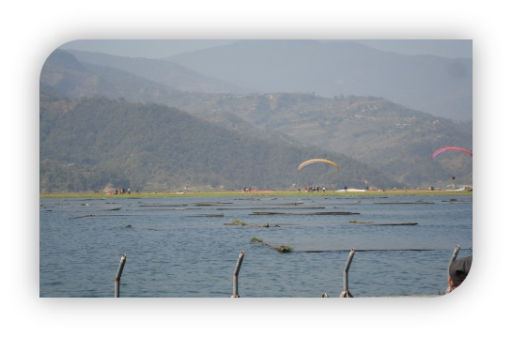

Recent Publications
Husen M.A. (2010a). Internship Report: Cage culture practices by Jalari community in khapudi of Phewa Lake. Institute of Agriculture and Animal Science (IAAS), Nepal. http://www.aarm-asialink.info/internship/IAAS/akbal.pdf
Husen, M.A. (2010b). Natural productivity assessment of cage fish culture in Phewa Lake. MS. Thesis. Institute of Agriculture and Animal Science (IAAS), Rampur, Chitwan, Nepal.
Husen, M. A., Nepal A. P., Bista J.D. (2010). Present status of enclosure fish farming in the lakes of Pokhara valley. P. 358-365.In: Proceedings of Ninth National Outreach Research Workshop held 7-8 June, 2010, Khumaltar, Lalitpur, Nepal. NARC, ORD, Kumaltar, Lalitpur, Nepal.
Husen, M.A., Yadav, C.N.R., Shrestha, M.K. and Bista, J.D. (2012). Growth and production of planktivorous fish species in cages stocked as monoculture and polyculture at Khapuadi in Phewa Lake, Nepal. Asian Fisheries Science, 25, 218-231.
.Prasad, S., Husen, M.A. and Silwal, B.P. (2017). Effect of different feed on caged fish in Kulekhani reservoir. P. 64-68 In: Proceedings of 10th National workshops on Livestock and Fisheries Research Nepal. Nepal Agricultural Research Council, Singhdrabar, Plaza, Kathmandu.

Fig.2. Fish culture in bamboo floating nylon cages in Phewa Lake
Biography

Dr. Md. Akbal Husen has completed his M.Sc. Aquaculture from Tribhuvan University, Kathmanu, Nepal and Ph.D. from Kathmandu University, Nepal. At present, he is working as a Senior Scientist (S3) in Nepal Agricultural Research Council (NARC), Nepal at Fishery Research Station, Pokhara, Nepal. He has experience of 18 years in research and technology generation in the aquaculture and fisheries sector. He has published over 30 paper in the journals and proceedings.
Email:akbalhusen@yahoo.com

