Prospects of pearl culture and its initiation in Nepal for aquaculture diversification
Md. Akbal Husen, Ph.D., Fishery Research Station, Pokhara, Kaski, Nepal
Tek. Bahadur Gurung, Post Doc., Nepal Agricultural Research Council (NARC), Nepal
Agni Prasad Nepal, M.Sc. Aquaculture Fishery Research Station, Pokhara, Kaski, Nepal
Nita Pradhan, M.Sc. Aquaculture, Fisheries Research Division, Godawari, Nepal

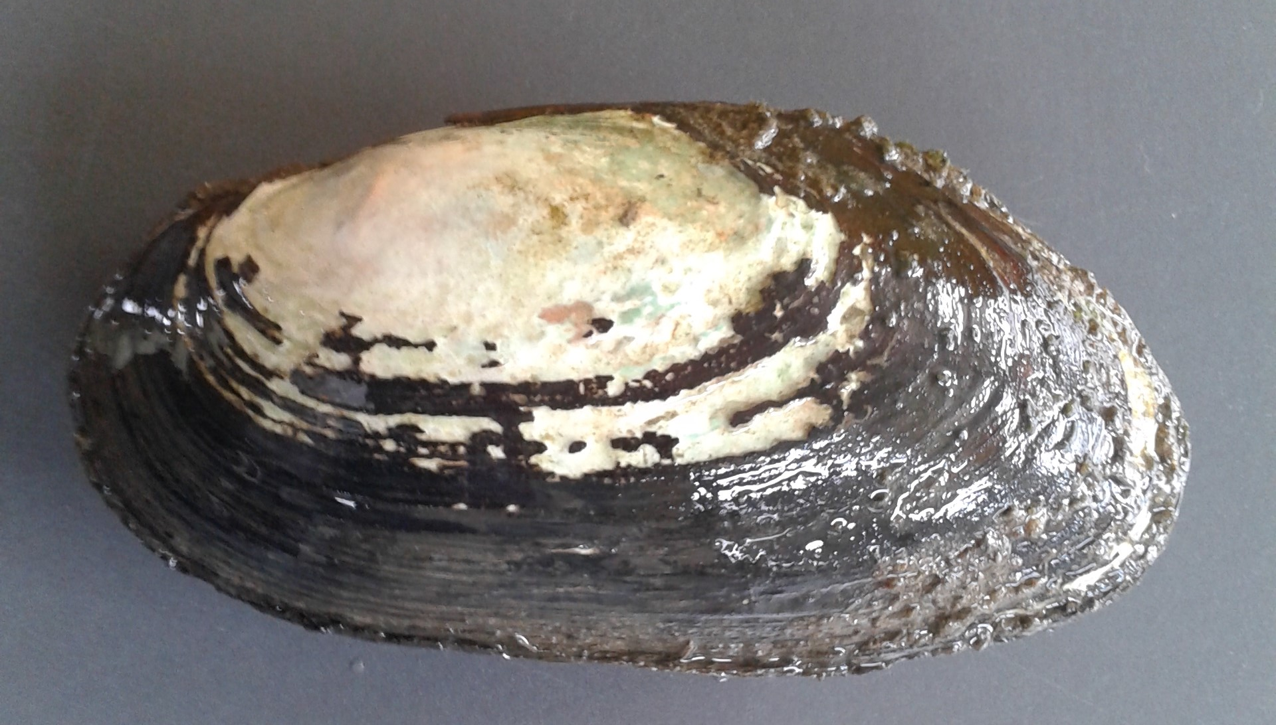

Abstract
Diversification of aquaculture is necessary for the resilience and optimum profitability of farming systems. Freshwater pearl culture is one of the emerging areas in aquaculture sector. Nepal is rich in water resources with abundant species of mussel’s which could be utilized for pearl culture. The species of mussels, Lamillidens corrianus, Lamillidens jenkinsianus, Lamillidens marginalis, Parreysia favidens, and Parreysia corrugate are readily available in various water bodies of Nepal, which could be exploited for initiating pearl aquaculture in the country. The wider area of fish farming available in which pearl culture could be integrated in the country. Although the technology for pearl culture techniques is lacking in Nepal, it explore in research has started in Nepal. In the preliminary study, the acceptance of inserted bead and development of white coating with glister on the inserted bead in the mussels Lamillidens marginalis observed. This could be an attractive strategy for investment and development for government as well as for private sector. It will improve the welfare of fish growing farmers with extra income. This paper reviews the status of pearl farming in global arena and looks forward to explore the potential of its farming and highlight the initiation of research works in Nepal.
Key words: mussels, pearl culture, Lamillidens marginalis, aquaculture

Fig.1. Lamillidens marginalis
References
ICAR. (2004). Selected agricultural technologies- A compendium. Indian Council of Agricultural Research, New Delhi.91-94pp.
Miah, M.I., Rahman, A.S. M.K, Rahmatullah, S.M., Saha, J, K. and Islam, M.A. (2000). Culture of pearl in freshwater mussels (Lamellidens marginalis Lamarck) Bangladesh. Fish. Res., 4(1): 57-61.
Misra, G., Jena, J. and Kumar, K. (2009).Freshwater pearl crop: an emerging enterprise in the Indian subcontinent. Aquaculture Asia Magazine Volume XIV No. 4.
Nesemann, H., Sharma S., Sharma, G., Khanal, S. N., Pradhan, B., Shah, D. N., Tachamo, R. D. (2007). Aquatic Invertebrates of the Ganga River System (Mollusca, Annelida, Crustacea [in part]), Volume 1. 11-56pp.
Pandey, A. and Singh, A. (2015). Effect of different pearl nuclei implantation and rearing methods on survival, growth and pearl formation in freshwater mussel, Lamellidens marginalis in Punjab. Eco. Env. & Cons. 21 (August Suppl.): pp. (AS331-AS335).



Biography
Dr. Md. Akbal Husen has completed his M.Sc. Aquaculture from Tribhuvan University, Kathmanu, Nepal and Ph.D. from Kathmandu University, Nepal. At present, he is working as a Senior Scientist (S3) in Nepal Agricultural Research Council (NARC), Nepal at Fishery Research Station, Pokhara, Nepal. He has experience of 18 years in research and technology generation in the aquaculture and fisheries sector. He has published over 30 paper in the journals and proceedings.
Email:akbalhusen@yahoo.com

