Combined experimental test and numerical simulations
for robust design and certification of Vehicle Restraint Systems
Michel Massenzio¹, Denis Brizard¹, Clément Goubel²

¹Univ Lyon, Université Claude Bernard Lyon 1, IFSTTAR, LBMC UMR_T9406, F69622, Lyon, France
²DynaS+ 5, avenue Didier DAURAT 31 400 TOULOUSE, France

Abstract

Vehicles Restraint Systems (VRS) are designed and implanted along roads as safety elements dedicated to motorcyclists and/or vehicles. In order to validate the efficiency of the VRS in terms of injury criteria and redirection of the vehicles, crash tests are commonly used. Crash tests are also compulsory for certifications. However, even if the number of crash conditions of the VRS are innumerable in the real life, one cannot afford economically to test more than a few crash configurations. The uncertainties are linked on the one hand to the material mechanical properties or the tolerances of manufacture that cannot be controlled and on the other hand to the impact conditions such as velocity, angle of impact, size of the vehicle, location of impact.
A new approach is then proposed combining a few numbers of crash tests, the development of a low calculation cost finite element model and sensitivity analysis.
The actual crash tests are those required by European Norm (e.g. EN1317 for vehicles). It provides data to validate the finite element model.
The finite element model (LS-DYNA) is developed in order to provide results for the huge number of parameter sets. Moreover, the impact duration is quite long, about one second and both the vehicle/motorcyclist and the VRS are to be modeled. Hence the calculation can become really costly. So an optimised numerical model is required.
The other major purpose of this work is to find an approach for Sensitivity Analysis (SA) of such complex engineering systems. Screening SA methods (such as 2-level screening methods and Morris method) can be used to identify the few factors that are influential. Variance-based SA method (such as SOBOL method) can be used to quantity the influence of the remaining parameters.

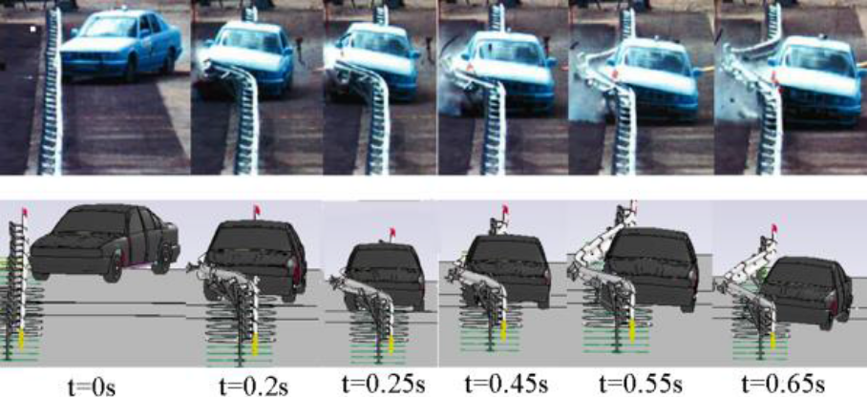
Crashing test and simulation at different impact time
Keywords—crash simulation – finite element simulation - sensitivity analysis – Vehicle Restraint Systems

Professional Biography

Michel MASSENZIO has a mechanical engineering degree (1992) and a PhD in the field of acoustics (1997) from Institut National des Sciences Appliquées – Lyon (France). He has developed turbomachinery test bench at Ecole Centrale de Lyon until 1999. As a lecturer at Université Claude Bernard Lyon 1, he carried out research on the dynamic behaviour of composite strengthening of concrete structures with and without cracks. Since 2008, as a professor, his research topics deal with transport safety and mechanical devices for medical treatments. He has been head of the Mechanical Department of the University Institute of Technology – Lyon1 University. Since 2012, he is deputy director of the institute.

Denis BRIZARD has completed his PhD in structural mechanics at Ecole Centrale de Lyon (France) and now works as a fellow researcher at LBMC (Univ Lyon/IFSTTAR). His fields of interest are uncertainty quantification and sensitivity analysis, with specific applications to impact mechanics,

Clément GOUBEL has completed his PhD at the university of Lyon (France) and worked for ten years at the French Laboratory for Road Equipment testing as computational mechanics team leader. He is now working for DynaS+, the French distributor of Ls-Dyna in France. He has a strong knowledge of Vehicle Restraint System behaviour under impact loading and of the modelling strategies required to properly represent the failure modes of these structures.

Michel MASSENZIO | Denis BRIZARD | Clément GOUBEL

Email Id: michel.massenzio@univ-lyon1.fr

Any Comments:
Full Name: Michel MASSENZIO
Current Affiliation (Hospital/University/Organization):
Univ Lyon, Université Claude Bernard Lyon 1, IFSTTAR, LBMC UMR_T9406, F69622, Lyon, France
17, rue de France 69 627 Villeurbanne, France

